This document contains the validation scripts which can be used as individual as well as the whole document as adding to the .aspx or any web page where it’s the need of using the validations.
See below the expression for the various purposes:
- Show confirm box

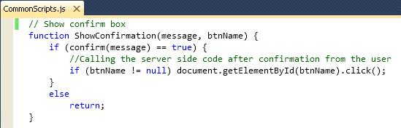

- Show Alert box

- Validate mandatory check

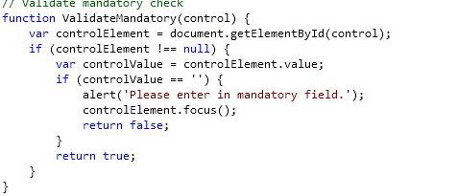

- Script to compare two dates(From Date and To Date)

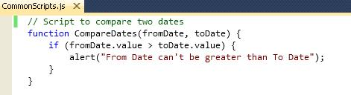
- Script to compare salary(Min Salary and Max Salary)

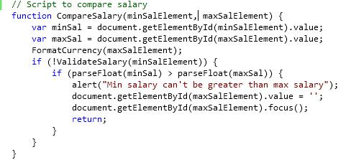
- Script to compare service(Min Service Period and Maximum Service Period)
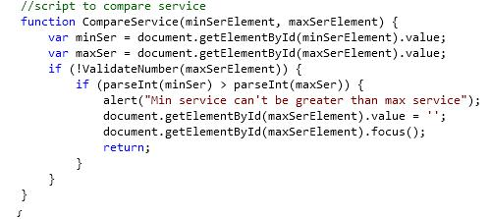

- Validate numbers

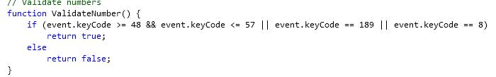

- Validate numbers with padding

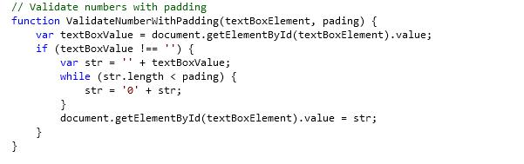

- Validate last name as Mandatory field and the user should enter at-least 2 letters

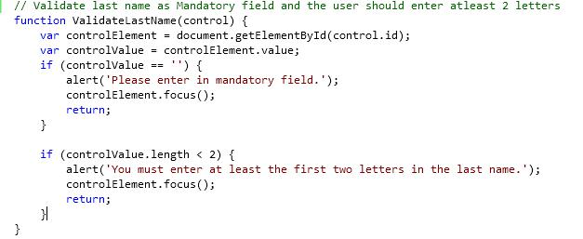

- Validate alphanumeric

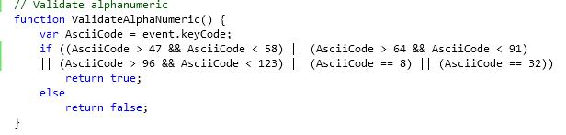

- Validate alphanumeric with apostrophe(')

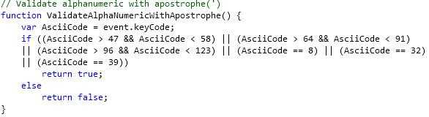

- Validate number with a .(dot)

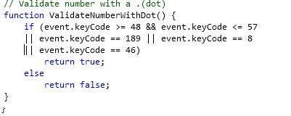

- Validate number with a .(dot) and Comma(,)

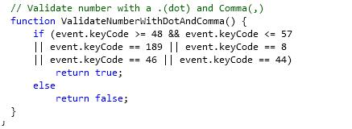

- Validate salary

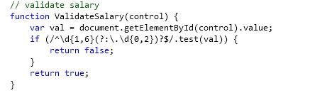

- Format Non-US currency

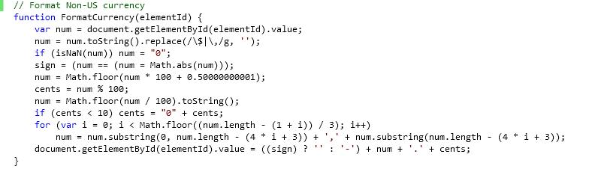
- Format US currency

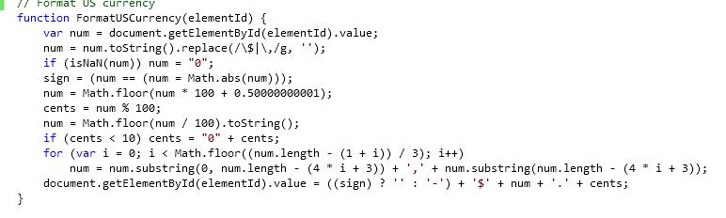
- Validate Yes/No status

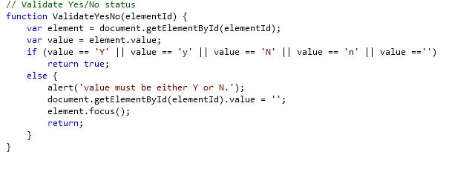
- Validate range numbers
