Steps To Create Windows Service:
The following screenshot will guide you to create Window Services in .Net Framework
File New Project Window Serivce.
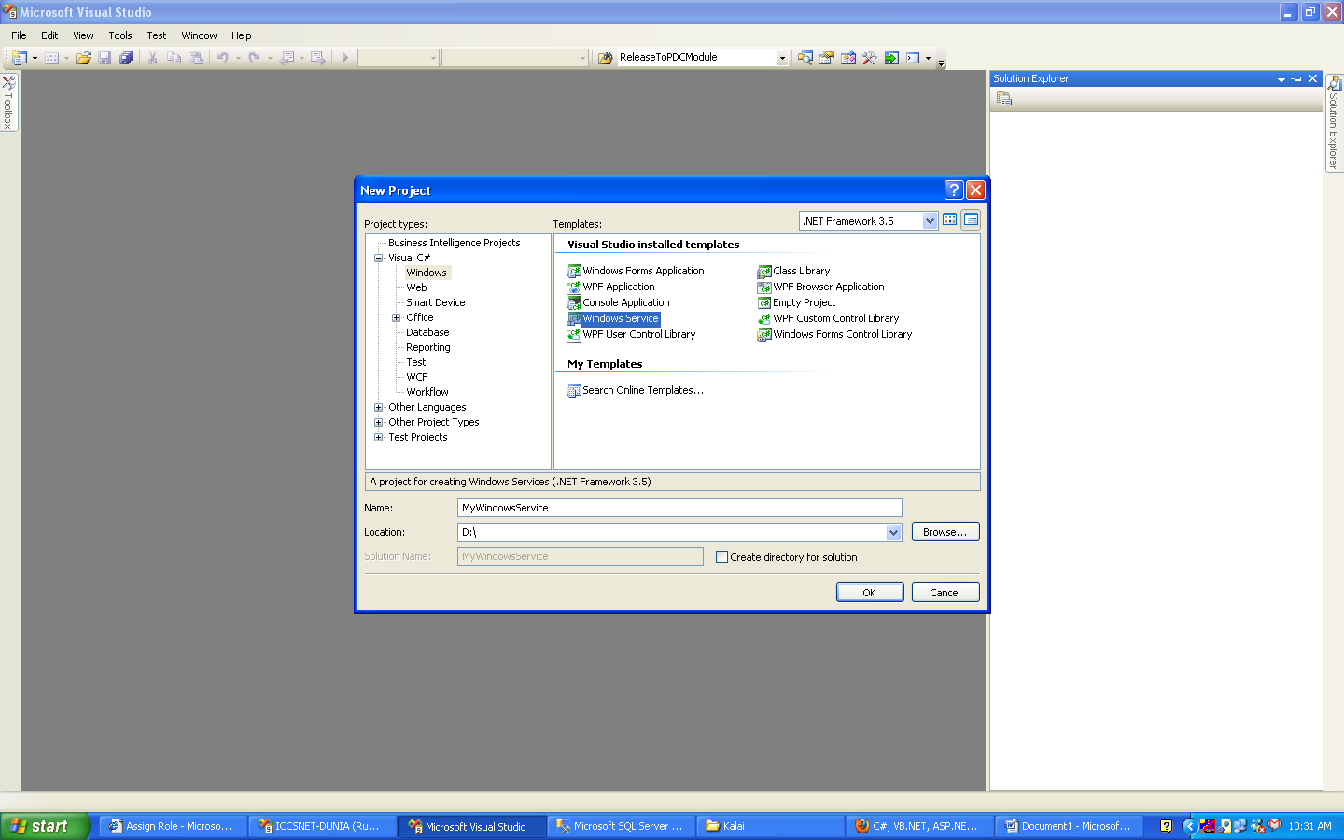

In New Windows service Project Service1.cs file will created. Then goto Code view of Service1.cs file. In the code file override events of the service. Like Onstart, Onstop etc …

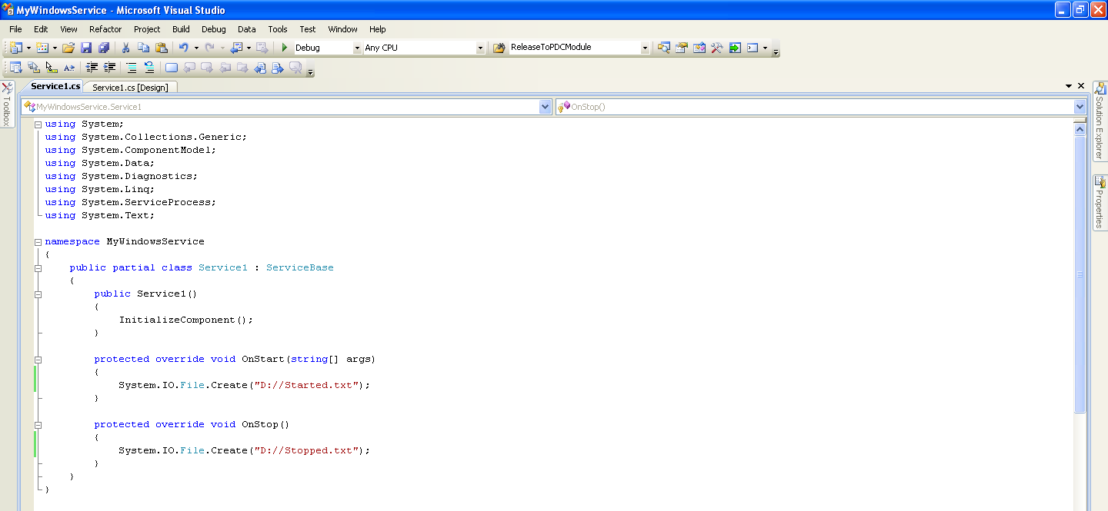

Then switchover to design view of Service1.cs, then Rightclick in Design view Click AddInstaller. Service installer and service process installer will be added.

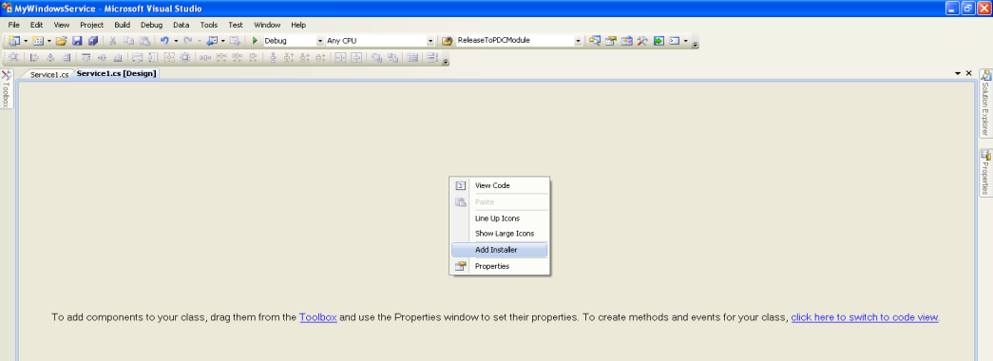

Then Click ProjectInstaller.Designer.cs in this code file you should specify username, password and service Account.

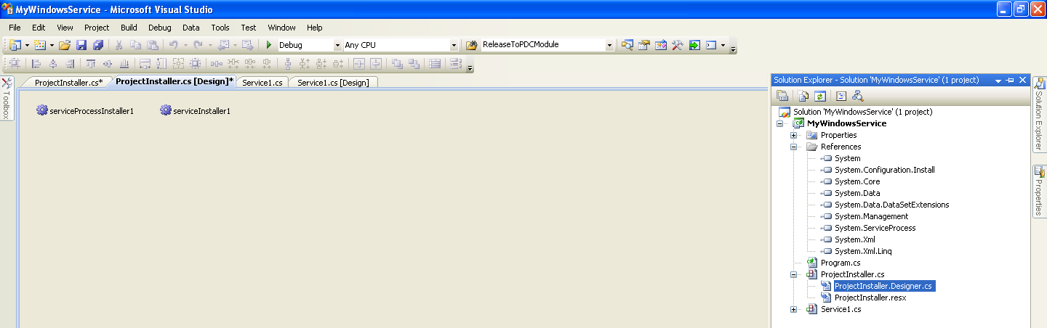

Ex: this.serviceProcessInstaller1.Account = System.ServiceProcess.ServiceAccount.LocalSystem;
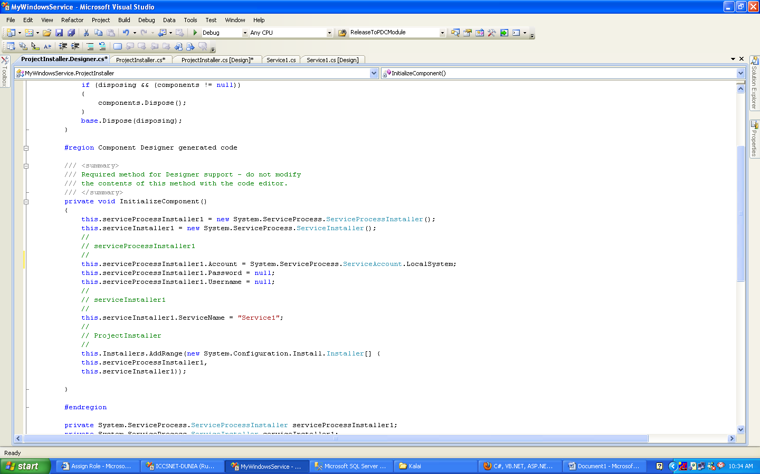

Finally Build the Project. Service project created.
The Next step is installation of Window Service

To install window service, you should create the Setup Project. To create setup Project Right click Solution then select Add New Project.
Add new Project template will display, in that select setup and deployment - setup project
Then Right Click SetupProject (Which is added to solution),
Then select Add Project Output
Then Select Your Window Service Project
Then select view Custom Action

The RightClick Custom Action select Application Folder

Setup File and Installer file will be generated. If You Click installer file means service will be installed into your machine

