CONTENTS

SL.NO. DESCRIPTION

- Acknowledgement
- Introduction
- DFD’S
- The list of features in the project
- SYNOPSIS
- Configuration
- Process Description
- About ‘C#’
- Creation of database
- Screen shots with Coding in (C#)
- Certificate
- The project trainee letter
- Conclusion

CERTIFICATE

This is to certify that the project report entitled

Submitted to SIKKIM MANIPAL UNIVERSITY, DE in partial fulfilment of the requirement

For the award of the degree of BACHELOR OF COMPUTER APPLICATIONS (BCA), is

An original work carried out by Ms PRADEEP KUMAR

Enrolment No.: 520764026 under the guidance of Ms. RAKESH ROSHAN

The matter embodied in this project is a genuine work done by the student and has not been

Submitted whether to this University or to any other University / Institute for the fulfilment of the

Requirement of any course of study.

Signature of the Student Signature of the
Guide Director

Registration No.:520764026

THE LIST OF FEATURES IN THE PROJECT:
- CREATION OF ACCOUNT AND NEW ACCOUNT
- CANCELLATION OF ACCOUNT.
- DEBIT
- CREDIT && CREDIT CARD
- LOAN SYSTEM
- RECORD MODIFICATION.
- AUTOMATIC UPDATION.
- TRANSACTION
- BALANCE CHECK
- EMI CALCULATOR
- CHECK NEW SCHEMES ON WEB

ACKNOWLEDGEMENT
We owe our sincere thanks to all who co-operated and assisted us for the successful accomplishment of this project work.
We express our gratitude to our college for providing us an opportunity to achieve our vision. We are also indebted to our course co-ordinator Ms. RAKESH ROSHAN & Ms. RAJEEV for his valuable guidance and also to our external for evaluating our project by giving valuable suggestions.

INTRODUCTION

Ever since the nationalization of banks, they have been playing an important role in the development of the country’s economy . All people generally use banking services besides national banks many co-operative banks are also being started to provide services to the people . With the increase in population the number of people using the banks is increasing day by day leading to increased number of transactions. Thus computerization of accounts i.e., Banking information system is justified.
Present system:
Present banking system is the process where all the transactions are recorded with facilities like deposit of money or withdrawal of money etc. Consider a bank where any person who desires to save his money or to do certain transactions, here after called as customer has opened an account. The customer will be allotted an account number wherein this will be stored in a file and transactions are processed henceforth a group of such account numbers will be put under a section called “ledger folio”. A customer when deposits certain money or wants to withdraw money the ledger folio with his account number will be taken out and transactions are carried out.
DRAWBACKS OF PRESENT SYSTEM:
1. Requires a lot of manual and paper work.
- Time consuming
- May not be accurate.
- Generation of reports would be difficult and would need maintenance of additional files which would be redundant.
- A lot of maintenance should be required to keep the records safe from external damages.
ADVANTAGES OF BANK INFORMATION SYSTEM
- Bank information system is a continuous process involving day to day transactions .each time a transaction is made all the necessary details are updated in their respective files automatically.
- Computations of various accounts savings, current and recurring will be easier and faster.
- Coordination is brought about between various departments as the information is centralized.
- Reliable information can be obtained unlike the manual system

CONFIGURATION
HARDWARE: INTEL PENTIUM-I
32MB RAM
2.1HDD

OPERATING SYSTEM: MS-DOS (VER 6.2)
TERMINAL: IBM PC.
MONITOR: COLOR.
VDU MEMORY: 64 Kb
BACKUP MEDIA : HARD DISK.

PROJECT DESCRIPTION
The project description is on the ‘computerization of banking information system’. This project is a replica of the general banking system followed. The project facilitates mainly in various transactions, deposits, loans etc. On different accounts.
The various types of accounts maintained are:
1. Savings account
2. Current account
3. Recurring account
These have been programmed assuming the general regulations followed by our banks. This project gives us full details about customers and their transactions.
1. Savings account:
Savings account is one of the general accounts in a bank. Any one can open a savings account in a bank. For a customer to make a transaction, his account should show a minimum balance. Check book facility is another important feature of savings account. In this account the interest will be paid only in June and December.
2. CURRENT ACCOUNT
Current account is mainly used by business people. It is just with a savings account where the transactions are frequently made. Here in this case the minimum balance maintained is more than the minimum balance maintained in a savings account.
3. RECURRING ACCOUNT
Recurring deposit is very useful for employees for saving their money .in this the transactions are made on monthly basis. For every month the customer has to pay fixed amount of money. At the time of opening this account we have fixed the duration and the monthly payable amount. The bank gives compound interest on this total amount. Suppose in any case the customer is not able to pay his monthly amount or in case he would like to cancel his account, he is subjected to a penalty in the form of interest. In such cases the bank reduces the interest rate on the deposited amount. If the customer wants to withdraw his account within the period of the maturity date then he will be paid interest till date.

PROJECT TRAINEE LETTER

Date:

Subject: Project Trainee
Sir,

This is to certify that Mr. / Ms PRADEEP KUMAR who’s Enrolment No. 520764026 is a student of BCA Programme of SIKKIM MANIPAL UNIVERSITY, DE and have to do a project in his final year starting from January session. The project is compulsory for BCA programme. He has to do a project for 3-6 months in Industry/Research Laboratories under the supervision of a guide preferably from the same organization. During his course, the student has gone through / will go through several theoretical papers such as Data Structures, Database Management System, Programming Languages (C#, TCP/IP Programming, Intranet Administration, Computer Networks, S/W Engineering etc. The student also attends practical sessions in all courses in which practical sessions were prescribed for various subjects.
Looking forward for your positive response.

Signature& Name of Project Coordinator
With date

ABOUT ‘C#’ LANGUAGE
The C# Language
C# (pronounced C-Sharp) is no doubt the language of choice in the .Net environment. It is a whole new language
Free of the backward compatibility curse with a whole bunch of new, exciting and promising features. It is an
Object Oriented Programming language and has at its core, many similarities to Java, C++ and VB. In fact, C#
Combines the power and efficiency of C++, the simple and clean OO design of Java and the language
Simplification of Visual Basic.
17
Programmers Heaven: C# School
Like Java, C# also does not allow multiple inheritance or the use of pointers (in safe/managed code), but does
Provide garbage memory collection at runtime, type and memory access checking. However, contrary to JAVA,
C# maintains the unique useful operations of C++ like operator overloading, enumerations, pre-processor
Directives, pointers (in unmanaged/un-safe code), function pointers (in the form of delegates) and promises to have
Template support in the next versions. Like VB, it also supports the concepts of properties (context sensitive fields).
In addition to this, C# comes up with some new and exciting features such as reflections, attributes, marshalling,
Removing, threads, streams, data access with ADO.Net and more
The .Net Architecture and .Net Framework
In the .Net Architecture and the .Net Framework there are different important terms and concepts which we will
Discuss one by one:-
The Common Language Runtime (CLR)
The most important concept of the .Net Framework is the existence and functionality of the .Net Common
Language Runtime (CLR) also called .Net Runtime for short. It is a framework layer that resides above the OS and
Handles the execution of all the .Net applications. Our programs don't directly communicate with the OS but go
Through the CLR.
Our .Net Applications
Common Language Runtime (CLR)
Windows OS
MSIL (Microsoft Intermediate Language) Code
When we compile our .Net Program using any .Net compliant language (such as C#, VB.Net or C++.Net) our
Source code does not get converted into the executable binary code, but to an intermediate code known as MSIL
Which is interpreted by the Common Language Runtime? MSIL is operating system and hardware independent
Code. Upon program execution, this MSIL (intermediate code) is converted to binary executable code (native
Code). Cross language relationships are possible as the MSIL code is similar for each .Net language.
Language
Just In Time
Code in any .Net
MSIL
Executable
Compiler
Compiler
Language
Code
Native Code
Compile time run time
18
Programmers Heaven: C# School
Just In Time Compilers (Jitters)
When our IL compiled code needs to be executed, the CLR invokes the JIT compiler, which compile the IL code to
Native executable code (.exe or .dll) that is designed for the specific machine and OS. JITers in many ways are
different from traditional compilers as they compile the IL to native code only when desired; e.g., when a function
is called, the IL of the function's body is converted to native code
just in time
. So, the part of code that is not used
by that particular run is never converted to native code. If some IL code is converted to native code, then the next
time it's needed, the CLR reuses the same (already compiled) copy without re-compiling. So, if a program runs for
some time (assuming that all or most of the functions get called), then it won't have any just-in-time performance
penalty.
As JITers are aware of the specific processor and OS at runtime, they can optimize the code extremely efficiently
resulting in very robust applications. Also, since a JIT compiler knows the exact current state of executable code,
they can also optimize the code by in-lining small function calls (like replacing body of small function when its
called in a loop, saving the function call time). Although Microsoft stated that C# and .Net are not competing with
languages like C++ in efficiency and speed of execution, JITers can make your code even faster than C++ code in
some cases when the program is run over an extended period of time (like web-servers).
The Framework Class Library (FCL)
The .Net Framework provides a huge Framework (or Base) Class Library (FCL) for common, usual tasks. FCL
contains thousands of classes to provide access to Windows API and common functions like String Manipulation,
Common Data Structures, IO, Streams, Threads, Security, Network Programming, Windows Programming, Web
Programming, Data Access, etc. It is simply the largest standard library ever shipped with
any
development
environment or programming language. The best part of this library is they follow extremely efficient OO design
(design patterns) making their access and use very simple and predictable. You can use the classes in FCL in your
program just as you would use any other class. You can even apply inheritance and polymorphism to these classes.
The Common Language Specification (CLS)
Earlier, we used the term '.Net Compliant Language' and stated that all the .Net compliant languages can make use
of CLR and FCL. But what makes a language a '.Net compliant' language? The answer is the Common Language
Specification (CLS). Microsoft has released a small set of specifications that each language should meet to qualify
as a .Net Compliant Language. As IL is a very rich language, it is not necessary for a language to implement all the
IL functionality; rather, it merely needs to meet a small subset of CLS to qualify as a .Net compliant language. This
is the reason why so many languages (procedural and OO) are now running under the .Net umbrella. CLS basically
addresses language design issues and lays down certain standards. For instance, there shouldn't be any global
function declarations, no pointers, no multiple inheritance and things like that. The important point to note here is
that if you keep your code within the CLS boundary, your code is guaranteed to be usable in any other .Net
language.
19
Programmers Heaven: C# School
The Common Type System (CTS)
.Net also defines a Common Type System (CTS). Like CLS, CTS is also a set of standards. CTS defines the basic
data types that IL understands. Each .Net compliant language should map its data types to these standard data
types. This makes it possible for the 2 languages to communicate with each other by passing/receiving parameters
to and from each other. For example, CTS defines a type, Int32, an integral data type of 32 bits (4 bytes) which is
mapped by C# through int and VB.Net through its Integer data type.
Garbage Collection (GC)
CLR also contains the Garbage Collector (GC), which runs in a low-priority thread and checks for un-referenced,
dynamically allocated memory space. If it finds some data that is no longer referenced by any variable/reference, it
re-claims it and returns it to the OS. The presence of a standard Garbage Collector frees the programmer from
keeping track of dangling data. Ask any C++ programmer how big a relief it is!
The .Net Framework
The .Net Framework is the combination of layers of CLR, FCL, Data and XML Classes and our Windows, Web
applications and Web Services. A diagram of the .Net Framework is presented below for better understanding.
Our .Net Applications
(WinForms, Web Applications, Web Services)
Data (ADO.Net) and XML Library
Framework Class Library (FCL)
(IO, Streams, Sockets, Security, Reflection, UI)
Common Language Runtime (CLR)
(Debugger, Type Checking, JIT, exceptions, GC)
Windows OS

CREATION OF DATABASE
//table for storing bank account info
create table bankinfo(accountno int primary key,
name varchar(200),
address varchar(250),
phoneno int,
age int,
gender varchar(20),
occupation varchar(200),
annualincome real,
statementamount real)

//table for storing creditcard info
create table creditcard
(cardtype varchar(20),
accountno references bankinfo,
name varchar(200),salary real)

//table for storing goldloan
create table goldloan
(accountinfo int references bankinfo ,
name varchar(200),
interestmode varchar(20),
loanamount real,
mode varchar(50)

//table for houseloan
create table houseloan
(accountno int references bankinfo,
name varchar(200),
loamamount real,
monthlysalary real);

//table for educationloan
create table educationloan
(accountid int references bankinfo,
name varchar(200),
location varchar(150),
loanfor varchar(30),
ssc int null,
inter int null,
degree int null);
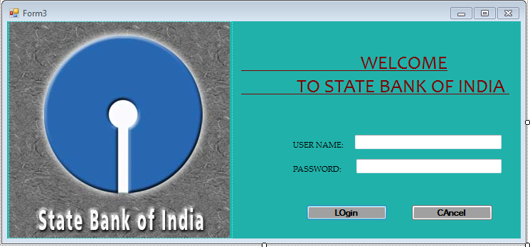using System;
using System.Collections.Generic;
using System.Linq;
using System.Windows.Forms;

namespace bankingproject1
{
static class Program
{
/// <summary>
/// The main entry point for the application.
/// </summary>
[STAThread]
static void Main()
{
Application.EnableVisualStyles();
Application.SetCompatibleTextRenderingDefault(false);
Application.Run(new Form2 ());
}
}
}

MAIN PAGE:
using System;
using System.Collections.Generic;
using System.ComponentModel;
using System.Data;
using System.Drawing;
using System.Linq;
using System.Text;
using System.Windows.Forms;

namespace bankingproject1
{
public partial class Form3 : Form
{
public Form3()
{
InitializeComponent();
}

private void button1_Click(object sender, EventArgs e)
{
if (textBox1.Text.Length > 0 && textBox2.Text.Length > 0)
{
if (textBox1.Text == "rahul" && textBox2.Text == "123")
{
Form2 f2 = new Form2();
f2.Show();
}
else
{
MessageBox.Show("Invalid username and password");
}
}
else
{
MessageBox.Show("Please enter the Username and Password");
}
}

private void button2_Click(object sender, EventArgs e)
{
Application.Exit();
}

private void Form3_Load(object sender, EventArgs e)
{

}
}
}
MDI FORM:
using System;
using System.Collections.Generic;
using System.ComponentModel;
using System.Data;
using System.Drawing;
using System.Linq;
using System.Text;
using System.Windows.Forms;

namespace bankingproject1
{
public partial class Form2 : Form
{
public Form2()
{
InitializeComponent();
}

private void debitToolStripMenuItem_Click(object sender, EventArgs e)
{
debit d = new debit();

d.MdiParent = this;
f = this.ActiveMdiChild;

if (f == null)
{
d.Show();
} }

private void simpleCreditToolStripMenuItem_Click(object sender, EventArgs e)
{
credit c = new credit();

c.MdiParent = this;
f = this.ActiveMdiChild;

if (f == null)
{
c.Show();
}
}

private void creditCardToolStripMenuItem_Click(object sender, EventArgs e)
{
creditcard cc = new creditcard();

cc.MdiParent = this;
f = this.ActiveMdiChild;

if (f == null)
{
cc.Show();
}
}

private void emiCalculatorToolStripMenuItem_Click(object sender, EventArgs e)
{
emicalculator emi = new emicalculator();

emi.MdiParent = this;
f = this.ActiveMdiChild;

if (f == null)
{
emi.Show();
}
}

private void createAccountToolStripMenuItem_Click(object sender, EventArgs e)
{
createaccount ca = new createaccount();
ca.MdiParent = this;
f = this.ActiveMdiChild;

if (f == null)
{
ca.Show();
} }

private void balanceCheckToolStripMenuItem_Click(object sender, EventArgs e)
{
balancecheck bc = new balancecheck();

bc.MdiParent = this;
f = this.ActiveMdiChild;

if (f == null)
{
bc.Show();
}
}

private void toolStripMenuItem2_Click(object sender, EventArgs e)
{

}

private void transactionToolStripMenuItem_Click(object sender, EventArgs e)
{
transaction t = new transaction();
t.MdiParent = this;
f = this.ActiveMdiChild;
if (f == null)
{
t.Show();
}

}

private void homeLoanToolStripMenuItem_Click(object sender, EventArgs e)
{
houseloan h = new houseloan();

h.MdiParent = this;
f = this.ActiveMdiChild;
if (f == null)
{
h.Show();
}
}

private void educationLoanToolStripMenuItem_Click(object sender, EventArgs e)
{
eduloan edu = new eduloan();

edu.MdiParent = this;
f = this.ActiveMdiChild;

if (f == null)
{
edu.Show();
}

}

private void carLoanToolStripMenuItem_Click(object sender, EventArgs e)
{

}

private void goldLoanToolStripMenuItem_Click(object sender, EventArgs e)
{
goldloan g = new goldloan();
g.MdiParent = this;
f = this.ActiveMdiChild;
if (f == null)
{
g.Show();
}
} }

private void newSchemesOnWebToolStripMenuItem_Click(object sender, EventArgs e)
{
Form4 f4 = new Form4();

f4.MdiParent = this;
f = this.ActiveMdiChild;
if (f == null)
{
f4.Show();
}
}

private void Form2_Load(object sender, EventArgs e)
{

}
}
}
CREATE ACCOUNT:
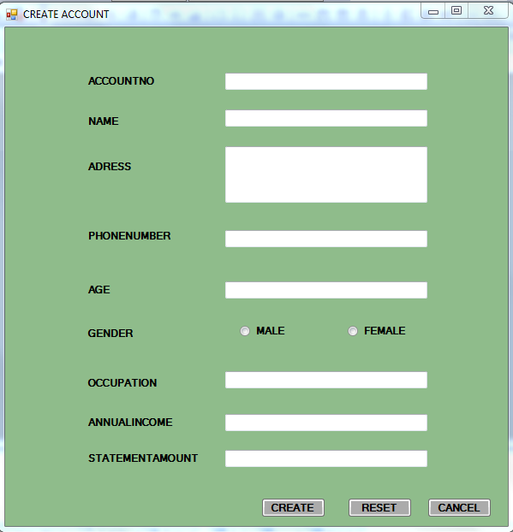

using System;
using System.Collections.Generic;
using System.ComponentModel;
using System.Data;
using System.Drawing;
using System.Linq;
using System.Text;
using System.Windows.Forms;
using System.Data.SqlClient;
namespace bankingproject1
{
public partial class createaccount : Form
{
public createaccount()
{
InitializeComponent();
}
public void clear()
{
textBox1.Clear();
textBox2.Clear();
textBox3.Clear();
textBox4.Clear();
textBox5.Clear();
textBox6.Clear();
textBox7.Clear();
textBox8.Clear();
radioButton1.Checked = false;
radioButton2.Checked = false;
textBox1.Focus();
}
public void createaccounttype()
{
if (textBox1.Text.Length > 0 && textBox2.Text.Length > 0 && textBox3.Text.Length > 0 && textBox4.Text.Length > 0 && textBox5.Text.Length > 0 && textBox6.Text.Length > 0 && textBox7.Text.Length > 0 && textBox8.Text.Length > 0)
{
SqlConnection cn = new SqlConnection("server =.;uid=sa;pwd=;database=Banking");
cn.Open();
int j;
int a = int.Parse(textBox8.Text);
string gender;
if (radioButton1.Checked == true)
gender = "male";
else
gender = "female";
MessageBox.Show(a.ToString());
if (a > 1000)
{
SqlCommand cmd = new SqlCommand("select * from bankinfo", cn);
cmd.CommandType = CommandType.Text;
cmd.CommandText = "insert into bankinfo values ('" + textBox1.Text + "','" + textBox2.Text + "','" + textBox3.Text + "','" + textBox4.Text + "','" + textBox5.Text + "','" + gender + "','" + textBox6.Text + "','" + textBox7.Text + "','" + textBox8.Text + "')";
j = cmd.ExecuteNonQuery();
cn.Close();
}
else
{
MessageBox.Show("no sufficient data ");
}
if (MessageBox.Show("do u want to create another account", "add", MessageBoxButtons.YesNo, MessageBoxIcon.Question) == DialogResult.Yes)
{
clear();
}
else
{

if (MessageBox.Show("do u want to view any data plz enter name to view accountid...", "view", MessageBoxButtons.YesNo, MessageBoxIcon.Question) == DialogResult.Yes) ;
clear();
textBox2.Focus();
}
}
else
{
MessageBox.Show("Remember you should not leave any empty fields");
}
}
private void button2_Click(object sender, EventArgs e)
{
clear();
}

private void createaccount_Load(object sender, EventArgs e)
{

}

private void button1_Click(object sender, EventArgs e)
{
createaccounttype();
}

private void button3_Click(object sender, EventArgs e)
{ string sql1="select accountno from bankinfo where name ='"+textBox2 .Text +"'";
SqlConnection cn = new SqlConnection("server =.;uid=sa;pwd=;database=Banking");
SqlDataAdapter da = new SqlDataAdapter(sql1, cn);
SqlCommandBuilder cmd = new SqlCommandBuilder(da);
DataSet ds = new DataSet();
da.Fill(ds, "temp");
}

private void button3_Click_1(object sender, EventArgs e)
{
this.Close();
}
}
}
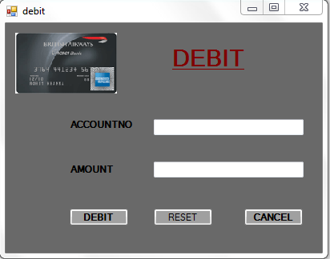
DEBIT: using System;
using System.Collections.Generic;
using System.ComponentModel;
using System.Data;
using System.Drawing;
using System.Linq;
using System.Text;
using System.Windows.Forms;
using System.Data.SqlClient;

namespace bankingproject1
{
public partial class debit : Form
{
public debit()
{
InitializeComponent();
}
void clear()
{
textBox1.Clear();
textBox3.Clear();
}

private void button2_Click(object sender, EventArgs e)
{
this.Close();
}

private void button1_Click(object sender, EventArgs e)
{
if (textBox1.Text.Length > 0 && textBox3.Text.Length > 0)
{
int a = System.Convert.ToInt32(textBox1.Text);
int j;
SqlConnection cn = new SqlConnection("server=.;uid=;pwd=;database=Banking");
SqlCommand cmd = new SqlCommand("select * from bankinfo", cn);
SqlTransaction trans;
cn.Open();
trans = cn.BeginTransaction();
cmd.Connection = cn;

cmd.Transaction = trans;
cmd.CommandType = CommandType.Text;
cmd.CommandText = "update bankinfo set statementamount=statementamount + '" + textBox3.Text + "' where accountno='" + textBox1.Text + "' and name='" + "'";
j = cmd.ExecuteNonQuery();
if (j == 1)
{
trans.Commit();
MessageBox.Show("amount is debited....");
}

else
trans.Rollback();
}
else
{
MessageBox.Show("Please enter the account number and amount");
}
}

private void button3_Click(object sender, EventArgs e)
{
clear();
}

private void debit_Load(object sender, EventArgs e)
{

}
}
}
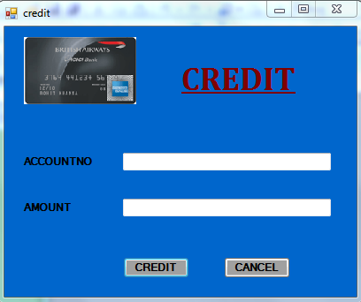
CREDIT
using System;
using System.Collections.Generic;
using System.ComponentModel;
using System.Data;
using System.Drawing;
using System.Linq;
using System.Text;
using System.Windows.Forms;
using System.Data.SqlClient;

namespace bankingproject1
{
public partial class credit : Form
{
public void clear()
{
textBox1.Clear();

textBox3.Clear();
textBox1.Focus();

}
public credit()
{
InitializeComponent();
}

private void button2_Click(object sender, EventArgs e)
{
this.Close();
}

private void button1_Click(object sender, EventArgs e)
{
if (textBox1.Text.Length > 0 && textBox3.Text.Length > 0)
{
int accno = System.Convert.ToInt32(textBox1.Text);
string sql = "select statementamount from bankinfo where accountno='" + textBox1.Text + "'";

SqlConnection cn = new SqlConnection("server=.;uid=sa;pwd=;database=Banking");
SqlCommand cmd = new SqlCommand(sql, cn);
cn.Open();
accno = int.Parse(cmd.ExecuteScalar().ToString());

if (accno > 1000)
{
int j;

SqlTransaction trans;
SqlCommand cmd1 = new SqlCommand();
trans = cn.BeginTransaction();
cmd1.Connection = cn;
cmd1.Transaction = trans;
cmd1.CommandType = CommandType.Text;

cmd1.CommandText = "update bankinfo set statementamount=statementamount-'" + textBox3.Text + "' where accountno='" + textBox1.Text + "' and name= '";

j = cmd1.ExecuteNonQuery();
if (j == 1)
{
trans.Commit();
MessageBox.Show("credited...");
clear();

}
else
trans.Rollback();

}
else
{
MessageBox.Show("u can't make credit...");
}

}
else
{
MessageBox.Show("Please enter the valid account number and credit amount ");

}
}

private void credit_Load(object sender, EventArgs e)
{

}

}
}
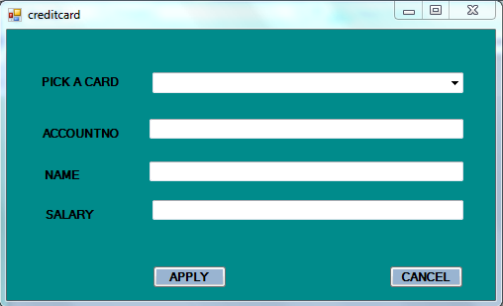
CREDIT CARD
using System;
using System.Collections.Generic;
using System.ComponentModel;
using System.Data;
using System.Drawing;
using System.Linq;
using System.Text;
using System.Windows.Forms;
using System.Data.SqlClient;

namespace bankingproject1
{
public partial class creditcard : Form
{
public void clear()
{
textBox1.Clear();
textBox2.Clear();
textBox4.Clear();
textBox1.Focus();
}
public creditcard()
{
InitializeComponent();
}

private void label3_Click(object sender, EventArgs e)
{

}

private void textBox1_TextChanged(object sender, EventArgs e)
{

}

private void creditcard_Load(object sender, EventArgs e)
{

}

private void label2_Click(object sender, EventArgs e)
{

}

private void textBox2_TextChanged(object sender, EventArgs e)
{

}

private void button2_Click(object sender, EventArgs e)
{
clear();
}

private void button1_Click(object sender, EventArgs e)
{
if (comboBox1.Text.Length > 0 && textBox1.Text.Length > 0 && textBox2.Text.Length > 0 && textBox4.Text.Length > 0)
{
int a = 150000;
int b = System.Convert.ToInt32(textBox4.Text);
if (b > a)
{
SqlConnection cn = new SqlConnection("server=.;uid=sa;pwd=;database=Banking");

string sql = "insert into creditcard values ('" + comboBox1.SelectedItem.ToString() + "','" + textBox1.Text + "','" + textBox2.Text + "','" + textBox4.Text + "')";

SqlCommand cmd = new SqlCommand(sql, cn);

cn.Open();
int j = cmd.ExecuteNonQuery();

if (j == 1)
{
MessageBox.Show("CREDIT CARD IS GRANTED...");
clear();
}
}
else
{
MessageBox.Show("your salary is too low for a card to be sanctioned ");

}
}
else
{
MessageBox.Show("Remember the fields are not empty");
}
}

private void button2_Click_1(object sender, EventArgs e)
{
this.Close();
}
}
}
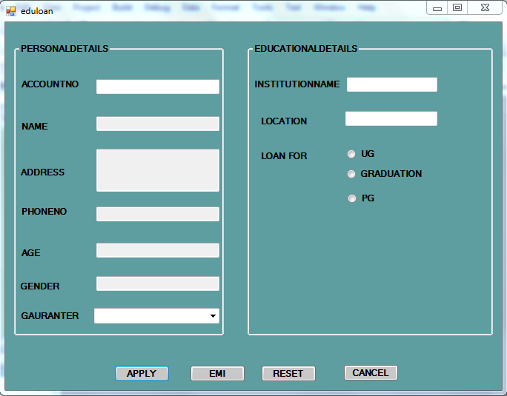
EDUCATION LOAN:
using System;
using System.Collections.Generic;
using System.ComponentModel;
using System.Data;
using System.Drawing;
using System.Linq;
using System.Text;
using System.Windows.Forms;
using System.Data.SqlClient;

namespace bankingproject1
{
public partial class eduloan : Form
{
public void clear()
{
textBox1.Clear();
textBox10.Clear();
textBox11.Clear();
textBox2.Clear();
textBox3.Clear();
textBox4.Clear();
textBox5.Clear();
textBox6.Clear();
textBox7.Clear();
textBox8.Clear();
textBox9.Clear();
radioButton1.Checked = false;
radioButton2.Checked = false;
radioButton3.Checked = false;
}

public eduloan()
{
InitializeComponent();
}

private void button3_Click(object sender, EventArgs e)
{
textBox1.Clear();
comboBox1.ResetText();
}

private void textBox1_TextChanged(object sender, EventArgs e)
{
SqlConnection cn = new SqlConnection("server=.;uid=sa;pwd=;database=Banking");
string sql = "select name,address,phoneno,age,gender from bankinfo where accountno='" + textBox1.Text + "'";
SqlCommand cmd = new SqlCommand(sql, cn);
if (cn.State == ConnectionState.Closed)
cn.Open();
SqlDataReader dr = cmd.ExecuteReader();
if (dr.Read ())
{
textBox2.Text = dr.GetValue(0).ToString();
textBox3.Text = dr.GetValue(1).ToString();
textBox4.Text = dr.GetValue(2).ToString();
textBox5.Text = dr.GetValue(3).ToString();
textBox6.Text = dr.GetValue(4).ToString();
comboBox1.Text = dr.GetValue(50).ToString();

}
else
{
clear();
}

}

private void button2_Click(object sender, EventArgs e)
{
emicalculator ec = new emicalculator();
ec.Show();
}

private void button1_Click(object sender, EventArgs e)
{
string loanfor = "";
if (radioButton3.Checked == true)
loanfor = "pg";
if (radioButton2.Checked == true)
loanfor = "graduation";
if (radioButton1.Checked == true)
loanfor = "ug";

SqlConnection cn = new SqlConnection("server=.;uid=sa;pwd=;database=Banking");
string s1 = "insert into educationloan values ('" + textBox11.Text + "','" + textBox7.Text + "', '" + textBox8.Text + "','" + loanfor + "','" + textBox9.Text + "','" + textBox10.Text + "','" + textBox11.Text + "')";
SqlCommand cmd = new SqlCommand(s1, cn);
if (cn.State == ConnectionState.Closed)
cn.Open();
int j = cmd.ExecuteNonQuery();
if (j == 1)
MessageBox.Show("loan sanctioned..");
else
MessageBox .Show ("no credentials satisfied");

}

private void textBox9_TextChanged(object sender, EventArgs e)
{

}

private void radioButton1_CheckedChanged(object sender, EventArgs e)
{
if (radioButton1.Checked == true)
{

label10.Visible = true;
label11.Visible = true;
textBox9.Visible = true;

}
}

private void radioButton2_CheckedChanged(object sender, EventArgs e)
{
if (radioButton2.Checked == true)
{

label10.Visible = true;
label11.Visible = true;
textBox9.Visible = true;
label12.Visible = true;
textBox10.Visible = true;

}

}

private void radioButton3_CheckedChanged(object sender, EventArgs e)
{
if (radioButton3.Checked == true)
{

label10.Visible = true;
label11.Visible = true;
textBox9.Visible = true;
label12.Visible = true;
textBox10.Visible = true;
label13.Visible = true;
textBox11.Visible = true;

}

}

private void button4_Click(object sender, EventArgs e)
{
this.Close();
}

private void eduloan_Load(object sender, EventArgs e)
{

}
}
}
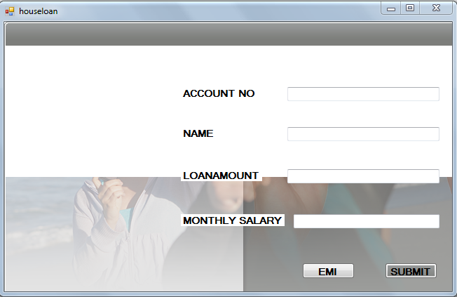
HOUSE LOAN:

namespace bankingproject1
{
public partial class houseloan : Form
{

public houseloan()
{
InitializeComponent();
}

private void button2_Click(object sender, EventArgs e)
{
if (textBox1.Text.Length > 0 && textBox2.Text.Length > 0 && textBox3.Text.Length > 0 && textBox4.Text.Length > 0)
{
int i = 1500000;
int loanamount = System.Convert.ToInt32(textBox3.Text);
SqlConnection cn = new SqlConnection("server=.;uid=sa;pwd=;database=Banking");

if (loanamount < i)
{

string sql = "insert into houseloan values('" + textBox1.Text + "','" + textBox2.Text + "','" + textBox3.Text + "','" + textBox4.Text + "')";

SqlCommand cmd = new SqlCommand(sql, cn);

if (cn.State == ConnectionState.Closed)
cn.Open();
int z = cmd.ExecuteNonQuery();
if (z == 1)
MessageBox.Show("HOUSE LOAN IS SANCTIONED......");
else
MessageBox.Show("PLZ !!! ENTER CORRECT DETAILS...");

}
else
{
MessageBox.Show("The amount is too high to be snactioned...");
}
}
else
{
MessageBox.Show("Do not leave any empty fields");
}
}

private void button1_Click(object sender, EventArgs e)
{

emicalculator ec = new emicalculator();
ec.Show();
}

private void houseloan_Load(object sender, EventArgs e)
{

}
}
}
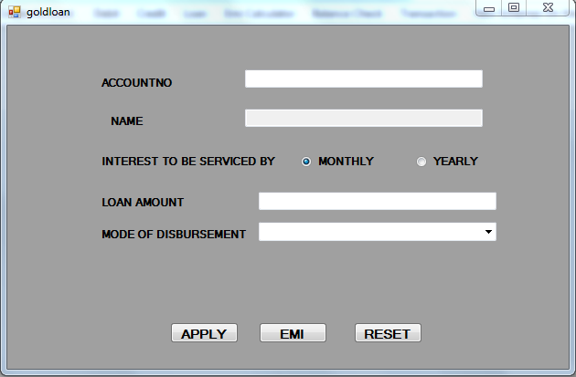
GOLDLOAN:
using System;
using System.Collections.Generic;
using System.ComponentModel;
using System.Data;
using System.Drawing;
using System.Linq;
using System.Text;
using System.Windows.Forms;
using System.Data.SqlClient;

namespace bankingproject1
{
public partial class goldloan : Form
{
public void clear()
{
textBox1.Clear();
textBox2.Clear();
textBox3.Clear();
textBox1.Focus();

}
public goldloan()
{
InitializeComponent();
}

private void goldloan_Load(object sender, EventArgs e)
{

}

private void button2_Click(object sender, EventArgs e)
{
emicalculator ec = new emicalculator();
ec.Show();

}

private void button3_Click(object sender, EventArgs e)
{
clear();
}

private void button1_Click(object sender, EventArgs e)
{
if (textBox1.Text.Length > 0 && textBox2.Text.Length > 0 && textBox3.Text.Length > 0)
{
string mode;
if (radioButton1.Checked == true)
mode = "monthly";
else
mode = "yearly";
int a = System.Convert.ToInt32(textBox3.Text);
int k = 100000;
if (a < k)
{
SqlConnection cn = new SqlConnection("server=.;uid=sa;pwd=;database=Banking");
string sql = "insert into goldloan values ('" + textBox1.Text + "','" + textBox2.Text + "', '" + mode + "' , '" + textBox3.Text + "', '" + comboBox1.SelectedItem.ToString() + "')";
SqlCommand cmd = new SqlCommand(sql, cn);
cn.Open();
int j = cmd.ExecuteNonQuery();

if (j == 1)
{
MessageBox.Show("loan is sanctioned...");
clear();
}

}
else
{
MessageBox.Show("U'R LOAN AMOUNT IS TOO HIGH TO GRANT.....");
}
}
else
{
MessageBox.Show("Do not leave any blank space");
}

}

private void textBox2_TextChanged(object sender, EventArgs e)
{

}

private void textBox1_TextChanged(object sender, EventArgs e)
{
SqlConnection cn = new SqlConnection("server=.;uid=sa;pwd=;database=Banking");
string sql="select name from bankinfo where accountno='"+textBox1 .Text +"'";

SqlCommand cmd = new SqlCommand(sql, cn);
cn.Open();
string s1 = cmd.ExecuteScalar().ToString();
textBox2.Text = s1.ToString();
}
}
}
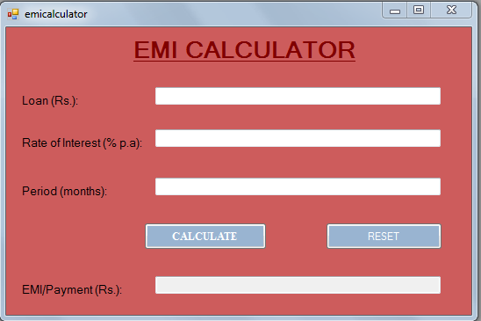
EMI CALCULATOR
using System;
using System.Collections.Generic;
using System.ComponentModel;
using System.Data;
using System.Drawing;
using System.Linq;
using System.Text;
using System.Windows.Forms;

namespace bankingproject1
{
public partial class emicalculator : Form
{
public emicalculator()
{
InitializeComponent();
}
void clear()
{
TextBox1.Clear();
TextBox2.Clear();
TextBox3.Clear();
TextBox4.Clear();
}

private void button1_Click(object sender, EventArgs e)
{

}

private void Button1_Click_1(object sender, EventArgs e)
{
if (TextBox1.Text.Length > 0 && TextBox2.Text.Length > 0 && TextBox3.Text.Length > 0)
{
double p, t, n, m, i;

p = Convert.ToInt32(TextBox1.Text);
t = Convert.ToInt32(TextBox2.Text);
n = Convert.ToInt32(TextBox3.Text);
i = ((t / 100) / 12);
t = Math.Pow((1 + i), n);
m = p * ((i * t) / (t - 1));
n = Math.Round(m, 2, MidpointRounding.AwayFromZero);
TextBox4.Text += (n);
}
else
{
MessageBox.Show("Remember You Should Not Leave Any Empty Fields");
}

}

private void button2_Click(object sender, EventArgs e)
{
clear();
}

private void emicalculator_Load(object sender, EventArgs e)
{

}
}
}
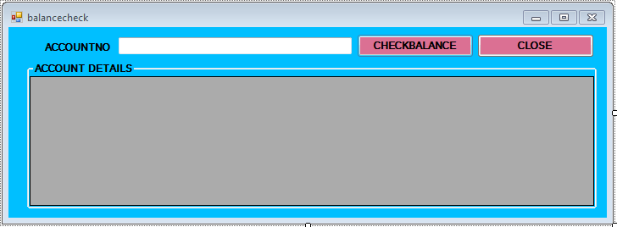
CHECK BALANCE:
using System;
using System.Collections.Generic;
using System.ComponentModel;
using System.Data;
using System.Drawing;
using System.Linq;
using System.Text;
using System.Windows.Forms;
using System.Data.SqlClient;

namespace bankingproject1
{
public partial class balancecheck : Form
{
public balancecheck()
{
InitializeComponent();
}
private void button2_Click(object sender, EventArgs e)
{
this.Close();
}
private void button1_Click(object sender, EventArgs e)
{
if (textBox1.Text.Length > 0)
{
SqlConnection cn = new SqlConnection("server=.;uid=sa;pwd=;database=Banking");
string sql = "select name,statementamount from bankinfo where accountno='" + textBox1.Text + "'";
DataSet ds;
SqlCommand cmd = new SqlCommand();
SqlCommandBuilder cb;
SqlDataAdapter da = new SqlDataAdapter();
cmd = new SqlCommand(sql, cn);
da = new SqlDataAdapter(cmd);
cb = new SqlCommandBuilder(da);
ds = new DataSet();
da.Fill(ds, "person,details");
dataGridView1.DataSource = ds.Tables[0];
}
else
{
MessageBox.Show("Please enter the account number");
}
}

private void balancecheck_Load(object sender, EventArgs e)
{
}
private void dataGridView1_CellContentClick(object sender, DataGridViewCellEventArgs e)
{
}
}
}
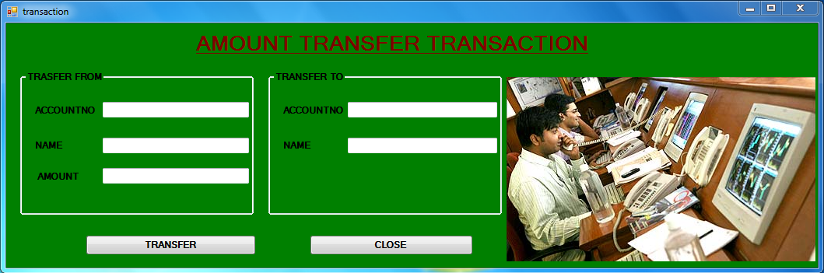
TRANSACTION:
using System;
using System.Collections.Generic;
using System.ComponentModel;
using System.Data;
using System.Drawing;
using System.Linq;
using System.Text;
using System.Windows.Forms;
using System.Data.SqlClient;

namespace bankingproject1
{
public partial class transaction : Form
{
public transaction()
{
InitializeComponent();
}

private void button2_Click(object sender, EventArgs e)
{
this.Close();

}

public void clear()
{
textBox1.Clear();
textBox2.Clear();
textBox3.Clear();
textBox4.Clear();
textBox5.Clear();
textBox1.Focus();
}

private void button1_Click(object sender, EventArgs e)
{

int amount;
SqlConnection cn = new SqlConnection("server=.;uid=sa;pwd=;database=Banking");
string sql="select statementamount from bankinfo where accountno='"+textBox1 .Text +"'";

SqlCommand cmd = new SqlCommand(sql, cn);
if (cn.State == ConnectionState.Closed)
cn.Open();

amount = int.Parse (cmd.ExecuteScalar().ToString());

if (amount > 1000)
{
int b;
int b1;
SqlCommand cmd1=new SqlCommand ();
SqlTransaction trans;
if (cn.State == ConnectionState.Closed)
cn.Open();
trans=cn.BeginTransaction();

cmd1.Connection = cn;
cmd1.CommandType =CommandType .Text ;
cmd1.Transaction = trans;
cmd1.CommandText = "update bankinfo set statementamount=statementamount-'" + textBox3.Text + "' where accountno='" + textBox1.Text + "' and name='" + textBox2.Text + "'";
b = cmd1.ExecuteNonQuery();

cmd1.CommandText = "update bankinfo set statementamount=statementamount+'" + textBox3.Text + "' where accountno='" + textBox5.Text + "' and name='" + textBox4.Text + "'";
b1 = cmd1.ExecuteNonQuery();
if (b == 1 && b1 == 1)
{
trans.Commit();
MessageBox.Show("Money transfered");
clear();
}
else
trans.Rollback();

}
else
MessageBox.Show("no minimum amount to transfer.....");

}

private void transaction_Load(object sender, EventArgs e)
{
}
}
}
WEBPAGE OF our NEW SCHEMES
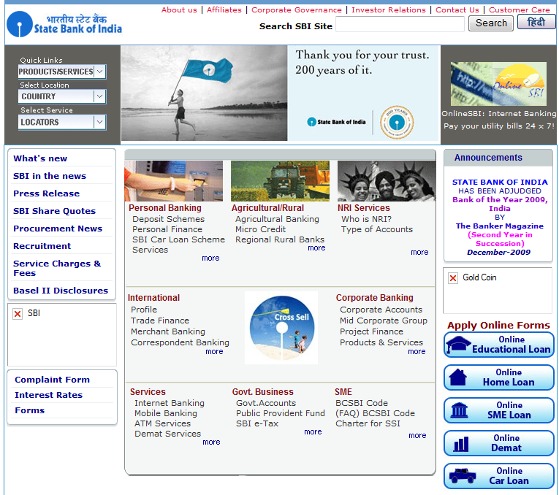

CONCLUSIONS

Banking information system has been a rewarding experience in more than one way. During the case study for the first time we realized the importance of this system.
It might be a common experience for all the students that they learn things practically rather than theoretically.
It helped us to have an insight of all the views of the project and it is plays a vital role in our life.

