CRM Simple Hotel Booking System

Please read full document before starting the test.

Pre-Requisites:
Candidate should have CRM online free trial or Dynamics CRM 2015/2016/D365 on-premise environment.
Test will be shared with candidate after getting confirmation on environment readyness.

Instructions:
In this assignment, we want you to develop an XRM application using Dynamics CRM which will be used by a hotel company for checking-in and out people.
You have max three hours to complete this asssignment including self verification, sharing artifacts. If you complete the requirements in two hours, in expected quality, you can have additional %5 on overall evalutation points.

Requirement:
The application specifications are below:
- All custom components prefix should begin with first two letters of your first name and first two letters of your last name. E.g. If your name is John Brown, your prefix should be ‘jobr’.
- Room entity. We expect you to define a room entity in the system. The entity should have the following attributes:
  - Room Number (Primary Field)
  - Floor Number
  - Type: Drop down of the following (Standard, Deluxe, Studio)
  - Check in / check out - Room Status
  - Check-in contact
  - Check-in date
  - Planned check-out date
Remark: Date fields should be in “Date and Time” format.
- Duplicate detection. Define duplicate detection rule so that the same room should not be entered into the system twice. You can use room number field for this.
- Security Roles. Define the following security roles in the system: Receptionist, Manager
- Only Managers should be able to
- add
- modify
- change ownership
rooms into the system in organization level .
- Receptionist can check-in and check-out only the room records that they own. They should be able to see other receptionists’ room records in their branch but should not be able to write to these room records.
- Reporting. Develop a report using reporting wizard showing all the rooms where status are check-in. In the report, include the most relevant six fields.
- Check in reminder workflow: Develop a workflow covering below points.
- Send an e-mail reminder to the contact who did not check-out one day after planned check-out date.
- In case a customer checks out before the planned check out date –
  - The workflow should stop executing.
  - Also, no email should be sent to him in such a case since he has already checked out.
Hint: One way you can do it is by implementing “Parallel Wait” branch; you can have your own way of implementing too. However, the above requirements should be met.
Note: This is the most critical task in the entire requirement.

For example – Suppose check in date is 4/16/2019 and planned checked out date is 4/19/2019. Now, consider the below different scenarios in this case now
Scenario 1: In case Customer hasn’t checked out until 4/20/2019
- Customer should receive an email reminding him to check out
Scenario 2: In case Customer checks out on 4/18/2019
- Customer should not receive any email because he has checked out as planned.

- Develop a JavaScript for “On change” event of the Check in / check out status and automatically set check-in date to current date. (When status is “Check-in” check-in date field is automatically set to current date. When status is “Check-out”, actual check-in date field should be cleared)
- Bonus/Optional requirement: Apply field validations which you think needed applicable on planned check-out date field. (you can have additional up to %10 on overall evaluation points)

Deliverables
- Please send us your deliverable considering the below points
  - You need to attach individual screenshots in this document itself
    - below the individual points stated later in this section
  - Prefix the name of this document with your Name
  - Pl make sure your screenshots are basically viewable and readable.
- Required screenshots –
  - Room entity’s main form with all the fields populated
  - Fields you created for the Room entity (Hint: Settings -> Customize The System -> Entities -> Room -> Fields)
      - No need to show the out of the box fields; show only the ones you created
      - Screenshot should also include the primary field defined for this entity
      - If you need to, you may take two / multiple screenshots
  - Duplicate detection rule definition on the room entity
  - Screenshot of Check-in reminder workflow. Entire screenshot including –
    - Workflow definition (Entity, Trigger, Scope, etc)
    - Screenshot of the field over which trigger is applied
    - The steps should be visible
You may take two screenshots if required
  - Security role showing permissions to Manager
  - Security role showing permissions to Receptionist
  - Screenshot of Report
    - Filter Criteria definition page
    - Result page
  - Any / All javascript that you have written for this assignment including
    - For setting the check-in date
    - For planned check-out date field validation
    - (if any other)
  - Screenshot of CRM Solution displaying all the components of the created solution
    - Pl also send us the CRM Solution file (as a separate attachment in your reply email) which has the components related to the requirements
- Any comments / notes you want us to be aware while looking through this deliverable. You may simply respond as NA or NONE if no such comments.
==================== Deliverables==================================
2
(a)
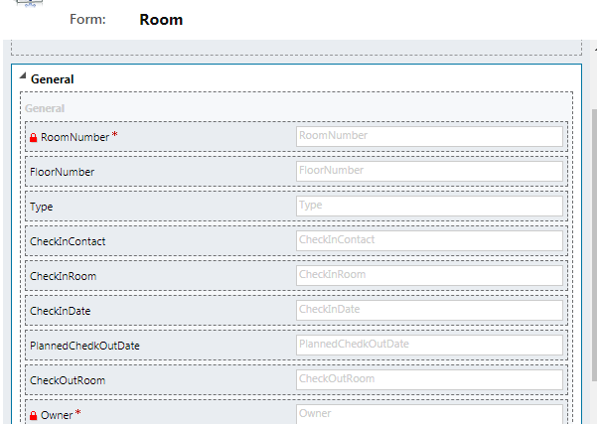
2(b)
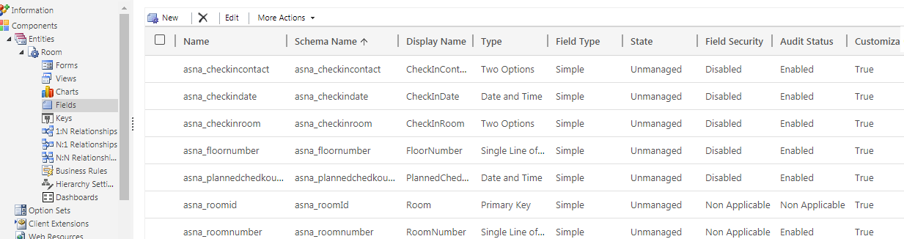

2 C
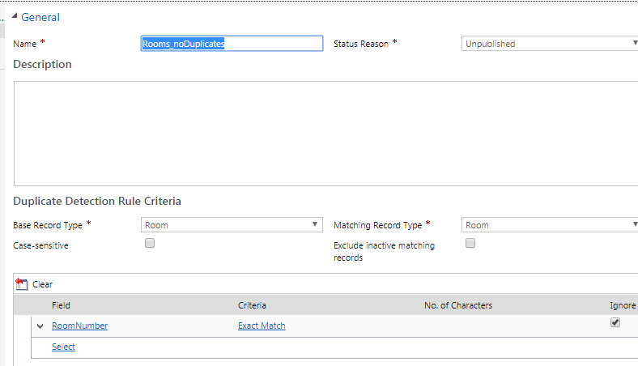

2. d
(i)
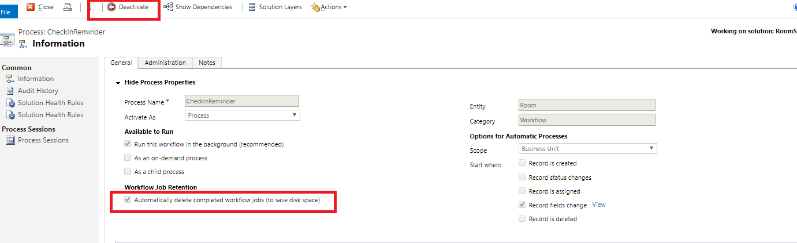

(ii)

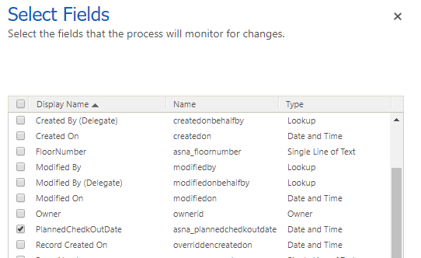

(iii)
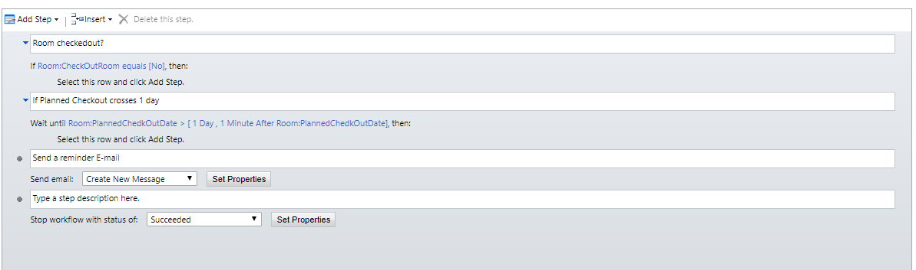

2(e)
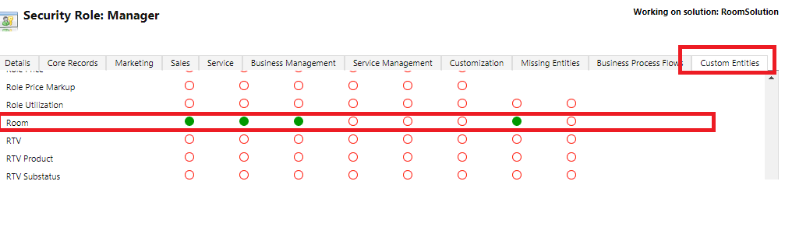

2(f)

2 (g)
(i)
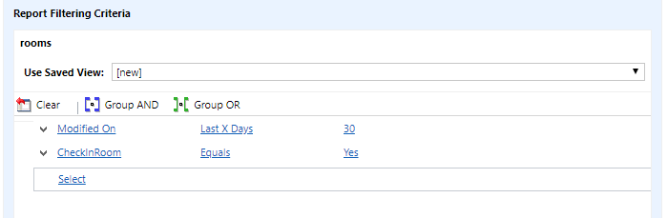

(ii) *Could not prepare the records to display

