ASP.Net
* ASP.Net 3.5 specifications are used in Web, Mobile technologies.
* ASP.Net 3.5 using Visual C#:
Contents:
- Introduction to ASP.Net Architecture and Life Cycle
- Websites development using ASP.Net controls
- Skins, Themes and Style sheets
- Master Pages (like Power point templates)
- ADO.Net 3.5 (implementation difference from VB.Net)
- LINQ
- State Management
      - Page level management
      - Session level management
      - Application level management
- Profiles
- Security
      - Forms Authentication
      - Windows Authentication
      - Passport Authentication
- Roles & Memberships

- Caching
      - Page output cache
      - Page fragmentation cache
      - Substitution cache
      - Data cache
- Web parts
- HTML screen scraping
- Sending emails using ASP.NET
- Intranet search using Index server
- XML Web services
- Globalization & Localization
- Tracing
      - Application level tracing
      - Page level tracing
- Web custom controls
- Custom errors
- WPF (includes Sliver light also)
- ASP.NET Ajax
- Setup & Development

* www.sekharonline4U.co.nr
* http://groups.yahoo.com/group/sekharoline

*The technologies existing before ASP.Net: -
Internet Technologies:
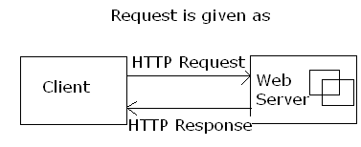
HTTP → Hyper Text Transfer Protocol.
This HTTP is called “Connection Oriented” and “Stateless Protocol”.
Connection between client and server maintained up to server sends a response. After sending response connection will be disconnected.
Limitation:
Whenever a client sends a request to the Web server then if the request is for HTML contents then the response will be provided but if the client sends a request for any external resources like flat files, database or other network then the web server cannot handle the request.
Requirements: A technology to contact the external resources and to provide the response to the clients.
Solution: Sever Side Technology (SST)

SST:
*CGI (Common Gateway Interface) Technology: -
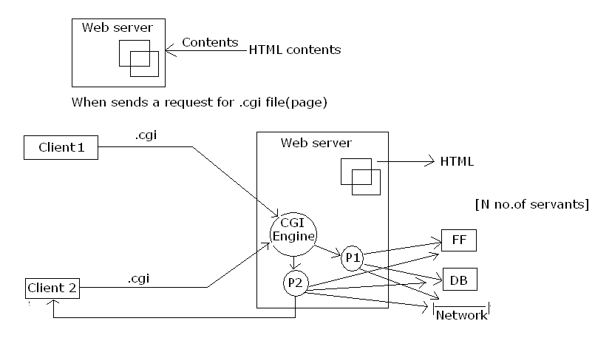
CGI engine creates a process. This process interacts with flat file, Database and Network and sends response.
Advantage: Performance will be faster
Limitation:
- Server will be creating a dedicated process for the client’s requests and hence burden will be given to the Web server.
- Resources of the Web server will not be used efficiently and its is going to block the Resources.
Requirements: A technology to contact the external resources and to provide the response to the clients without providing any burden to the server.
Solution: Servlets technology.

How servlets technology works:
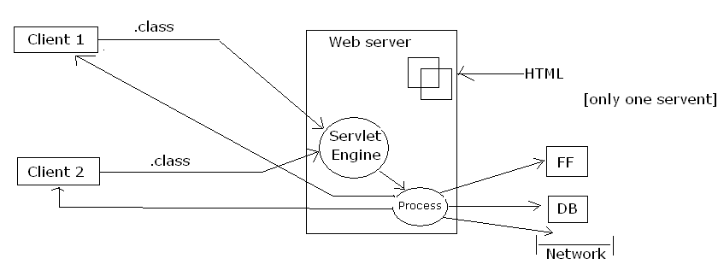
Process is capable to interact with flat files Database (DB) and Network and this provide the Response back to the client1. If another client2 sends a other request the same process is sends a Response. Single process handles ‘N’ no. of client Responses
Advantage:
Resources of the web server will be used efficiently and web server will not have any burden.
Limitation: Performance will be very slow.
Requirement: A technology to contact the external resources and to provide the response to the clients without providing any burden to the web server and also to the clients.
Solution: Server Pages Technology.

Server Pages Technology
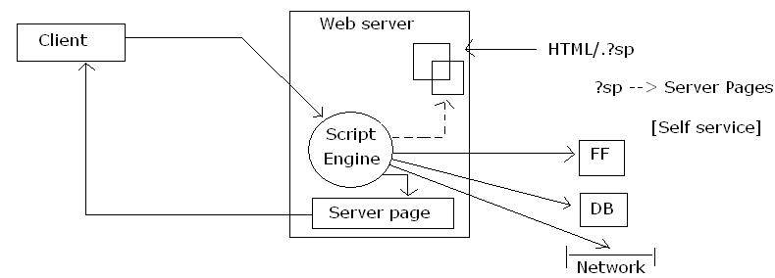
Script engine reads information present in HTML pages and contact (interact) FF, DB, Net work and creates Server Page.
This server page sends as a response. Once response is provided, pages removed from the server are deleted. If different clients (c1, c2, c3 …) sends a request at a time, then the time of sending response depends upon the time to create the process for that particular request.
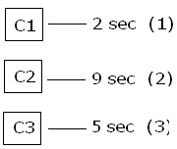
In the case of c1 (2 sec means), the time to create the process is 2 seconds. In case of c2 is 9 sec and in case of c3 is 5 sec.
Hence, c1 gets a first response then c3 and then c2.
*Sun Microsystems:- Implemented Java Server Pages (JSP)
*Oracle Corporations:- PL SQL Server (PSP)
*Microsoft Corporation:- Active Server Pages (ASP)

*ASP 3.0 Architecture:
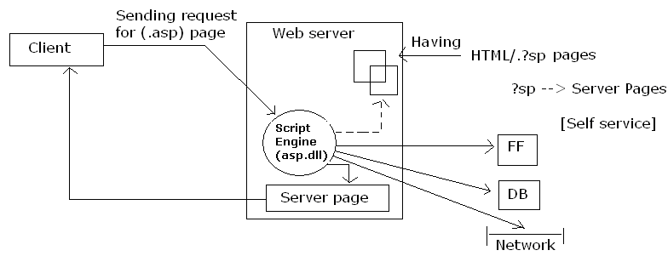
Whenever, a client sends a request for the ASP page then the Script Engine (asp.dll) accepts the request and interacts with the relevant external resources based on the instruction and creates a server page which will be provided the response to the clients.
Once, the response is given then the server page created at the server will be __________ collected.
Note: The same process will takes place for any no. of further client’s request.
ASP.Net Architecture:
For 1st Client Request:-
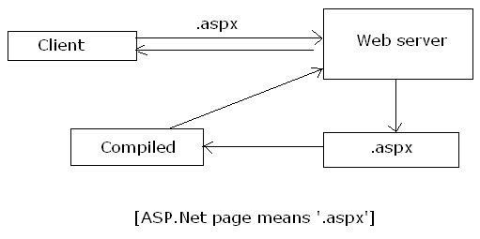

For 2nd or N th time client Request and if source code is modified:-
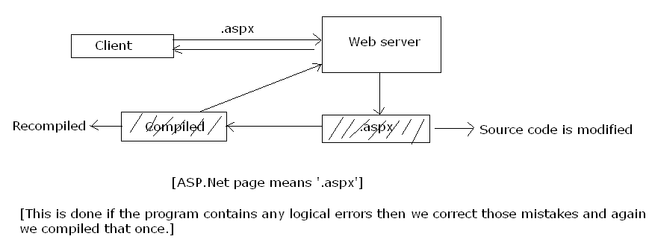
Whenever, a client sends a request for the ASPX page then the web server identifies the page and the page will be compiled and he compiled instructions will be provided to the server and the server returns the result as a response to the clients.
Note:- The same process will take place if a client sends a request for the 2nd or Nth time and if source code is modified.
For 2nd or nth time client request and if source code is not modified:
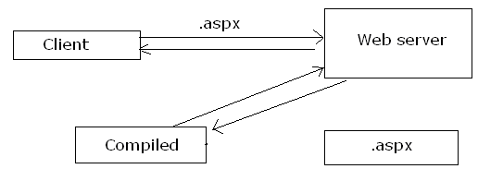
Whenever, a client sends a request for the 2nd or Nth time and if source code is not modified then the web server reads the compiled instructions and the result will be provided as the response to the clients.

ASP 3.0 Programming Model:-
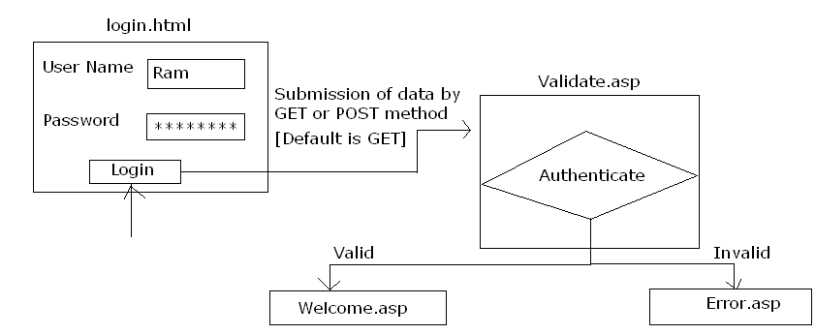
To call the data:-
GET → Request.QueryString(“_______”)
POST → Request.Form(“_______”)
*ASP.Net programming model:
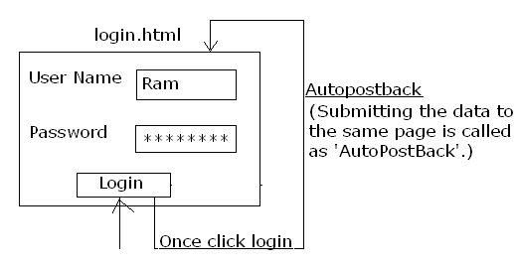
To collect the data: ControlName.PropertyName
Page.IsPostBack:-
It returns a Boolean value false if the page is requested for the first time and if the data is submitted to the server then this property will return true.

Limitations of ASP 3.0:-
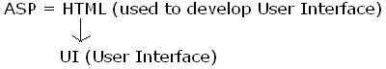
- Huge coding is required
- Code readability will be complex.
- Performance is slow then compared with other server pages technologies.
E.g.: ASP pages are slower than JSP pages
*ASP uses VB Script to write the server pages.
*JSP used Java to write the server pages.
*ASP is Intermediate based.
*JSP is Compilation based.
- No Inbuilt security support.
- State management is not efficient.
- Caching is not supported at the server side.
- All the drawbacks of COM is applicable for ASP pages.
- Setup and Deployment will be complex.
To solve these limitations, solution from Microsoft is ASP.NET. ASP.Net: It is a specification for developing
- Websites
- Web Services
- Mobile applications
Websites:
Whenever, a client uses a web browser and sends a request to the web server and receives the response from the server to the client using HTTP/ HTTPS protocol then such type of application are called as websites.
(OR) A website can be considered as a collection of related web documents or web pages.
E. g: - www.orkut.com
Web services:
It is a specification for achieving cross language, cross platform and cross device integration.
(OR) A web service can be considered as a class definition maintained at the web server as a service such that the definitions can be used from any application developed using any language for any platform or any device.
Mobile Application:
It is used to develop device independent applications.
ASP.Net Architecture:
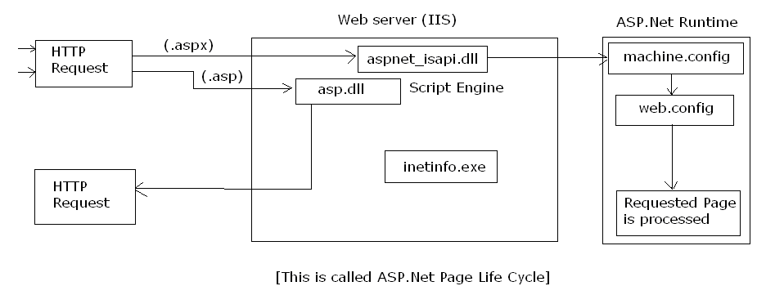
Whenever, a client sends a request to the ASPX page to the web server then “inetinfo.exe” is a process which will identify the request type and sends a request to the ASPX engine “aspnet_isapi.dll – ASP.Net Internet Server Application Programming Interface).
ASPX engine accepts the requests and then sends a request to the ASP.Net Runtime environment (aspnet_wp.exe – ASP.Net Work process) for further processing.
Once, the request is passed to the runtime environment then the “machine.config” and “web.config” files are verified and then the requested page is processed the result of the page will be provided as HTTP Response to the clients.
Machine.config:
It is used to provide the complete configuration details for all the ASP.Net web sites registered with the web server.
Web.config:
It is used to maintain the configuration details of a single website.
Where configuration details includes the language to be used for implementing ASP.Net specification, state management details, database connection string information, tracing information, security to be used for the website, globalization and localization details etc.

*Requirements for ASP.Net:
O/s Service Pack .Net Framework 3.5
Windows 2000 4 √
Windows XP 2 √
Vista No need √
Windows 2003 2/3 √
Windows 2008 No need √ Along with IIS.
Tools:
Microsoft Visual Web Developer 2008 using visual C# for developing ASP.Net applications:
- Microsoft Visual Studio.Net 2008
- Microsoft Express Studio.Net 2008
- Macromedia Dreamweaver Mx.

*ASP.Net Applications can be developed using two methods.
1. In Page Technique
2. Code File Technique
1. In Page Technique:
Whenever, the presentation logic (design) and the business logic (code) is written in a single ASPX web form then it is said to be ‘In Page Technique’.
Advantages:
- Deploying the application will be very easy.
- If any modifications are performed in any of the web form present within the website it will not affect the other web forms present at the website.
Limitations:
- The code has to be provided with the applications.
- The code cannot be reused in other web forms.
2. Code File Technique: It is default technique. If used then the presentation logic (design) will exist in ASPX web form and the business logic (code) will exist in a code file. That is, ‘.cs’ or ‘.vb’ file.
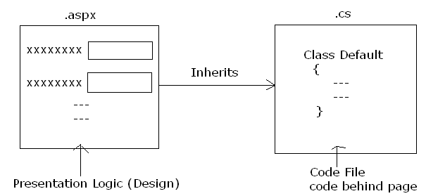

Advantage:
- The complete business logic will be abstracted from the clients by maintaining the business logic code within class library files (.dll).
- The code can be reused from ‘N’ no. of web forms present within the website.
Limitations:
- If any modification is performed on any one web form then the entire web application has to be recompiled and has to be re-uploaded to the server.
Note: Within a single ASP.Net web form, In page technique and code file technique can be used.

ASP.Net Runtime Compilation Process:-
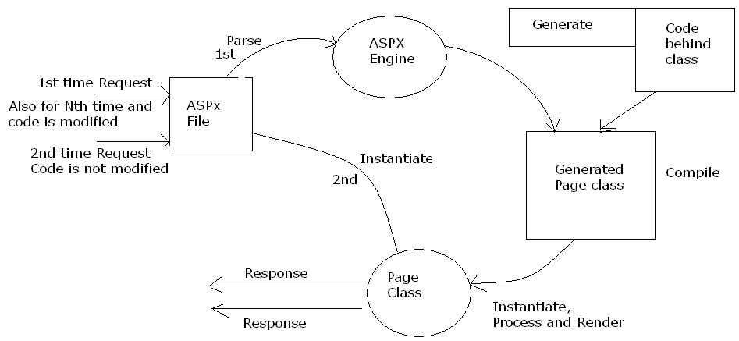

*ASP.net 2.0 onwards supports two types of programming models:
1. CallBack method (Default)
2. Cross Page Submission method
1. Call Back Method:
It is default method. If used then the data will always be submitted to the same page.
Note: Submitting the data to the same page is also called as ‘AutoPostBack’.
*Even though the user specify conditions to submit the data to a different form still the data will be submitted to the same form only. 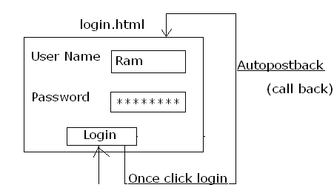
To collect the data:
ControlName.PropertyName
Note:
Page.IsPostBack: It returns false if the ASPX page is requested for the first time and returns true if the ASPX page is requested for 2nd and Nth time by submitting the data.

*ASP.Net page life cycle:
If client sends request for the 1st time: CallBack Life Cycle:
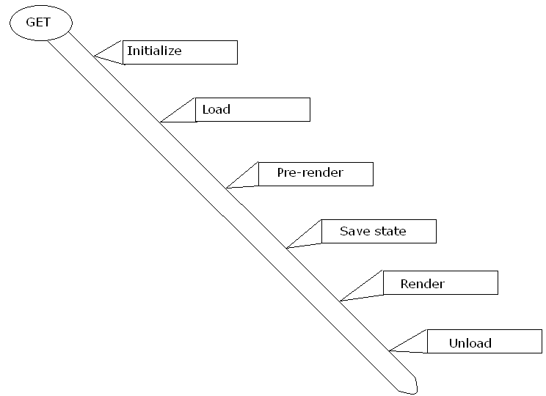
ASP.Net page life cycle for call back method after submitting the data:
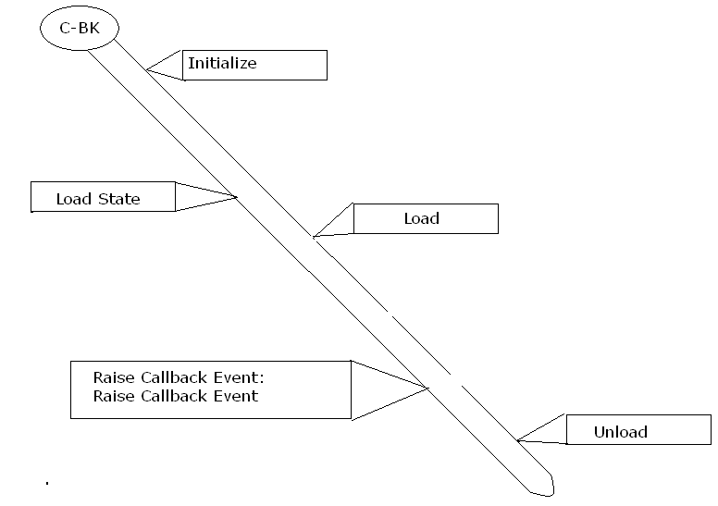
Initialize: Executes the code present in all the events which will be raised before pages loaded.
Load: Executes the code when the pages loaded.
Pre-render: The code written in pre-render will be used to customize the asp.net server controls.
Save State: It will bind the data with a relevant control and saves that information.
Render: It will create the HTML content based on the ASP.Net page class definition.
Unload: The code will be executed whenever the pages
Load State: It is used to bind the data to the relevant control once the data has been submitted to the server.
Raise Callback Events: These are the events which are used for submitting a request to the server.
2. Cross Page Submission method:
It is a new programming model introduced in ASP.Net 2.0 for submitting the data from one form to the other webform.
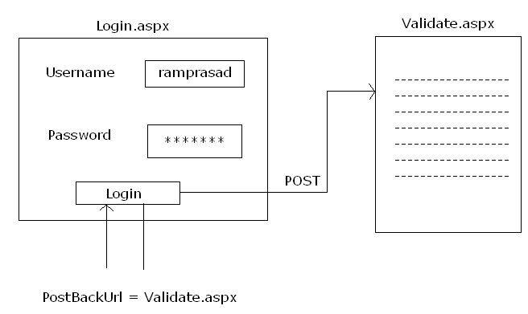
To collect the data:
For GET method: Request.QueryString[“name”]
For POST method: Request.Form[“name”]
*ASP.Net Page Life Cycle for cross-page submission:
→If the page is requested for the first time:
→ Once the data is submitted to the server:
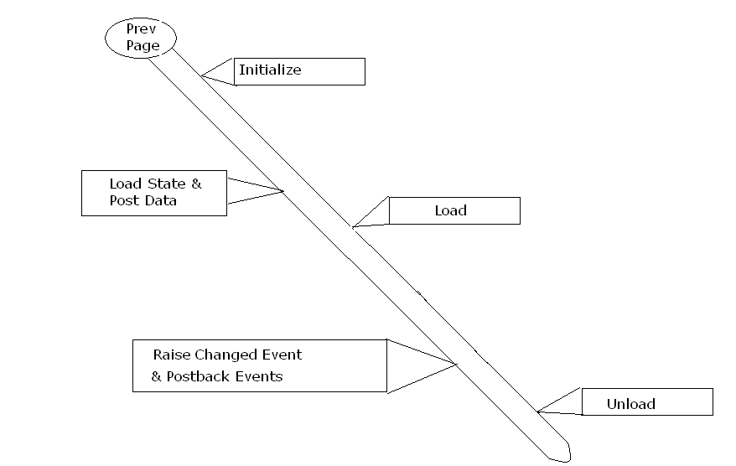

Designing ASP.Net website using Visual Studio .Net 2008:
→Start
→Visual Studio 2008
→File Menu
→New
→Website
→Templates
→ASP.Net Website
→Specify the location
→Specify the type
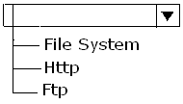
→Specify the language
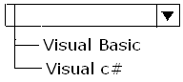
→Click ‘OK’

*Understanding visual studio .Net:
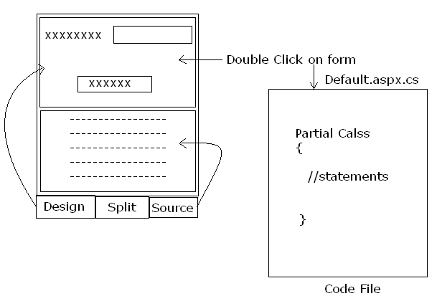
TextBox control [Ctrl + Alt + X]:
It maintains the collection of controls that can be used from the ASP.Net webform.
Properties window [F4]:
It is used to set or get the attributes for the control.
Solution Explorer [Ctrl + Alt + L]:
It maintains the information about all the forms that are used within the website.
*In order to set the auto positioning for the controls:
→ Tools menu → Options → HTML Designer → CSS Styling
→ Change positioning to absolute positioning.
(* Always this auto positioning is not advisable)
*In order to design ASP.Net webforms, we will use tables.
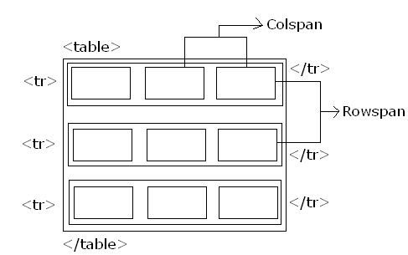
*To insert table:
→ Table
→ Insert Table
→ Specify rows and columns
→ Click “OK”
Webserver controls:
These are the new powerful server side controls introduced by ASP.Net for providing the user interface for the application.
Syntax: <asp:ControlType Id = “_ _ _ _ _”
Runat = “Server”>Data</asp:ControlType>
Note:
*Webserver controls are WYSWYG (What You Set What You Get) controls. That is, these controls have a capability to identify the clients’ web browser and can able to render the HTML tags accordingly.
*Webserver controls are state manages controls. That is, these controls have a capability to retain its value after the data is submitted to the server.
Label control:
It is used to provide the static information on the webform.
Common properties for all the server side controls:
Id | Used to specify the unique identifier for the control placed on the webform
Text | It is used to set or get the value from the server side control

Button control:
It is used to submit the data to the server.
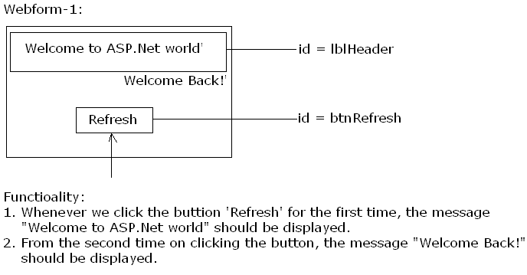

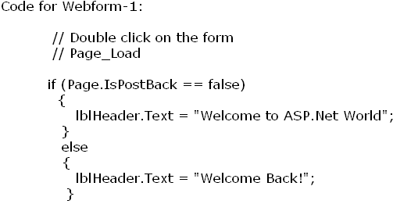
*To execute:
→ Solution Explorer (Ctrl + Alt + L)
→ R.click on the desired form
→ ‘Set as a start page’
→ Press F5
*To add new form:
→ Website Menu
→ Add New Item
→ Templates
→ Webform
→ Specify Language, Location ……etc
*For Inpage Techinique:
Place code in separate file.

TextBox control:
It is used to accept SingleLine, MultiLine or Password characters as the input.
Property:
TextMode | Specifies the mode to be used for accepting the input from the user. (Default mode is ‘SingleLine’)
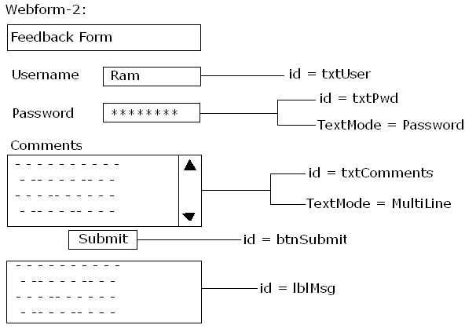
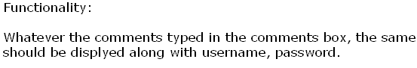
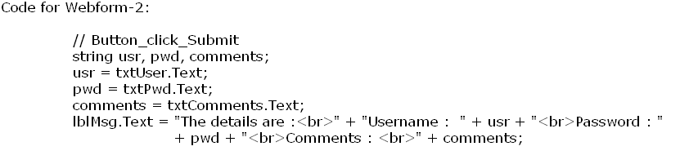
*Crosspage Techinique:
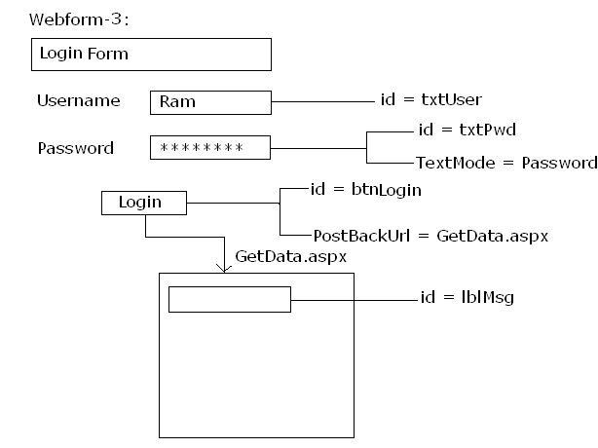
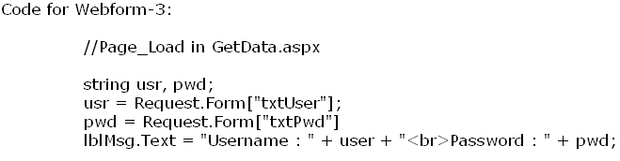
RadioButton control:
It is used to select a single item from a collection of related RadioButtons.
Properties:
Checked | Returns ‘true’ if the RadioButton is selected else returns ‘false’
GroupName | Used to logically group the controls together

RadioButtonList control:
It is used to select the single item from the collection of RadioButtonList items.
*Common properties for all the controls which supports ‘Single item’ selection:
Items | It is used to maintain the collection of list items
SelectedItem.Text | Returns the text of the selected list item
SelectedItem.Value  Or SelectedValue | Returns the value of the selected list item
SelectedIndex | Returns the index number of the selected list item
RepeatDirection | Specifies the direction in which the items should be displayed  (Default direction is ‘Vertical’)
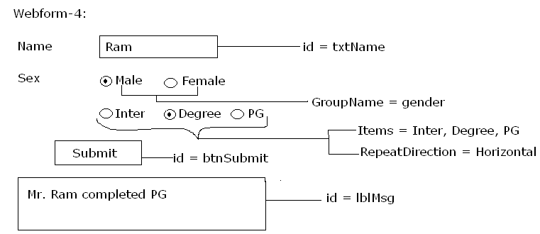
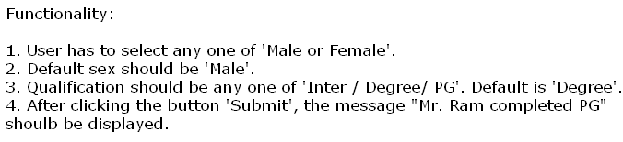
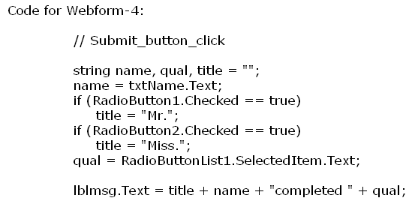
DropdownList control:
It is used to select the single item from a collection of list items.
Note: Properties used for RadioButtonList control can be used for the DropdownList control.
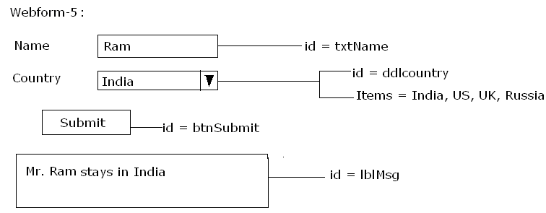
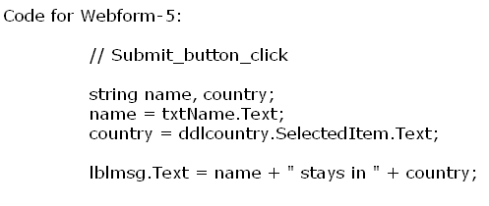
Webform-6:
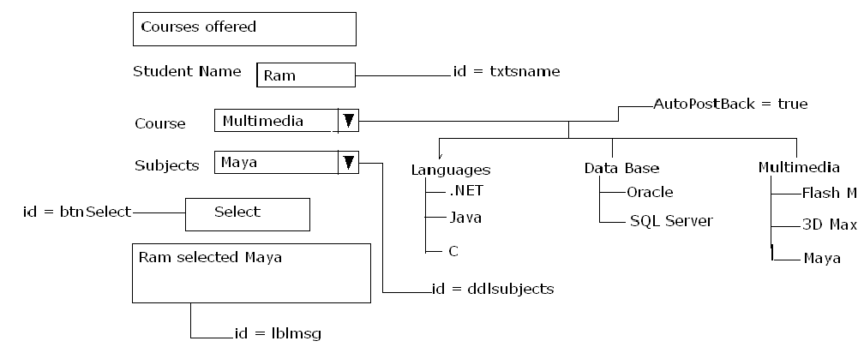

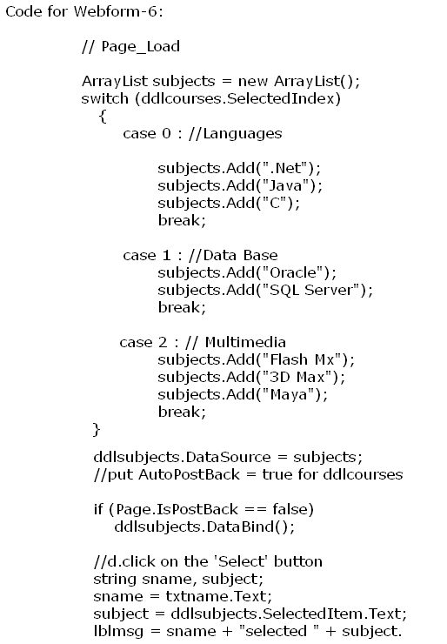
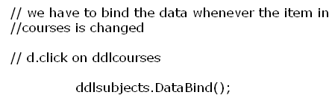

Note:
For this web application, code is written in the following event handler:
- Page_Load
- Select_Button_click
- courses (ddlcourse_SelectedIndexChanged)
If the page is loaded for first time events raised:
  - Page_Load only
If ‘Select’ button is checked, events raised are:
- Page_Load
- Select (Button_Click)
If course is selected, events raised are:
1). Page_Load
2). Ddlcourses_SelectedIndexChanged.
Homework: Webform-7
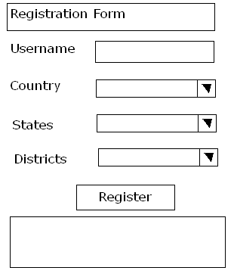
CheckBox:
It is used to select the Boolean value true or false, but not the multiple selections.
Property:
Checked | Returns ‘true’ if the CheckBox is checked else returns ‘false’
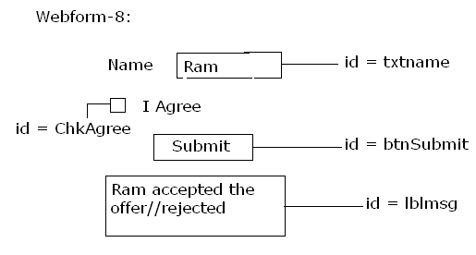
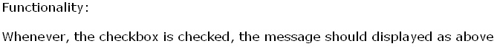
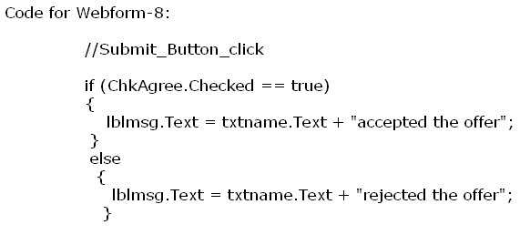

CheckBoxList control:
It is a collection of CheckBoxList items which allows the user to select multiple items from the collections.
*Common properties for all the list controls that supports multiple item selection:
Items | It is used to maintain the collection of list items
Items.Count | Returns the no. of list items present within the items collection of the list control
Items[Index].Selected | Returns ‘true’ if the list item is selected else ‘false’
Items[Index].Text | Returns the text of the specified list item
Items[Index].Value | Returns the value of the specified list item
RepeatDirection | Specifies the direction in which the list items should be displayed
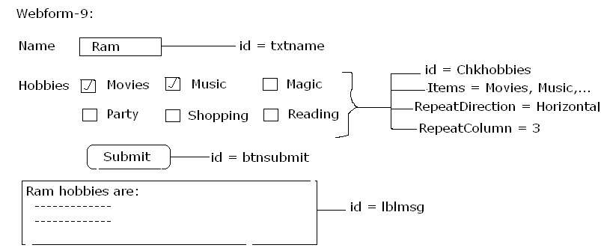
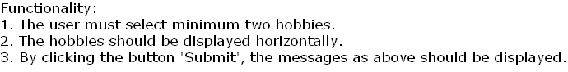
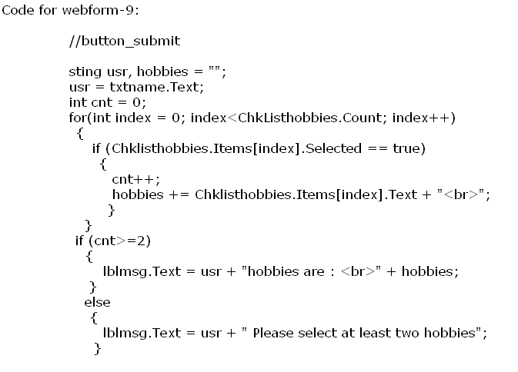
ListBox control:
It is used to select a single item or multiple items from a collection of list items.
Properties:
SelectionMode | Used to specify the mode for selecting the list item from the items collection. Default is ‘Single’.

Note:
If the selection mode is ‘Single’ then the properties used for RadioButtonList should be used and if the selection mode is ‘Multiple’ then the properties used for ‘CheckBoxList’ should be used.

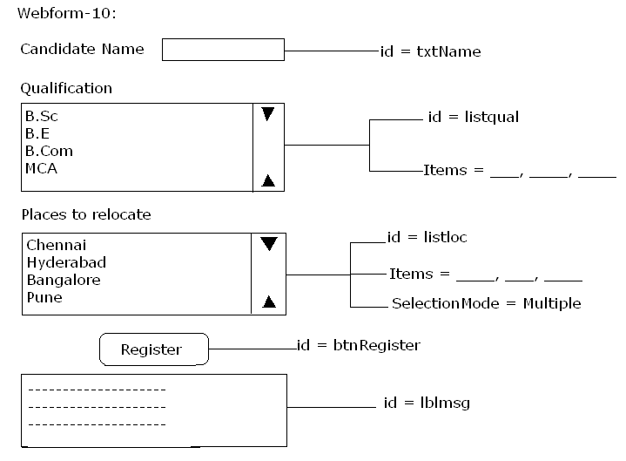
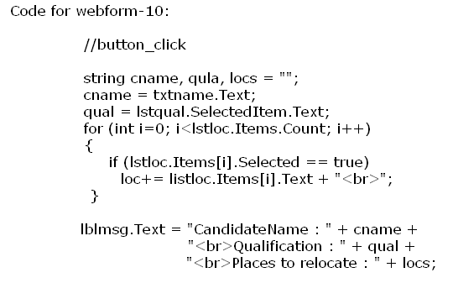

Homework: Webform-11
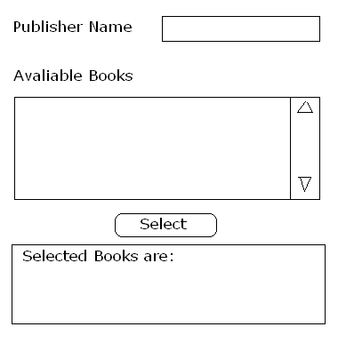

*Common methods for all the list controls:
Items.Add(ListItem |String) | It is used to add a list item to the items’ collection of the list control  *If string is passed as the argument value then the text and the value for the list item will remain same.  *In order to provide different data to the text and the value of the list item then list item object should be passed as the argument value.
Items.RemoveAt(Listindex) | It is used to remove a list item from the items’ collection based on the list index.
Items.Clear() | It is used to clear all the list items present at the list control.
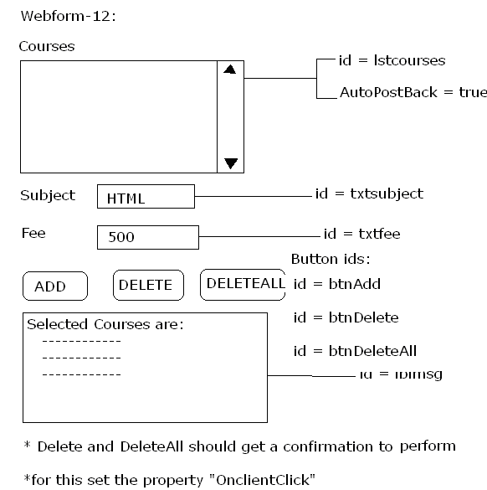
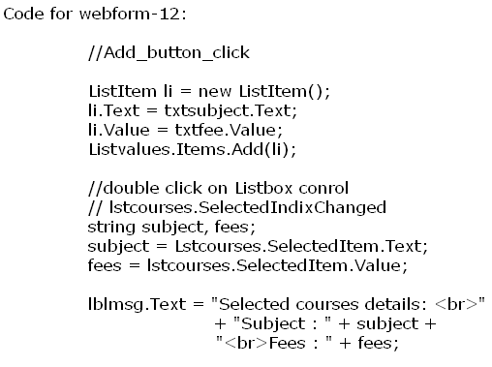
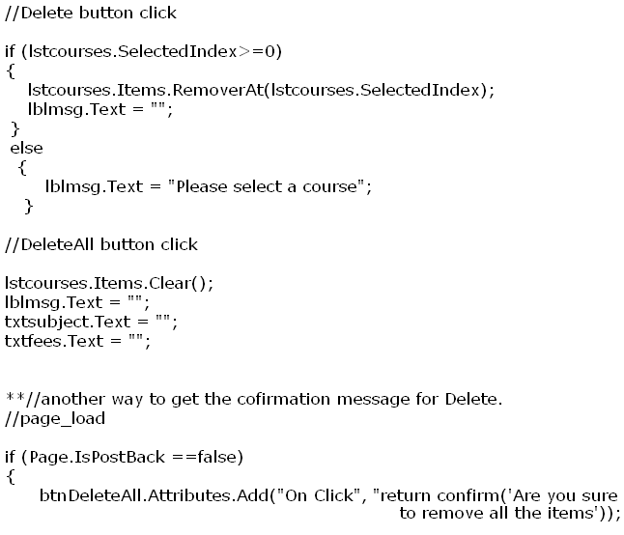

Homework: Webform-13:
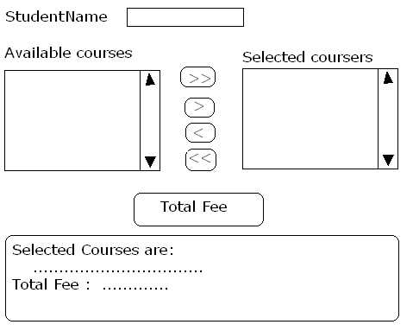

AdRotator control:
It is used to place the advertisements on the webform.
Properties:
AdvertisementFile | Specifies the name of the XML document which provides the details about the advertisement to be placed on the form
Target | It is used to specify the target frame in which the advertisement should be displayed. Default is “_top”.
*Structure of an AdvertisementFile:
<Advertisements>
<Ad> (for single advertisement)
<ImageUrl>………….</ImageUrl>
<NavigateUrl>…………</NavigateUrl>
<AlternativeText>…………</AlternativeText>
<Impressions>……………..</Impressions>
</Ad>
<Ad>
--------------
--------------
--------------
--------------
</Ad>
</Advertisements>

<Advertisements> | It is used to specify that the XML document is an advertisement file.
<Ad> | It is used to provide the details of a single advertisement.
<ImageUrl> | Used ot specify the Url of the image to be displayed as an advertisement
<NavigateUrl> | Used to specify the Url to which the user has to navigate whenever the advertisement has been clicked.
<AlternativeText> | Used to specify the alternative text to be displayed if the image specified at ImageUrl is not displayed.  *If image is displayed then <AlternativeText> will act like tooltip.
<Impressions> | If is used to specify the importance of an advertisement where the value for a single advertisement should be between 1 to 100.
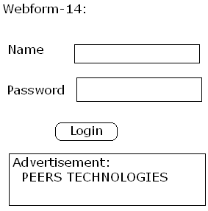
**To copy the image to the application folder:
→ Solution Explorer
→ Right click on the application name
→ Add Existing Item
→ Select and browse the image
**To add and XML document which provides the details of the advertisement:
→ Solution Explorer
→ Right click on the application name
→ Add New Item
→ Templates
→ XML File
→ Specify the name of XML file (e.g: Addsinfo.xml)
**Addsinfo.xml:
<Advertisements>
<Ad>
<ImageUrl>Sekharonline.gif</ImageUrl>
<NavigateUrl>http://www.orkut.com</NavigateUrl>
<AlternativeText>Official Website</AlternativeText>
<Impressions>80</Impressions>
</Ad>
<Ad>
<ImageUrl>Sekharonline.gif</ImageUrl>
<NavigateUrl>http://www.peers.com</NavigateUrl>
<AlternativeText>Official Website</AlternativeText>
<Impressions>40</Impressions>
</Ad>
</Advertisements>
**To put advertisement on the webform, we use the control called “AdRotator”.
*Set the following properties for AdRotator:
AdvertisementFile = Addsinfo.xml
Height = 75px
Widht = 100%
Target = _blank

Calendar control:
It is used to place the calendar on the webform.
Properties: NextPrevFormat = FullMonth
DayNameFormat = Full
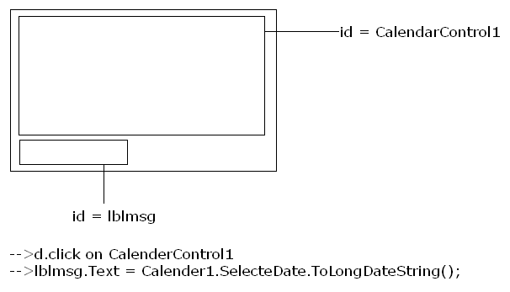
*Customizing CalendarControl:
CalendarControl is a collection of Tablecells where the table cells present at the CalendarControl will be a collection of CalendarDay.
Note:*In order to customize the CalendarControl then “DayRender” event should be used.
*DayRender event will be executed for all the CalenderDays present within the CalendarControl.
*In order to retrieve the information of current TableCell
“(TableCell) e.Cell” should be used and in order to retrieve the information of current CalenderDay “(CalenderDay) e.Day” should be used. Where ‘e’ is a DayRender event Args variable.
E.g:- Display the calendar with holidays in red colour.
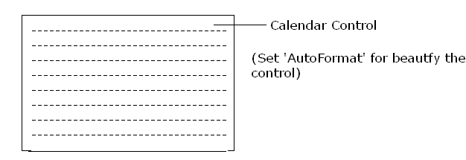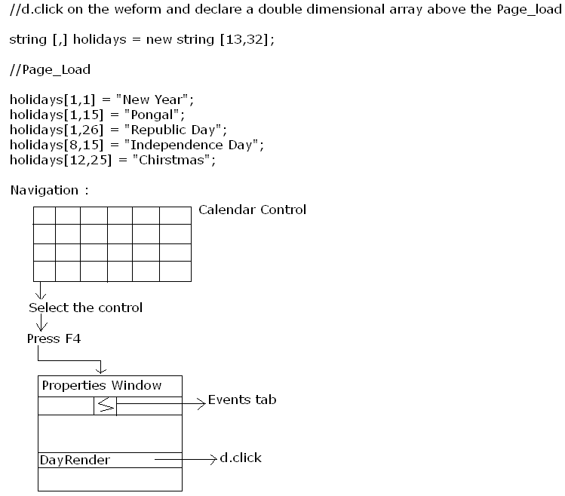
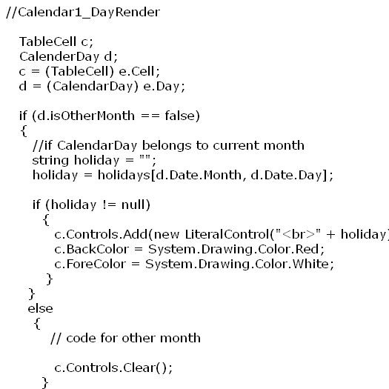
**Whenever a string has to be added as a control then ‘LiteralControl’ should be used.
**Enhance the above e.g. for displaying Sundays in red colour.
*Extending CalendarControl:
On ToolBox → Ajax Extensions
→ Script Manager Control 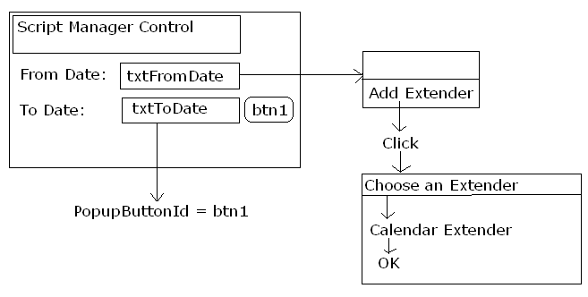
FileUpload Control:
It is a new control introduced in ASP.Net 2.0 for file uploading a file present at the client system to Webserver.
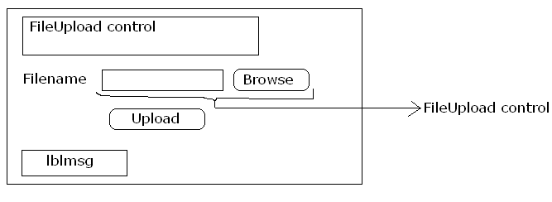
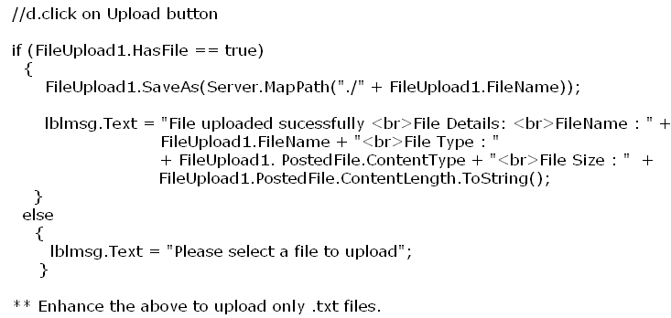

Panel Control:
It is used to logically group the controls together.
Note:
*It is used for adding the controls dynamically at the runtime.
*ASP.Net Ajax client centric controls are designed based on the panel by extending its functionality.
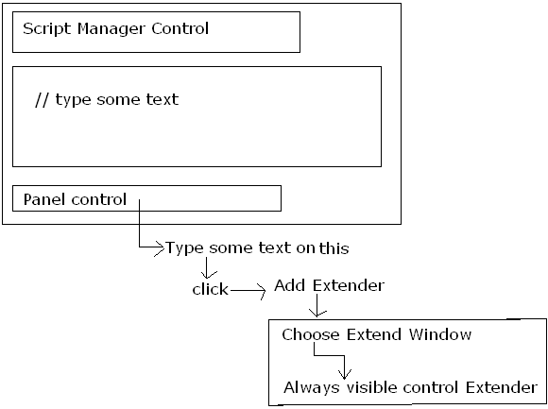
Set the panel control as follows:
HorizontalOffSet = 10
HorizontalSide = Right
VerticalOffSet = 10
VerticalSide = Top
----------

→By using panel control, we can add the controls dynamically at runtime:
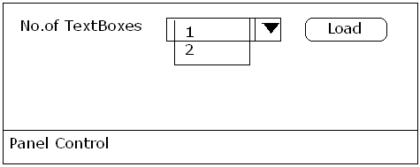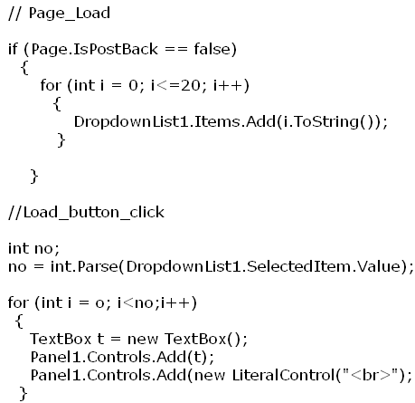

Validation controls:
These controls are used to validate the user input provided at the standard controls.
Note: *If the validation control returns ‘false’ then the data will not be submitted to the server.
*A single validation control can validate a single standard control.
*A single standard control can be binded with any no. of validation controls.
*Validation scripts should not be altered from ASP.Net 2.0 onwards. If any modifications are performed on the scripts then all the ASP.Net websites which uses validation controls will not function properly.
*Validation controls can be grouped together from ASP.Net 2.0 onwards.
We have six validation controls.
1. RequiredFieldValidator control:
It is used to verify if a value has been provided for a control or not.
*Common properties for all the validation controls:
ControlToValidate | Specifies the name of the control which has to be validated.
ErrorMessage | Specifies the error message to be displayed if the validation control returns ‘false’.
Note: *If customization or if validation controls has to be extended then the “Text” property for the validation controls should be set.
*If more than one validation control validates a standard control then it is mandatory that the “Display” property for all the validation controls should be set as “Dynamic”.
*Other than the ‘RequiredFieldValidator’ control, remaining validation controls will not validate the controls if the value for the control is empty.
E.g:-
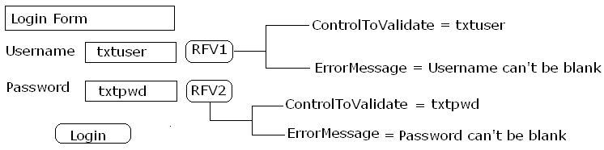

Extending the validation controls by using Ajax:
**Text for the Validation controls should be ‘*’.
→ Click on REV1
→ Add Extender
→ Choose an Extender Window
→ Select Validation Control Extender
→ Click “OK”

2. CompareValidator control:
If is used to validate the value of the one control based on the value present in other control.
Properties:
ControlToCompare | Specifies the name of the control which acts like a source control
Type | Specifies the data type to be used for validating the input. Default type is ‘string’.
Operator | Specifies the operator to be used for validating the user input.  Default is ‘Equal’.
e.g.:
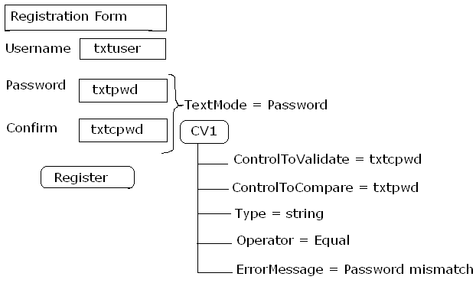
*Grouping the validation controls together: In order to group the validation controls together ‘ValidationGroup’ property for all the controls which belongs to the group should be set with the same name.

3. RangeValidator:
It is used to verify if the provided input is between a specific range or not.
Properties:
MaximumValue | Specifies the upper range
MinimumValue | Specifies the lower range
Type | Specifies the data type to be used for validating the user input

E.g.:
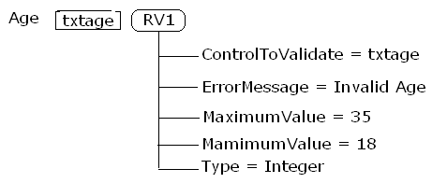

4. CustomValidator control:
It is used to validate user input based on the user defined functionality.
Note:
*CustomValidator is the only validator control which has the capability to validate the user input at the client side and also at the server side.
*Other than the CustomValidator, all the controls will validate the user input at the client side.
Property:
ClientValidationFunction | Specifies the JavaScript function name, which provides the definition to validate the user input at the client side.
Event:
ServerValidate | The code written within this event will be used to validate the user input at the server side.

e.g.:
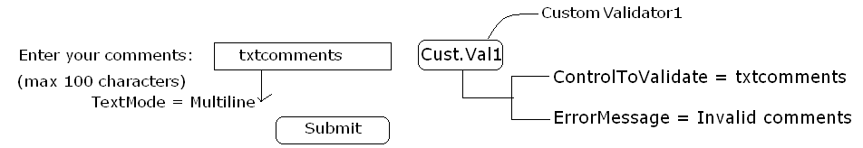
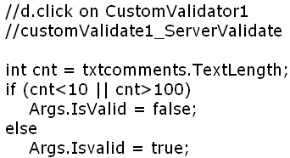

5. RegularExpressionValidator control:
It is used to validate the user input based on the validation expression.
Meta characters used to prepare the expression for single digit:
\d | Accepts a single digit
/D | Accepts a single character
\w | Accepts any character other than a white space (spacebar)
\s | Accepts a space
[A-Za-z] | Accepts upper or lower case characters
[0-9] | Accepts a numerical value
^[0-9] | Accepts any characters other than numeric value

Occurrences:
It is used to specify the occurrence of the meta characters within the expression.
{number} | Accepts the input if the length of the expression is equal to the specified number  E.g.: \d{5} → accepts 5 digits number
{Minnumber, } | Accepts the input if the length after expression is greater than or equal to the specified Minnumber.  E.g: [A-Za-z0-9_]{6, }
{Minnumber, Maxnumber} | Accepts the input if the length of the expression is between the specified range.  e.g.: \D{6,8}

Modes:
It is used to specify the occurrence of the meta characters within the expression.
Mode | MinOccurrence | MaxOccurrence
? | 0 | 1
. or * | 0 | Any
+ | 1 | Any
E.g.: \d{1, } <==> \d+
[ma+am] => accepts ‘madam, Malayalam ……’

E.g.:
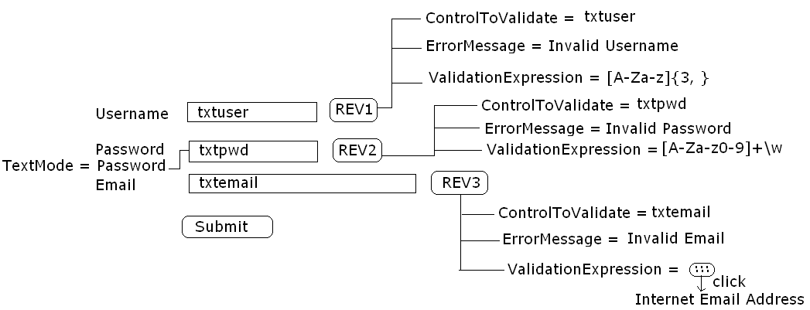

6. ValidationSummary control:
It is used to validate the other validation controls placed on the webform.
Note:
*Error messages of other validation controls will be considered as an input for the ValidationSummary control.
*ValidationSummary control is the only server side control which has a capability to project a MessageBox.
*If the ValidationSummary control is used on the webform then it is mandatory to set the “Text” property (*) for other validation controls.
*To display the error messages within a MessageBox, set the property “ShowMessageBox” as true.

ADO.NET
ADO.Net (ActiveX Data Objects for .Net):
It is framework for interacting with any database/XML document.
ADO.Net supports two models for interacting with the database.
- Disconnected Model
- Connected Model
1. Disconnected Model:
If is used to interact with the database then the connectivity between the application and database is not required while performing any navigations or manipulations on the data.
Note: Disconnected model establish the connection with database and process the connection implicitly based on the requirement.
ADO.Net Disconnected Model Architecture:
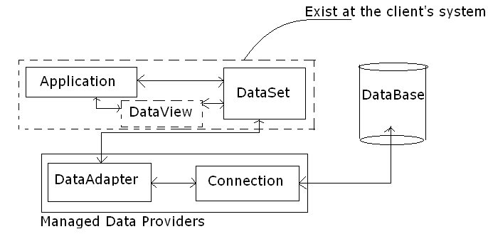
ADO.Net Connection Oriented Model:
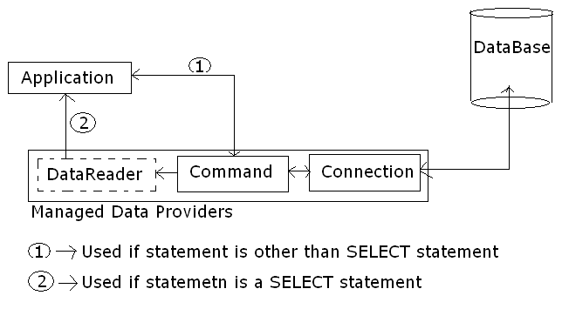
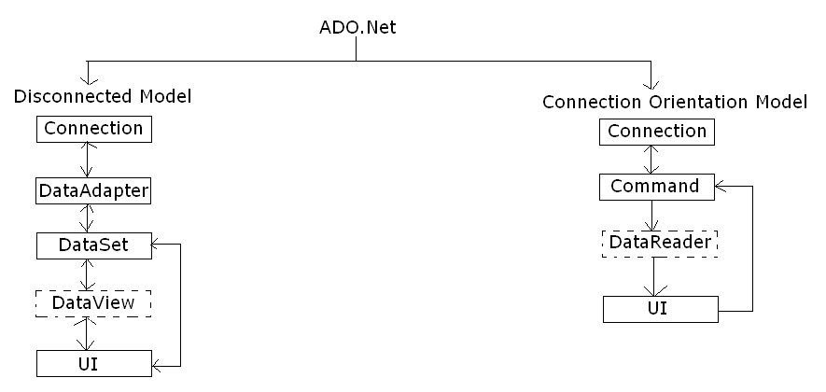
Connection object : It is used to establish physical connection between the Application and the Database.
DataAdapter object: It is a collection of Command object which acts like an interface or bridge between the Database and the Dataset for transferring the data.
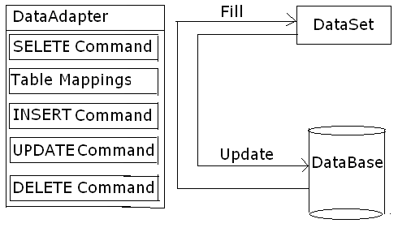
*Methods for DataAdapter:
1. FILL:
It is used to read the data from the database based on the SELECT statement of the SelectCommand of DataAdapter and used to fill the DataSet with the retrieved information.
2. Update:
It is used to read the data from the DataSet and used to update the Database with the information.
Note: DataAdapter can always interact with only one table for supporting manipulations.
DataSet:
It is an in-memory representation of the data at the client system in the format of XML.
Note:
*DataSet can maintain the information about any no. of data tables which belongs to any database.

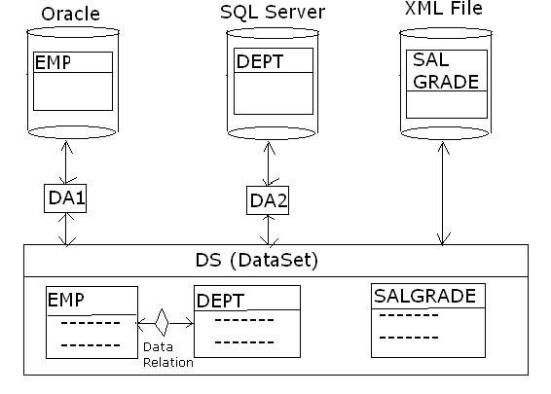
*DataSet supports establishing the relationships between the data tables present within the DataSet and if a relationship is established between the data tables then it is said t be “data relation”.
*Any manipulations performed on the data table of DataSet will not be reflected on the Database.
*Since, a DataSet maintains the information of more than one table, a DataSet is also considered as a collection of Data Tables.
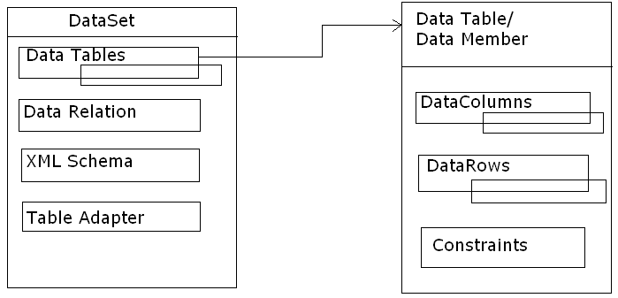
DataSet is of two types:
1. Typed DataSet 2. Untyped DataSet
1. Typed DataSet:
Whenever, a DataSet is defined based on XML Schema Definition (XSD) then it is said to be Typed DataSet.
Note:*Typed DataSet members will be binded with the application at the designed time.
*To refer the members of the Typed DataSet:
Syntax: DataSetname.DataTable
2. Untyped DataSet:
Whenever, a DataSet is defined without XML Schema Definition then it is said to be Untyped DataSet.
Note:*Untyped DataSet members will be binded with the application at the runtime.
*Untyped DataSet is faster than the Typed DataSet.
*To refer the members of Untyped DataSet:
Syntax: DatasetName.Tables(Table Index | Table Name)
E.g: DS.Tables[0] or DS.Tables(“EMP”)
DataView:
It is a logical representation of the data present within the data members of DataSet.
Note: DataView should be used whenever the data has to be filtered based on a condition or if the data has to be sorted or if the data has to be projected in page wise.

Command:
It is used to provide the source for the connection object.
(* What is the statement to execute is specified using Command)
*Methods of Command Object:
ExecuteScalar() | It is used to execute a SELECT statement which returns single column and a single row  *This method returns an object.  *If this method is used to execute a SELECT statement which returns more than one row or column then the method will not raise an error instead it will return the value present at the first row-first column.
ExecuteReader() | It is used to execute any valid SELECT statement.  *This method returns a DataReader object.
ExecuteNonQuery() | It is used to execute any valid statement other than SELECT statement.  *This method returns an integer.

DataReader: It is a read only and forward only record set which maintains the data retrieved by the Command Object.

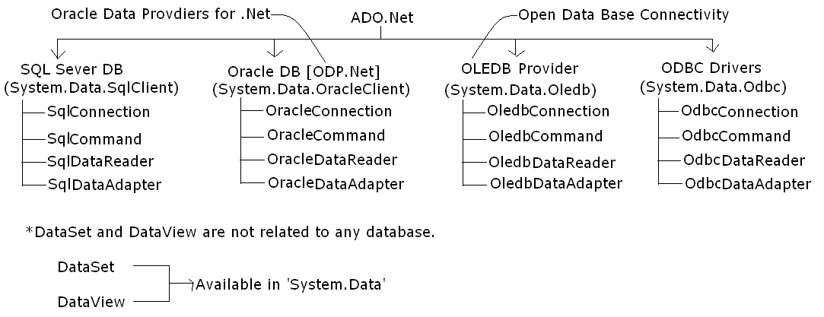
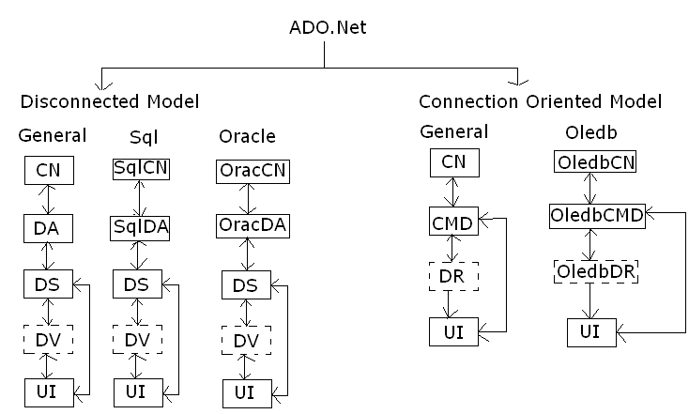

CommandBuilder:
It is used to build the commands for the DataAdapter object based on the table definition.
Syntax:
Note:
*If the table is defined with primary key then all the commands for the DataAdapter will be generated else the commands relevant for the DELETE command and UPDATE command will not be generated.
*If Untyped DataSet is used then in spite the tables are defined with primary key the data tables will not inherit the primary key.
*To add a primary key constraint programmatically:
Syntax:
*ConnectionString to connect SqlServer:
*ConnectionString to connect oracle:
*ConnectionString to connect Ms-Access:
Note:*If SqlConnection is used to connect SqlServer or OracleConnection is used to connect Oracle database then ‘Provider=ProviderName’ should not be mentioned within the ConnectionString.
*Navigation to Generate ConnectionStings:
→ R.click on desktop
→ New
→ Text Document
→ Open text file
→ File menu
→ SaveAs
→ Specify file name for e.g.: “myconnections.udl”
→ Save
→ D.click on ‘myconnectons.udl’
→ Click on ‘Provider’ tab
→ Select the required DataBase
→ Click ‘Next’
→ Specify the Servername, Username and Password
→ Check the checkbox : “Allow saving password”
→ Click on ‘Test Connection’ and we should get the message
“Test connection successfully”
→ Click “OK”
→ Click “YES”
→ R.click on “myconnectons.udl”
→ Open with Notepad
→ We can see the ConnectionString to connect the database

Presenting the data using Disconnected Model:
Design the webform as follows:
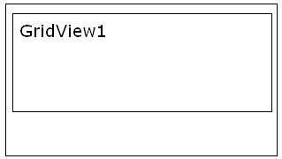
Code:
Using System.Data.SqlClient;
//Page_Load
SqlConnection cn = new SqlConnection(“user id=sa;password=; database = pubs;datasource=ptpl);
SqlDataAdapter da = new SqlDataAdapter(“select * from authors”, cn);
DataSet ds = new DataSet();
da.Fill(ds,”authors”);
GridView1.DataSource = ds.Tables[0];
GridVeiw1.DataBind(); //only for web app. Not for windows appl.

Presenting the data using Connection Orientation model:
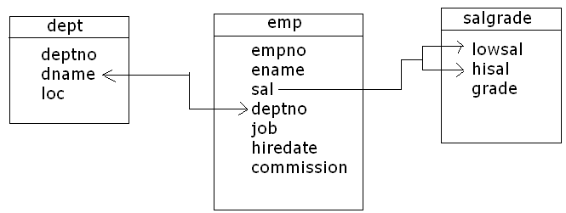

Design the form as follows:
Code: using Oracle DB:
Website → Add reference → System.Data.OracleClient
Using System.Data.OracleClient;
OracleConnection cn = new OracleConnection();
String sql = String.Empty();
Sql = “select emp.empno, emp.ename, emp.sal, emp.job, dept.deptno, dept.loc, salgrade.grade from emp, dept, salgrade
where dept.deptno = emp.deptno and emp.sal between salgrade.lowsal and slagrade.highsal”;
OracleCommand cmd = new OracleCommand(sql, cn);
OracleDataReader dr;
Cn.open();
dr = cmd.ExecuteReader();
GridView1.DataSource = dr;
GridView1.DataBind();
dr.Close();
cn.Close();

Disconnected Model
Steps to work with ADO.Net:
1. Common steps to perform Data Manipulation: (For example to connect to SqlServer Database)
Step | Description and Syntax
1 | Define a connection object.  Syntax: xxxConnection <connectionobjectname> = new xxxConnection(“<connectionstring>);  SqlConnection cn = new SqlConnection(“Data Source=TIGER;database=master;integrated security = true);
2 | Define a DataAdapter object  Syntax: xxxDataAdapter <DataAdapterName> = new xxxDataAdapter(“query”, <connectionobjectName>);  e.g: SqlDataAdapter da = new SqlDataAdapter(“select * form emp”, cn);
3 | Define a CommandBuilder object  Syntax: xxxCommandBuilder <CommandBuilderName> = new xxxCommandBuilder(<DataAdapterName>);  e.g: SqlCommandBuilder cmd = new SqlCommandBuilder(da);
4 | Define a DataSet object  Syntax: DataSet <DataSetName> = new DataSet(); e.g: DataSet ds = new DataSet();
5 | Fill the DataSet object.  Syntax: <DataAdapterName>.Fill(<DataSetName>, “<TableName>”); e.g: da.Fill(ds,”emp”);
6 | Add a primary key constraints for the DataColumn [optional for INSERT]  Syntax: <DataSetName>.DataTable.Constraints.Add(“<name for primary key>”, <DataSetName>.DataTable.Cloumns[“<column name in table>”], true);  e.g: ds.Tables[0].Constraints.Add(“usr_pk”, ds.Tables[0].Columns[“username”], true);
2. To select the data:

Step | Description and Syntax
1 | Define a connection object.  Syntax: xxxConnection <connectionobjectname> = new xxxConnection(“<connectionstring>);  SqlConnection cn = new SqlConnection(“Data Source=TIGER;database=master;integrated security = true);
2 | Define a DataAdapter object  Syntax: xxxDataAdapter <DataAdapterName> = new xxxDataAdapter(“query”, <connectionobjectName>);  e.g: SqlDataAdapter da = new SqlDataAdapter(“select * form emp”, cn);
3 | Define a CommandBuilder object  Syntax: xxxCommandBuilder <CommandBuilderName> = new xxxCommandBuilder(<DataAdapterName>);  e.g: SqlCommandBuilder cmd = new SqlCommandBuilder(da);
4 | Define a DataSet object  Syntax: DataSet <DataSetName> = new DataSet(); e.g: DataSet ds = new DataSet();
5 | Fill the DataSet object.  Syntax: <DataAdapterName>.Fill(<DataSetName>, “<TableName>”); e.g: da.Fill(ds,”emp”);
6 | Assign the DataSet object as a DataSource to the Data bound control or return the DataSet object.

3. To insert the data:

Step | Description and Syntax
1 | Define a DataRow variable  Syntax: DataRow <RowVariableName>; e.g: DataRow row;
2 | Assign the NewRow of the datamember of DataSet to the DataRow variable  Syntax: <DataRowVariable> = <DataSetName>.DataTable.NewRow();  e.g: row = ds.Tables[0].NewRow();
3 | Assign the values to the DataColumns fo the DataRowVariable  Syntax: <DataRowVariable>[columnIndex | ColumnName] = <value>;  e.g: row[“uname”] = txtusr.Text;
4 | Add the DataRowVariable to the data rows collection of the data member of the DataSet.  Syntax: <DataSetName>.DataTable.Rows.Add(<DataRowVariable>);  e.g: ds.Tables[0].Rows.Add(row);
5 | Update the DataAdapter object with the data present at the DataSet object  Syntax: <DataAdapterName>.Update(<DataSetname>.DataTable);  e.g: da.Update(ds.Tables[0]);

4. To update the data:
Step | Description and Syntax
1 | Define a DataRow variable  Syntax: DataRow <RowVariableName>; e.g: DataRow row;
2 | Assign the Datarow of the data member of the DataSet Which has to be modified to the DataRowVariable.  Syntax: <DataRowVariable> = <DataSetName>.DataTable.Rows.[RowIndex];  (or)  <DataRowVarible> = <DataSetName>.DataTable.Rows.Find(PrimaryKeyColumnValue);  e.g: row = ds.Tables[0].Rows[5];  row = ds.Tables[0].Rows.Find(uname);
3 | Start the Edit mode  Syntax: <DataRowVariable>.BeginEdit();  e.g: row.BeginEdit();
4 | Assign the values to the DataColumns fo the DataRowVariable  Syntax: <DataRowVariable>[columnIndex | ColumnName] = <value>;  e.g: row[“uname”] = txtusr.Text;
5 | End Edit mode.  Syntax: <DataRowVariable>.EndEdit(); e.g: row.EndEdit();
6 | Update the DataAdapter object with the data present at the DataSet object  Syntax: <DataAdapterName>.Update(<DataSetname>.DataTable);  e.g: da.Update(ds.Tables[0]);
4. To delete the data:

Step | Description and Syntax
1 | Delete the DataRow from the data rows collection of the data members of the DataSet  Syntax: <DataSetName>.DataTable.Rows.[rowindex].Delete();  (or)  <DataSetName>.DataTable.Rows.Find(Primarykeycolumnvalue).Delete();  e.g: ds.Tables[0].Rows[5].Delete();  ds.Tables[0].Rows.Find(uname).Delete()
2 | Update the DataAdapter object with the data present at the DataSet object  Syntax: <DataAdapterName>.Update(<DataSetname>.DataTable);  e.g: da.Update(ds.Tables[0]);

ObjectDataSource:
It is used to use a BusinessObject as a data source for interacting with the database and the XML document. Where a BusinessObject can be considered as a Class Definition with the methods which interacts with the database.
*Using ObjectDataSource for retrieving the data:
→ Solution Explorer
→ R.click on the application
→ Add ASP.NET folder
→ Click “App_code” (any classes interacts with the database, write here)
→ R.Click on ‘App_code’ folder
→ Add New Item
→ Under ‘Templates’ select ‘Class’
→ Specify name of the class (e.g: BusinessObject.cs)
→ Click ‘Add’
→ Solution Explorer
→ Click on ‘BusinessObject.cs
→ In ‘Public Class BusinessObject’ class write the following code:
Using System.Data.Oledb;
Public Class BusinessObject
{
Public DataSet ShowEmployees()
{
OledbConnection cn = new OledbConnection(“provider= oraoledb.oracle;userid = scott; password = tiger”);

OledbDataAdapter da = new OledbDataAdapter(“select * from emp”, cn);
DataSet ds = new DataSet();
da.Fill(ds,”emp”);
return ds;
}
Public DataView ShowEmployeesByDeptno(int dno)
{
DataSet ds = new DataSet();
ds = ShowEmployees();
DataView dv = new DataView(ds.Tables[0]);
dv.RowFilter = “deptno = “ + dno;
return dv;
}
}
→ Add a new webform
→ Design the form as follows:
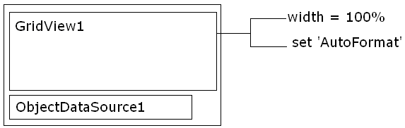
→ Click on the ObjectDatasource1 → Click ‘Configure DataSource’
→ Choose a BusinessObject from dropdownlist
→ Click ‘Next’ → In ‘Define Data Methods’ window click on ‘SELECT’ tab
→ Choose a appropriate method → Click ‘Finish’
→ Click on the ‘GridView1’ → Choose ‘DataSource’
→ Select the ‘ObjectDataSource1’ from the dropdownlist
→ Execute the form.
1. Presenting the data using Disconnected Model:
Disconnected Model: CN → DA → DS → DV → UI
Query: Get the employee details
Steps:
- Designing the form as follows:
→ ToolBox
→ Data Tab
→ Drag and Drop “GridView” control
→ Select GridView control and press F4
→ Set width as 100%
→ Select ‘AutoFormat’ as show below for GridView control
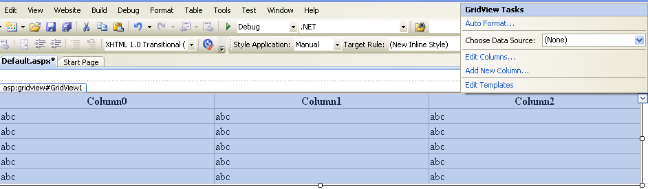
→ Double Click on the Form
→ Write the code for getting the data from the data base in “Page_Load”
- // Code for the above:
using System;
using System.Configuration;
using System.Data;
using System.Linq;
using System.Web;
using System.Web.Security;
using System.Web.UI;
using System.Web.UI.HtmlControls;
using System.Web.UI.WebControls;
using System.Web.UI.WebControls.WebParts;
using System.Xml.Linq;
using System.Data.SqlClient; // specifying the Sql specification

public partial class _Default : System.Web.UI.Page
{
protected void Page_Load(object sender, EventArgs e)
{
// Disconnected Model
//1. Establishing the connection to SqlServer
// Connectionstring is "Data Source=TIGER;database=master;integrated security = true"
SqlConnection cn = new SqlConnection("Data Source=TIGER;database=master;integrated security = true");

//2. Define DataAdapter and specify the query
SqlDataAdapter da = new SqlDataAdapter("select * from emp", cn);
//3. Define DataSet
DataSet ds = new DataSet();
//4. Fill the DataSet using FILL method
da.Fill(ds, "emp");
//5. Assign the DataSource to the GridView1
GridView1.DataSource = ds.Tables[0];
//6. Bind the data (only for web applications not for windows application)
GridView1.DataBind();
}}

- Execute and will get the output as follows: 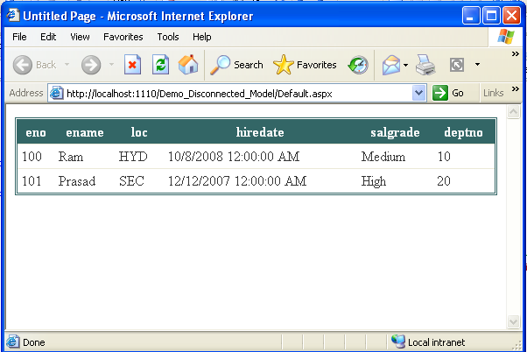

2. Presenting the data from more than two tables using Connection Orientation Model: CN → CMD → DR → UI
Assume that we have ‘dept’, ‘salgrade’ and ‘dept’ tables as below:
dept:
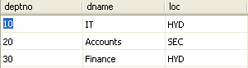
salgrade:
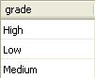
emp:
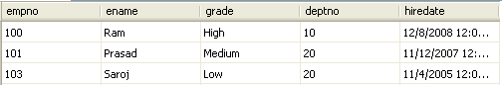
query: Get the employee details
Steps:
- Designing the form as follows:
→ ToolBox
→ Data Tab
→ Drag and Drop “GridView” control
→ Select GridView control and press F4
→ Set width as 100%
→ Select ‘AutoFormat’ as show below for GridView control
→ Double Click on the Form
→ Write the code for getting the data from the data base in “Page_Load”
- // Code for the above:
using System;
using System.Collections;
using System.Configuration;
using System.Data;
using System.Linq;
using System.Web;
using System.Web.Security;
using System.Web.UI;
using System.Web.UI.HtmlControls;
using System.Web.UI.WebControls;
using System.Web.UI.WebControls.WebParts;
using System.Xml.Linq;
using System.Data.SqlClient; // Specify the SQL connection
public partial class GetEmp : System.Web.UI.Page
{ protected void Page_Load(object sender, EventArgs e)
{ //1. Establish the connection to SqlServer
SqlConnection cn = new SqlConnection("Data Source=TIGER; database=master; integrated security = true");
string sql = string.Empty;
// assign the query to sql
sql = "select emp.empno, emp.ename, emp.grade, dept.dname, dept.loc from emp, dept where dept.deptno = emp.deptno";
//2. Define a command object and speify the sql query
SqlCommand cmd = new SqlCommand(sql,cn);
//3. Define DataReader object
SqlDataReader dr;
//4. Open connection
cn.Open();
//5. Assign the command to datareader
dr = cmd.ExecuteReader();
// 7. Assign the dr to GridView1 control
GridView1.DataSource = dr;
//8. Bind the data
GridView1.DataBind();
// 9. Close the datareader
dr.Close();
//10.Close the connection
cn.Close(); }}
- Output: 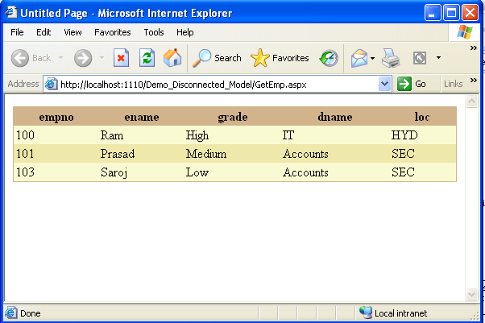

3. Using ObjectDataSource control performing SELECT, INSERT, DELETE and UPDATE in Disconnected Model:
→ // setting the ConnectionString in web.config file
→ Solution Explorer
→ D.click on ‘web.config’ file
→ Search for the text ‘ConnectionStrings’
→ After code the following for (SqlServer):
<connectionStrings>
<add name="SqlConnectionString" connectionString="Data Source=TIGER;database=master;integrated security = true"></add>
</connectionStrings>
→ R.click on the ‘App_Code’
→ Select ‘Add New Item’
→ Under ‘Templates’ window, select ‘Class’
→ Specify name of the class and then click ‘Add’
e.g : BusinessObject.cs
→ Under ‘App_Code’ select ‘BusinessObject.cs’ (d.click)
→ Write the code as shown below:
using System;
using System.Data;
using System.Configuration;
using System.Linq;
using System.Web;
using System.Web.Security;
using System.Web.UI;
using System.Web.UI.HtmlControls;
using System.Web.UI.WebControls;
using System.Web.UI.WebControls.WebParts;
using System.Xml.Linq;
using System.Data.SqlClient; //specify the Sqlconnection namespace
public class BusinessObject
{
private SqlConnection cn;
private SqlDataAdapter da;
private SqlCommandBuilder cmd;
private DataSet ds;
public BusinessObject() //instance constructor
{
// Selecting the data
string cs;
// For getting the connectionstring form web.config file
cs = ConfigurationManager.ConnectionStrings["SqlConnectionString"].ConnectionString;
// establishing the connection
cn = new SqlConnection(cs);
//getting the rows into dataAdapter
da = new SqlDataAdapter("select * from ram", cn);
//Defining the commanBuilder
cmd = new SqlCommandBuilder(da);
//defining DataSet
ds = new DataSet();
// fill the DataSet
da.Fill(ds, "ram");
// Add primary key programmitically
ds.Tables[0].Constraints.Add("usr_pk", ds.Tables[0].Columns["username"], true];
}
public DataSet ShowUsers() // Method for selecting the data
{
return ds;
}
public bool AddUser(string uname, string pwd)
{
// Inserting the data
// 1. Define a DataRow variable
DataRow row;
//2. Assign the NewRow of the datamember of the DataSet to rowvarible
row = ds.Tables[0].NewRow();
//3. Assign the values to DataColumns
row["username"] = uname;
row["password"] = pwd;
//4. Add to the datarow variable to the data rows of dataset
ds.Tables[0].Rows.Add(row);
//5. Updatae DataAdapter
da.Update(ds.Tables[0]);
return true;
}
public bool ChangePassword(string uname, string npwd)
{
// Updating the data
//1. Define a data row varible
DataRow row;
//2. Assign the datarow of hte dtamember of dataet which has to be modified
row = ds.Tables[0].Rows.Find(uname);
//3. Start Edit mode
row.Begin(Edit);
//4.Assign the values to the Datacolumns of the DataRow variable
row["password"] = npwd;
//5. End edit mode
row.End(EditCommandColumn);
//6. Update DataAdapter
da.Update(ds.Tables[0]);
return true;
}
public bool Deleteuser(string uname)
{
// Deleting the user
//1. Delete the datarow from dataset
ds.Tables[0].Rows.Find(uname).Delete();
//2. Update DataAdapter
da.Update(ds.Tables[0]);
return true;
}
}
→ Add new webform
→ Design the form as follows for showing the users: 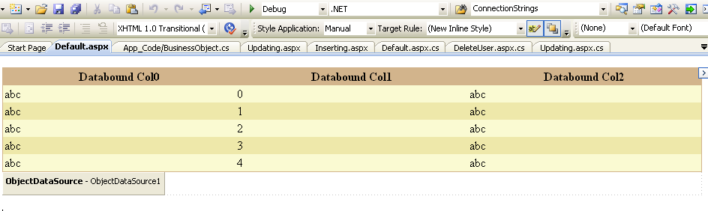
→ Click on ObjectDataSource
→ Select ‘Configure DataSource’
→ Choose ‘BusinessObject’
→ Click ‘Next’
→ Click ‘SELECT’ tab and select relevant method.
→ Click ‘Finish’
→ Output:
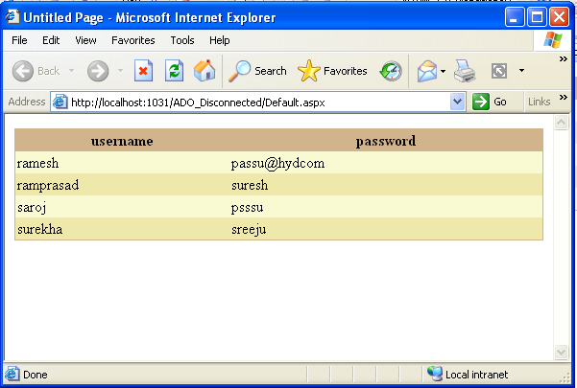

→ Design the form as follows for registering the user:
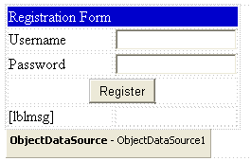

→ Click on ObjectDataSource
→ Select ‘Configure DataSource’
→ Choose ‘BusinessObject’
→ Click ‘Next’
→ Click ‘SELECT /INSERT’ tabs and select relevant method.
→ Click ‘Finish’
→ Open ObjectDataSource properties
→ Click ‘Events’ tab
→ D.click on ‘Inserting’ event
→ Write the code: //parameters assigning
//ObjectDataSource1_Inserting
e.InputParameters.Clear();
e.InputParameters.Add("username", txtusr.Text);
e.InputParameters.Add("password", txtpwd.Text);

→ D.click on ‘Register’ button
→ Write the code:
//btnRegister_Click
ObjectDataSource1.Insert();
lblmsg.Text = "User Registered";

→ Output: 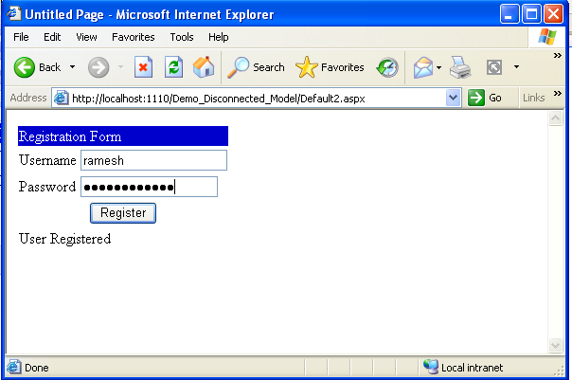

→Design the form for updating the password:
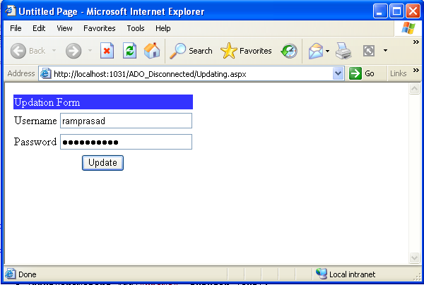
→ Click on ObjectDataSource
→ Select ‘Configure DataSource’
→ Choose ‘BusinessObject’
→ Click ‘Next’
→ Click ‘UPDATE’ tab and select relevant method.
→ Click ‘Finish’
→ Open ObjectDataSource properties
→ Click ‘Events’ tab
→ D.click on ‘Updating’ event
→ Write the code: //parameters assigning
//ObjectDataSource1_Updating
e.InputParameters.Clear();
e.InputParameters.Add("uname", txtuser.Text);
e.InputParameters.Add("npwd", txtpwd.Text);
→ D.click on ‘Update’ button
→ Write the code:
//btnUpdate_Click
ObjectDataSource1.Update();
lblmsg.Text = "Updated Successfully";

→ Output:
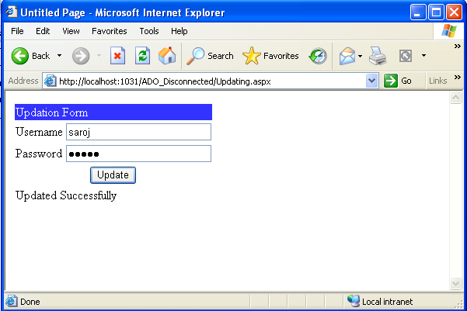

→Design the form for deleting the user:
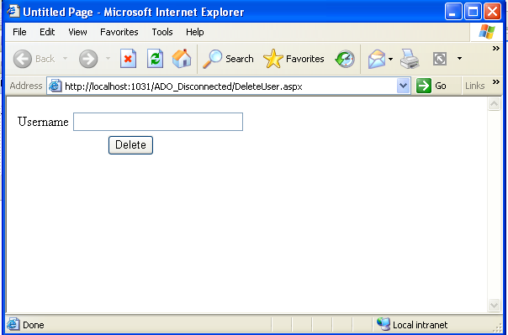
→ Click on ObjectDataSource → Select ‘Configure DataSource’
→ Choose ‘BusinessObject’ → Click ‘Next’
→ Click ‘DELETE’ tab and select relevant method.
→ Click ‘Finish’ → Open ObjectDataSource properties
→ Click ‘Events’ tab
→ D.click on ‘Deleting’ event
→ Write the code: //parameters assigning
//ObjectDataSource1_Deleting
e.InputParameters.Clear();
e.InputParameters.Add("uname", txtuser.Text);
→ D.click on ‘Delette’ button
→ Write the code:
//btnDelete_Click
ObjectDataSource1.Delete();
lblmsg.Text = "Deleted Successfully";
→ Output:
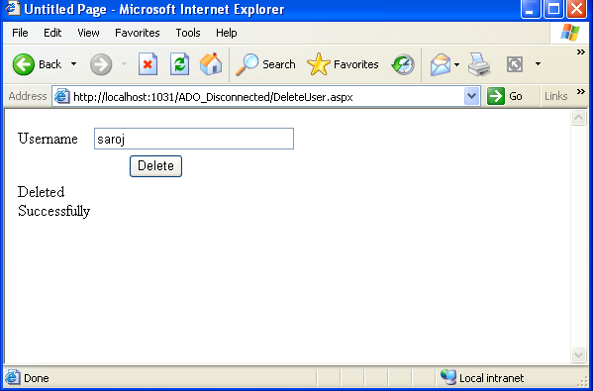

ADO.Net connection oriented Model:
Programming Model:
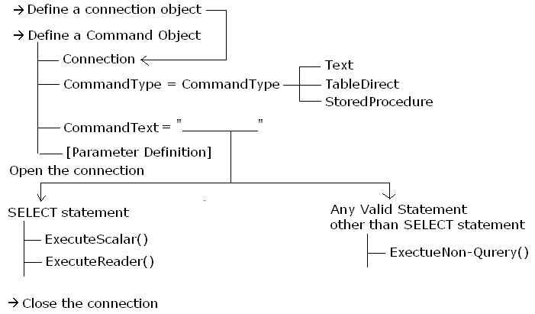
Steps for creating the SQL Sever 2008 Express Edition Database:
→ Solution Explorer
→ R.click on ‘App_Data’
→ Select ‘Add New Item’
→ Under ‘Templates’ window, select ‘SQL Server Database’
→ Give name : e.g: Database.mdf
→ Click ‘Add’
→ Open Server Explorer (Alt + ctrl + S)
→ R.click on Database Table
→ Select ‘Add New Table’
→ Specify the columns
E.g: deptno int → Set primary key constraint
dname varchar(50)
loc varchar(50)
→ Save the table (ctrl + s) e.g: dept
→ In Server Explorer, R.click on ‘dept’ table
→ Select ‘Show Table Data’
→ Add the data
e.g: 10 sales hyd
20 Marketing sec
30 Finance hyd
→ Click ‘Execute SQL’ button on toolbar

Putting the connection string in “web.config” file:
→ Solution Explorer
→ Click on ‘web.config’
→ Search for the term ‘ConnectionStrings’ in web.config file
→ Under <ConnectionStrings> tag add the following code
<connectionStrings>
<add name="SQLConnection" connectionString="Data Source = .\ SQLEXPRESS;AttachDbFilename=|DataDirectory|Database.mdf;
integrated Security = true;User Instance = true" providerName="System.Data.SqlClient"/>
</connectionStrings>

Projecting the data using ObjectDataSource using Connected Oriented Model:
→ Solution Explorer
→ R.Click on ‘App_Code’
→ Select ‘Add New Item’
→ Write code as shown below:
using System;
using System.Data;
using System.Configuration;
using System.Linq;
using System.Web;
using System.Web.Security;
using System.Web.UI;
using System.Web.UI.HtmlControls;
using System.Web.UI.WebControls;
using System.Web.UI.WebControls.WebParts;
using System.Xml.Linq;
using System.Data.SqlClient;
using System.Data.SqlClient;
public class DAL
{ private SqlConnection cn;
private SqlCommand cmd;
private SqlDataReader dr;
public DAL()
{ cn = new SqlConnection(ConfigurationManager.ConnectionStrings["SQLConnection"].ConnectionString);
cmd = new SqlCommand();
cmd.Connection = cn;
cmd.CommandType = CommandType.Text;
}
public SqlDataReader GetallDepartments()
{ cmd.CommandText = "select * from dept";
if (cn.State == ConnectionState.Closed)
cn.Open();
dr = cmd.ExecuteReader();
//cn.Close();
return dr;
}}
→ Design the form to ShowAllDepartments:
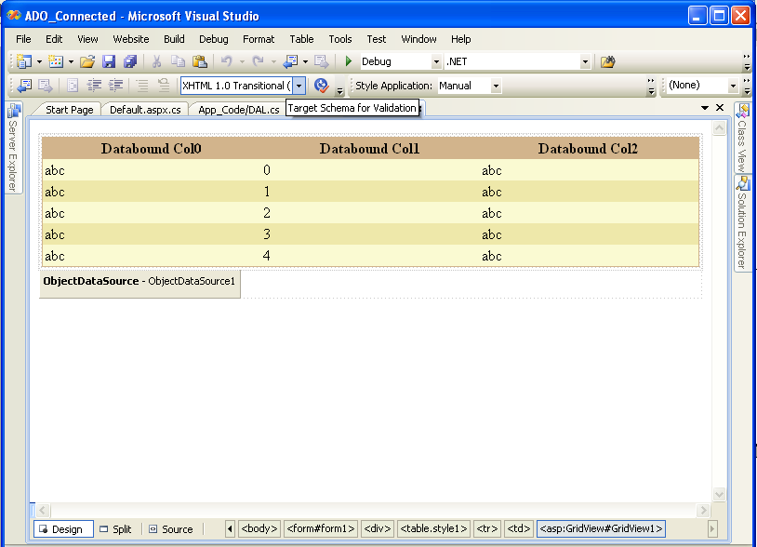
→ Click on ‘ObectDataSource Tasks’
→ Select ‘Configure DataSource’
→ Choose the BusinessObject e.g: DAL
→ Click ‘Next’
→ Click on ‘SELECT’ tab and choose relevant method
→ Click on ‘Finish’
→ Click on ‘GridView Tasks”
→ Choose Data source as ‘ObectDataSource1’
→ Execute
→ Output:
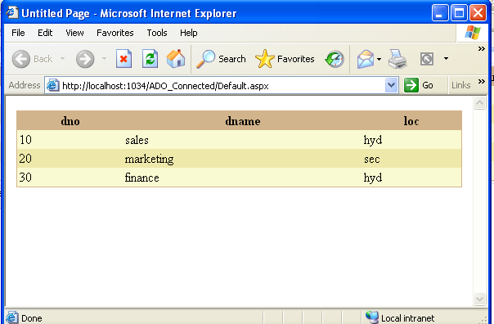

Note: We can add records to database though ‘Insert’ or ‘Stored Procedure’. Using Stored Procedure is much easier than ‘Insert’.

Accessing Stored Procedure using ADO.Net:
Stored Procedure:
It is a schema object which is stored permanently at the database.
Create a table as follows:
Columnname datatype
ImageId int → primary key and Identity(1,1)
ImageTitle Varchar(1000)
ImageUrl varchar(200)
ImageDesc varchar(200)
→ Save the table (e.g: ADDNEWPHOTO)
→ Create a stored procedure as follows:
CREATE PROCEDURE ADDNEWPHOTO
(
@IMAGETITLE VARCHAR(50),
@IMAGEURL VARCHAR(1000),
@IMAGEDESC VARCHAR(200)
)
AS
INSERT INTO PHOTOGALLERY(IMAGETITLE,IMAGERUL,IMAGEDESC)
VALUES(@IMAGETITLE,@IMAGEURL,@IMAGEDESC)
→ Save the Stored Procedure
→ R.click on the App_code
→ Add New Item
→ Templates
→ Class
→ Specify the name
→ Click ‘Add’ and write the code

using System;
using System.Data;
using System.Configuration;
using System.Linq;
using System.Web;
using System.Web.Security;
using System.Web.UI;
using System.Web.UI.HtmlControls;
using System.Web.UI.WebControls;
using System.Web.UI.WebControls.WebParts;
using System.Xml.Linq;
using System.Data.SqlClient;

/// <summary>
/// Summary description for Class1
/// </summary>
public class Class1
{
private SqlConnection cn;
private SqlCommand cmd;
private SqlDataAdapter dr;
public Class1()
{
cn = new SqlConnection("Data Source=TIGER;database=master;integrated security = true");
cmd = new SqlCommand();
cmd.Connection = cn;
cmd.CommandType = CommandType.StoredProcedure;
}

public bool AddNewPhoto(string Imagetitle, string ImageUrl, string Imagedesc)
{
cmd.CommandText = "ADDNEWPHOTO";
cmd.Parameters.AddWithValue("IMAGETITLE", Imagetitle);
cmd.Parameters.AddWithValue("IMAGEURL", ImageUrl);
cmd.Parameters.AddWithValue("IMAGEDESC", Imagedesc);
if (cn.State == ConnectionState.Closed)
cn.Open();
cmd.ExecuteNonQuery();
cn.Close();
return true; }}
→ Design the form as follows:
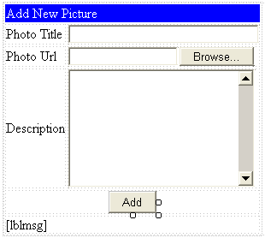
// write the code in Buttonclick ‘Add’
if (FileUpload1.HasFile == true)
FileUpload1.SaveAs(Server.MapPath(FileUpload1.FileName));
Class1 pac = new Class1();
if (pac.AddNewPhoto(txttitle.Text, FileUpload1.FileName, txtdesc.Text) == true)
lblmsg.Text = "Added Successfully";
else
lblmsg.Text = "Failed";

Customizing the GridView control:
→ Place a GridView control on form
→ //Page_Load
using System;
using System.Collections;
using System.Configuration;
using System.Data;
using System.Linq;
using System.Web;
using System.Web.Security;
using System.Web.UI;
using System.Web.UI.HtmlControls;
using System.Web.UI.WebControls;
using System.Web.UI.WebControls.WebParts;
using System.Xml.Linq;
using System.Data.SqlClient;

public partial class Default2 : System.Web.UI.Page
{
protected void Page_Load(object sender, EventArgs e)
{
SqlConnection cn = new SqlConnection(ConfigurationManager.ConnectionStrings["SqlConnectionString"].ConnectionString);
SqlDataAdapter da = new SqlDataAdapter("select * from photogallery", cn);
DataSet ds = new DataSet();
da.Fill(ds,"photogallery");
GridView1.DataSource = ds.Tables[0];
GridView1.DataBind();
}}
→ By executing, we will get the records present in the ‘Photogallery’ table’. But, to get the image in place of ImageUrl follow the steps below:
→ Click on Gridview tasks
→ Edit Columns
→ Unchek ‘Auto Generate Fields’
→ Select ‘BoundField’ under ‘Available Fields’
→ Click ‘Add’
→ HeaderText : Photo Title
→ DataField : ImageTitle
→ Select Template Field
→ Click ‘Add’
→ HeaderText : Photo
→ Select ‘BoundField’
→ HeaderText : Description
→ DataField : ImageDesc
→ Click ‘OK’
→ Click on ‘GridViewTasks’
→ Edit Templates
→ In Item Template place ‘Image control’ and resize
→ Click on ‘Image Tasks’
→ Edit Data Binding
→ Under ‘Bindable Properties’
→ Select ‘ImageUr’
→ Select the radiobutton ‘Code Expression’
→ Write : Eval(“ImageUrl”) =>column name in table
→Click “Ok”
→ R.click on Gridview
→ Select ‘End Template Editing’
→ Execute
→ Output:
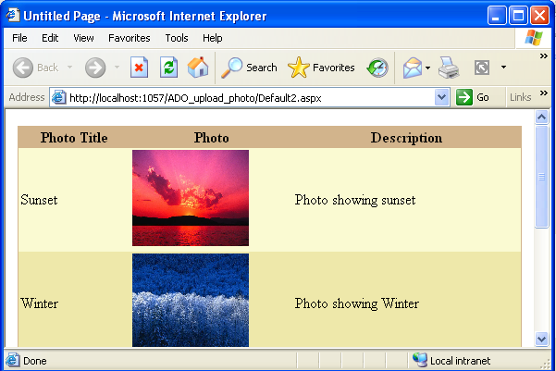

SqlDataSource:
It is used to perform any database related task using the disconnected model without any code.
Note:
*Whenever SqlDataSource is used to project the data hen it will implicitly set SqlDataCache with SqlCacheDependency and hence it improves the performance between 13 to 15%.
Limitation:
*If the tableis defined with a primary key then the SqlDataSource will support manipulations else DML tasks will not be supported.
*Data manipulations will be stored permanently iff the values are provided for all the columns present within the table.
Note:
*SqlDataSource usage is advisable for projecting the data but it is not adivisable for data manipulations.
Using SqlDataSource for Projecting the data:
→ Place the control ‘GridView’ on form
→ Width = 100%
→ Select ‘AutoFormat’ for look and feel
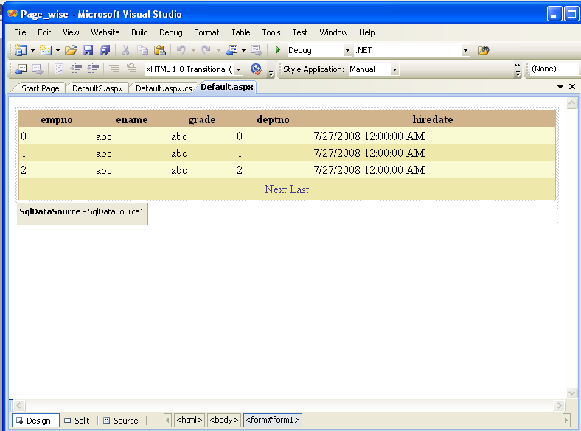
→ Select the control ‘SqlDataSource’ and drag and drop on the form
→ Click ‘Configure DataSource’
→ Click ‘New Connecton’
→ Click ‘Change’ if want to change from SqlServer to other Database
→ Select the name of Database
→ Click ‘OK’
→ Specify server name, user id and password
→ Check the checkbox ‘Save my password’
→ Click ‘OK”
→ Click ‘Next’
→ Configure the Select statement
→ Click ‘Next’
→ Click ‘Finish’
→ Click on ‘GridView Tasks’
→ Chose DataSource : SqlDataSource1
→ Edit Templates
→ Type: No Employees are there in this department
→ R.click on GridView Tasks
→ Select ‘End Template Editing’
→ Execute

Using SqlDataSource for filtering the data:
→ Design the form as follows:
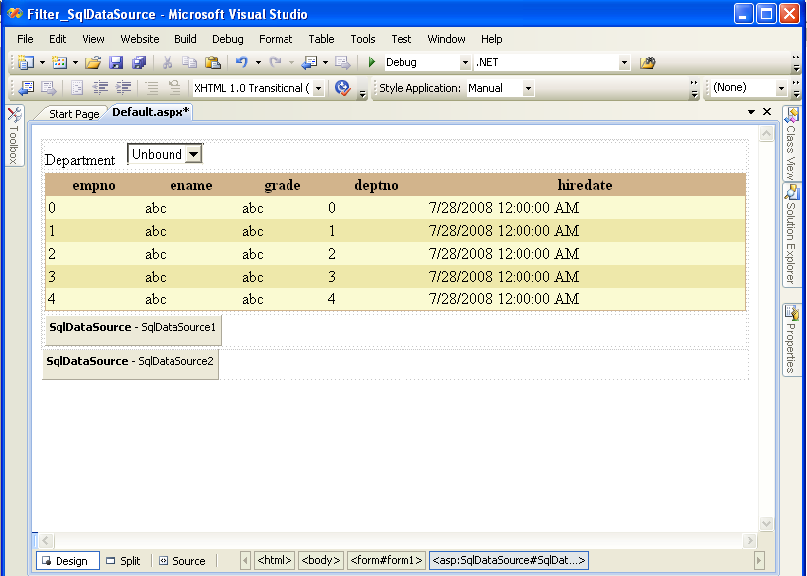
→ Click on ‘SqlDataSource1’
→ Click on ‘SqlDataSource Tasks’
→ Select ‘Configure DataSource’
→ Select ‘SqlConnctionString’ (if available or create new connection)
→ Select table and required fields (e.g: dept)
→ Click ‘Next’ and ‘Finish’
→ Click on ‘SqlDataSource2’
→ Select ‘Configure DataSource’
→ Select ‘SqlConnctionString’ (if available or create new connection)
→ Select table and required fields (e.g: emp)
→ For specifying the where condition:
→ Click on ‘WHERE’ button
→ Select ‘Column’ as ‘deptno’
→ Select ‘Operator’ as ‘=’
→ Select ‘Source’ as ‘Control’
→ Select ‘Control Id’ as ‘DropDownList1’
→ Click ‘Add’
→ Click on ‘DropDownList Tasks’
→ Choose Datasource : SqlDataSource1
→ Check the chenkbox ‘Enable AutoPostBack’
→ Click on ‘GridView Tasks’
→ Choose DataSource : SqlDataSource2
→ Execute
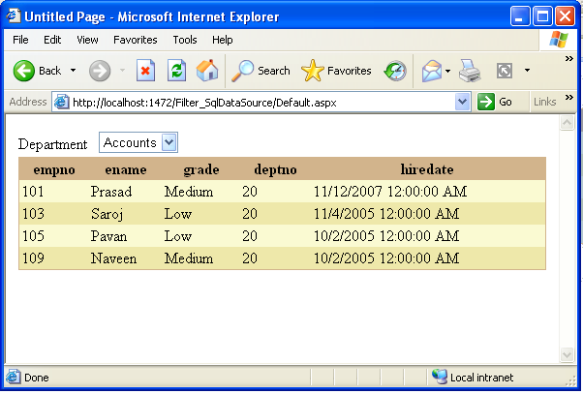

Using SqlDataSource for Projecting the data Pagewise:
→ Design the form as follows:
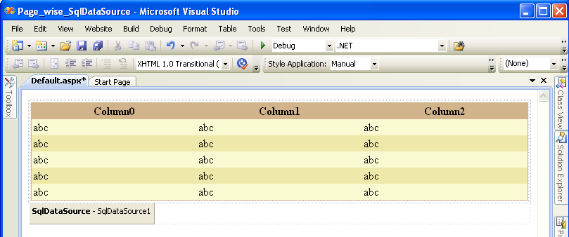
→ Set width of GridView control as 100% and also select ‘AutoFormat’
→ Click on ‘SqlDataSource Tasks”
→ Select ‘Configure DataSource’
→ Select ConnectionString for connecting to DB: ‘SQLConnectionString’
→ Click on ‘GridView Tasks’
→ Choose Data Source : SqlDataSource1
→ Go to ‘GridView’ control properties
→ Set ‘AllowPaging’ as ‘True’
→ In ‘PageSettings’:
Mode : NextPreviousFirstLast
FirstPageText : First
PreviousPageText : Previous
NextPageText : Next
LastPageText : Last
Position : TopAndBottom
→ PageSize = 3
→Output:
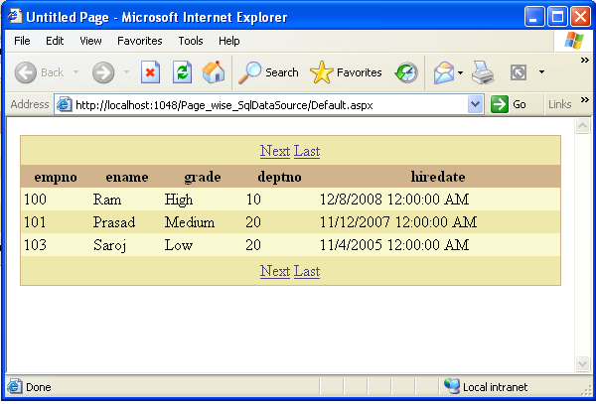
Note: The above feature is supported for ASP.Net 2.0.
Limitation: In ASP. 2.0, GridView supports paging options by attaching the Page Navigation buttons with the GridView control. But it will not support Page Navigation externally.
*ASP.Net 3.5 has been introduced with two new Data controls for supporting PageNavigations and rich support of data manipulations.

*Data controls introduced in ASP.Net 3.5 are:
1. ListView Control
2. DataPager Control
* In ListView control, there are two events known as ‘DataBound’ and ‘ItemDataBound’.
DataBound: Fires the event once the control is binded with the data.
ItemDataBound: Fires the event once the item present with in ListView control is binded with the data.
*Properties of DataPager control:
MaximumRows | Returns the no. of rows present within the data table binded to the control.
StartRowIndex | It is used to specify the row index from where the data should be projected.
PageSize | Used to set or get page size i.e. no. of records to be displayed per page.

*Methods for DataPager:
SetPageProperties(StartRowIndex,PageSize,booleanvalue):
It is used to set the information for page control for displaying the data based on the specified properties.

Note: If Boolean value is set to ‘true’ then the control will be binded with the data else any changes performed on the control will not be maintained.

Projecting the data using ListView and DataPager controls :
→ Design the form as follows:
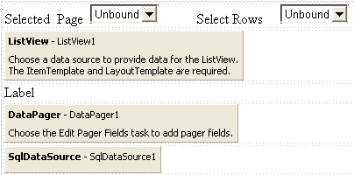
→ Configure SqlDataSource1 to some table e.g : emp
→ Click on ‘ListView Tasks’
→ Choose Data Source : SqlDataSource1
→ Click ‘Configure ListView’
→ Select ‘Layout’ as Grid and ‘Style’ as colorful
→ Go to ‘DataPager’ Properties
→ Select ‘PagerControlId’ as ListView1
→ Set PageSize : 3
→ Click on ‘DataPager Tasks’
→ Choose Pager style : NextPrevious Pager
→ Go to ‘ListView’ properties
→ Click ‘Events’ tab
→ D.click on ‘DataBound’ event
→ Write the following code:
//ListView1_DataBound
int currentpage = (DataPager1.StartRowIndex / DataPager1.PageSize) + 1;
decimal totalpages = (decimal)(DataPager1.TotalRowCount) / (decimal)(DataPager1.PageSize);
totalpages = Math.Ceiling(totalpages);
lblmsg.Text = "You are in " + currentpage + " of " + totalpages + " total pages";

if (Page.IsPostBack == false)
{
for (int i = 0; i < totalpages; i++)
{
DropDownList1.Items.Add((i + 1).ToString());
}
}
DropDownList1.ClearSelection();
DropDownList1.Items.FindByText(currentpage.ToString()).Selected = true;
→ Set ‘AutoPostBack’ is ‘true’ for DropDownList
→ D.click on DropDownList control
→ Write the following code:
//DropDownList1_SelectedIndexChanged
int startrow = ((int.Parse(DropDownList1.SelectedItem.Text)- 1) * DataPager1.PageSize) + 1;
DataPager1.SetPageProperties(startrow - 1, DataPager1.PageSize, true);
→ D.click on ‘Select Row’ dropdownlist
→ Write the code as follows:
//DropDownList2_SelectedIndexChanged
DataPager1.PageSize = int.Parse(DropDownList2.SelectedItem.Text);

Customizing GridViewControl using SqlDataSource and Ajax:
→Design the form as follows:
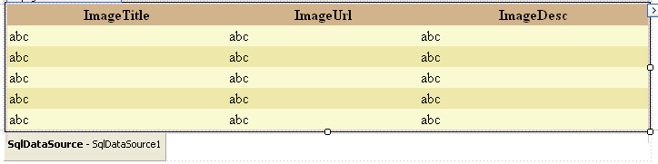
→ Configure SqlDataSource for getting ‘Photogallery’ table
→ Click on ‘GridView Tasks’
→ Choose Data source : SqlDataSource1
→ Edit columns
→ Under Selected Fields: Select ‘ImageUrl’
→ Click on ‘Change this into a Template Field’
→ Click ‘OK’
→ Click ‘GridView Tasks’
→ Click on ‘Edit Templates’
→ In ‘Item Template’ remove ‘Label’ and Place ‘Image’ control and resize
→ Click ‘Image Tasks’
→ Select ‘Edit Data Binding’
→ Under Bindable Properties, select ‘ImageUrl’
→ Select ‘File binding’ radiobutton
→ Select the relevant Bound file
→ Click ‘OK’
→ R.click on Grid and select ‘End Template Editing’
→ Execute
→ Output

Customizing GridView using Ajax support:
→ Design the form as follows:
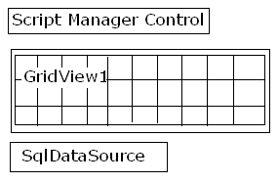
→ Select ‘SqlDataSource Tasks’
→ Select ‘Configure DataSource’
→ Select ‘ConnectionString’ to connect to SqlServer
→ Select table and required columns
→ Click ‘Next’ and then ‘Finish’
→ Click on ‘GridView’ control
→ Select ‘Choose DataSource’ : SqlDataSource1
→ Select ‘Edit Columns’
→ Remove all the selected fields (if any)
→ Select ‘Template Field’ under Available fields
→ Click ‘Add’
→ HeaderText: PhotAlbum
→ Click ‘OK’
→ Click on ‘Edit Templates’
→ Under ItemTemplate: Place a Image Control
→ Click ‘Image Tasks’
→ Select ‘Edit Data Binding’
→ Select column: ‘ImageUrl’
→ Click ‘OK’
→ Place a Panel control under Item Template
→ Within Panel control, take table (1,1)
→ Place the Image control in Panel and increase the size
→ Click on ‘Image Tasks’
→ Edit Data Binding
→ Field Bound to : ImageUrl
→ Click ‘OK’
→ Take a Label control and place in Panel
→ Click ‘Label Tasks’
→ Select ‘Text’ on bindable properties
→ Bound to : ImageTitle
→ Repeat the same for all the fields
→ Click on smaller Image ‘Image Tasks’
→ Click ‘Add Extender’
→ Choose an Extender called : HoverMenu Extender’
→ Click ‘OK’
→ Smaller Image Properties:
→ PopupControlId = Panel1; PopupPosition = Right
→ R. click on GridView
→ Select ‘End Template Editing’
→ Execute

H.W:
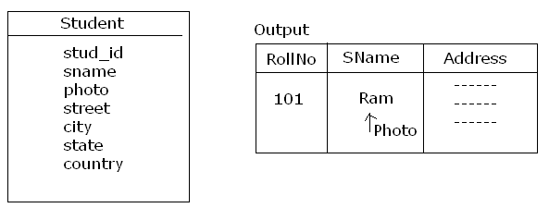

Reading values from the GridView control:
Note:
- The data within the GridView control will be projected at the DataRow template.

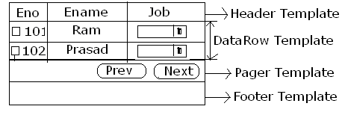
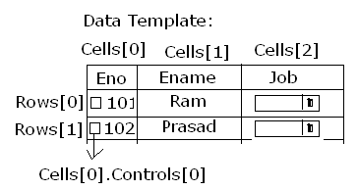
- The collection of all the data rows present at the GridView is called as ‘RowsCollection’.
- The DataRow present at the GridView will maintain the data either at the TableCell or at the control present at the TableCell.
- A DataRow can be accessed from three different event handlers.
  - Within the events of GridView control other than the SelectedIndexChanged event.
Syntax : e.Row
  - Within the SelectedIndexChanged event of GridView.
Syntax : GridViewName.SelectedRow
  - From the events of other controls.
Syntax : GridVeiwName.Rows[RowIndex]
- To read the value present at the control of DataRow TableCell:
(ControlType) DataRow.Cells[CellIndex].Controls[ControlIndex]
e.g: (CheckBox) GV1.Rows[0].Cells[0].Controls[0].
- If the controls are placed using Drag and Drop, then the control index will start from ‘1’ and if the controls are placed through program, then the index will start from ‘0’.
- To read the data present at the TableCell of DataRow:
(TableCell) DataRow.Cells[CellIndex]
→ Design form as follows:
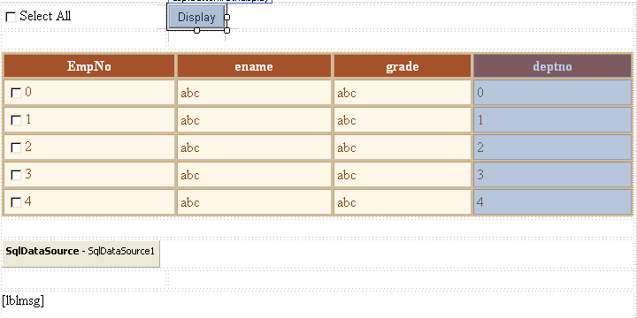
→ Configure the SqlDataSource to get data from ‘Emp’ table
→ Click on GridView and Choose Data source : SqlDataSource
→ Select ‘Edit Columns’
→ Delete ‘Empno’ from Selected Fields
→ Select ‘Template Field’ from the ‘Available Fields’
→ Click ‘Add’
→ Provide ‘HeaderText’ for Template Field as “ Empno
→ Click ‘OK’
→ Click on ‘GridView Tasks’
→ Select ‘Edit Templates’
→ In ‘Item Template’: Place a CheckBox control and provide text for it as ‘Select All’ and put ‘AutoPostBack’ = true for ‘Select All’ checkbox.
→ Click on ‘GridView’
→ Select ‘End Template Editing’
→ d.click on ‘Select All’ checkbox and write the code below:
//CheckBox1_CheckedChanged
for (int i = 0; i < GridView1.Rows.Count; i++)
{
CheckBox chkempno;
chkempno = (CheckBox) GridView1.Rows[i].Cells[0].Controls[1];
chkempno.Checked = CheckBox1.Checked;
}
→ D.click on Display button and write the code as below:
//btndisplay_Click
string ename = string.Empty;
for (int i = 0; i < GridView1.Rows.Count; i++)
{
CheckBox chkempno;
chkempno = (CheckBox)GridView1.Rows[i].Cells[0].Controls[1];
TableCell tcename;
if (chkempno.Checked == true)
tcename = (TableCell)GridView1.Rows[i].Cells[1];
ename = ename + tcename.Text + "<br>";
→ Execute

Working with Typed DataSet:
Typed DataSet: Whenever, a DataSet object is defined based on the XML Schema Definition (XSD) file then it is said to be Typed DataSet.
- Members of the Typed DataSet will be defined at the design time itself and hence whenever the data is filled to the Typed DataSet, valid data member name should be used.
- If the database tables are having any constraints then that information will be binded with the data members of DataSet.
Projecting data using Typed DataSet:
→ Project menu
→ Add New Item
→ Template
→ DataSet
→Specify name (DataSet1.xsd)
→ Click the option ‘ToolBox’
→ Drag and Drop ‘TableAdapter’
→ Click on ‘New Connection’
→ Specify ‘Server name’
→ Specify SQLServer Authentication’
→ Username = sa; Password=;
→ Check ‘Save my Password’ and specify database name
→ Click ‘OK”
→ Click ‘Next’
→ Check ‘Yes, Save the connectionString to application….’
→ Click ‘Next’
→ ‘Choose CommandType’ window
→ Check ‘Use SQL Statement’
→ Click ‘Next’
→ Specify query “Select * from emp”
→ Click ‘Next’
→ Choose methods to generate
☑ Fill a dataTable
☑ Return a Data table
☑ Creates methods to send updates directly to the database.
→ Click ‘Next’ and ‘Finish’
→ Save this file (Ctrl + S)
→ Add a Windform
→ Data menu
→ ‘Show Data Sources’
→ If we want to project the data on to the form, Click on DataTable
→ Select GridView
→ Click on ‘DataGrid Tasks’
→ Dock in Parent container
→ Execute

Projecting data in DetailsView:
→ ‘Data’ Tab
→ ‘Show DataSources’
→ Expand the DataTable
→ Select the columns and drag and drop
→ Set the ‘Photo’ column
→ Click
→ Select ‘PictureBox’

Alternative method:
→ Project menu
→ Add New Item
→ Select ‘DataSet’
→ Click ‘Add’
→ Click ‘Server Explorer’
→ Select the required database and click ‘Next’
→ Expand tables
→ Click Edit Table and select table.

Using Typed DataSet for DataRelations:
→ Project menu
→ Add New Item
→ Select DataSet
→ Specify name (DataSetEmpDept.xsd)
→ Click on ToolBox
→ Drag and drop TableAdaper
→ Click ‘Change’
→ Select required DB
→ Click ‘OK’
→ Click on ‘New Connection’
→ Specify ‘Server name’
→ Specify SQLServer Authentication’
→ Username = sa; Password=;
→ Check ‘Save my Password’ and specify database name
→ Click ‘OK”
→ Click ‘Next’
→ Check ‘Yes, Save the connectionString to application….’
→ Click ‘Next’
→ ‘Choose CommandType’ window
→ Check ‘Use SQL Statement’
→ Click ‘Next’
→ Specify query “Select * from dept”
→ Click ‘Next’
→ Choose methods to generate
☑ Fill a dataTable ☑ Return a Data table
☑ Creates methods to send updates directly to the database.
→ Click ‘Next’ and ‘Finish’
→ Save this file (Ctrl + S)
→ Add windows form
→ Take two Gridviews for Emp and Dept
→ Click on ‘GridView1 Tasks’
→ Choose Data Source
→ Project DataSource
→ Select DataSet Tab (Typed)
→ Select Dept
→ Click on GridView2 Tasks
→ Choose DataSource
→ Dept Binding Source
→ FK_DEPTNO
→ Execute

Customizing GridView using code:
*In order to customize the GridView then ‘RowCreated’ event should be used.
*RowCreated event of GridView will be executed for all the rows present at he GridView.
→ Add New form
→ Place a GridView on the form and set width as 100%
→ d.click on form
→ Write the code in Page_Load
DataSet ds;
//Page_Load
SqlConnection cn = new SqlConnection("Data Source=TIGER;database=master;integrated security = true");
SqlDataAdapter da = new SqlDataAdapter("select * from emp", cn);
ds = new DataSet(); da.Fill(ds, "emp");
GridView1.DataSource = ds.Tables[0];
GridView1.DataBind();
→ Above Page_Load, declare ‘DataSet ds’;
→ Click on GridView Tasks
→ Select ‘Edit Columns’
→ Uncheck ‘Auto Generate Fields’
→ From the ‘Available Properties’ select ‘BoundField’
→ Click ‘Add’
→ HeaderText : Employee#
→ DataField: empno
→ From the ‘Available Properties’, select ‘BoundField’
→ Click ‘Add’
→ HeaderText: Employeename
→ DataField : empname
→ From the ‘Available Fields’, select ‘Template Field’
→ Click ‘Add’
→ HeaderText : Annaual Salary
→ Click ‘OK’
→ Select ‘GridView’ control and Properties (F4)
→ Click ‘Events’ tab
→ D. click on ‘RowCreated’ event
→ Write the code in ‘GridView1_RowCreated’
if (e.Row.RowType == DataControlRowType.DataRow)
{
double annsal;
annsal = double.Parse(ds.Tables[0].Rows[e.Row.RowIndex]["salary"].ToString()) * 12;
e.Row.Cells[2].Controls .Add(new LiteralControl(annsal.ToString()));
if (annsal > 50000)
e.Row.BackColor = System.Drawing.Color.Green;
if (annsal < 10000)
e.Row.BackColor = System.Drawing.Color.Red; }
→ Execute
H.W:
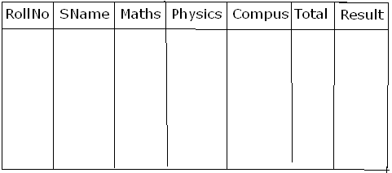

Using HyperLink in GridView:
→ Take a GridView Control
→ Width set 100%
→ Place ‘SqlDataSource’
→ Sql DataSource Tasks
→ Configure DataSource
→ Select ‘ConnectionString’
→ Select ‘Table’ e.g: Publisher
→ Select all the columns i.e. ☑ *
→ Click ‘Next’ and ‘Finish’
→ Click on ‘GridView Tasks’
→ Choose DataSource : SqlDataSource1
→ Select ‘Edit Columns’
→ By default all fields are BoundFields
→ From Selected fields, remove ‘pub_name’ filed
→ Under the ‘Available Properties’, select ‘HyderLink Field’
→ Click ‘Add’
→ HeaderText : Publisher Name
→ DataField : Pub_name
→ DataNavigateUrlFields : pub_id
→ DataNavigateUrlFormatString : ShowEmployees.aspx?pid={0}
→ Click ‘ok’
→ Add new form : ShowEmployees.aspx
→ Place a GridView2 control
→ Place a SqlDataSource2
→ Click on ‘Sql DataSource Tasks’
→ Select ‘Configure DataSource’
→ Configure to connect to any database (Sql Server)
→ Select table ‘emp’
→ Select all the columns i.e. ☑ *
→ Click on ‘Where’ button
→ Column : pub_id
→ Operator : =
→ Source : QueryString
→ QueryStringField : pid
→ Click ‘Add’
→ Click ‘Ok’
→ Click ‘Next’ and ‘Finish’
→ GridView2 Taks
→ Choose DataSource : SqlDataSource2
→ Execute

Using SqlDataSource for performing manipulations:
→ Place a GridView1 control on the form
→ width set as 1--%
→ Place a SqlDataSource1 on the form
→ Configre SqlDataSource
→ Select ‘SqlConnectionString’
→ Click ‘Next’
→ Select table : emp
→ Select all the columns i.e. ☑ *
→ Click on ‘Advance’ button
→ ☑ Generate Insert, Update and Delete statements
→ ☑ Use configuration conference
→ Click ‘OK’
→ Click ‘Next’ and ‘Finish’
→ Click ‘GridView Tasks’
→ Choose DataSource : SqlDataSource1
→ ☑ Enable Editing
→ Edit columns
→ Move ‘Edit’ to bottom
→ Select ‘Edit’ column
→ CommandField Properties
→ ButtonType and select ‘Button’
→ Click ‘OK’
→ Execute
Further, click on ‘GridView Tasks’
→ For Deleting, check ☑ Enabling Deleting
→ Click on ‘Edit Columns’
*Customizing GridView to support ‘Delete’ functionality with confirmation.
→ Template Fields
→ Click ‘Add’ and ‘OD’
→ Click on ‘GridView Tasks’
→ Edit Templates
→ In, ‘Item Template’ place a ‘Linkbutton’ control
→ Go to properties of ‘LinkButton’
→ CommandName : delete (lowercase)
→ Text : Delete Employee
→ OnClientClick : return confirm(“Are you sure to delete?”);
*GridView supports only Update and Delete. It will not support inserting the data.

DetailsView:
It is used to project only one record at a time based on the value selected at the master control.
→ Place a GrieView and set width as 100%
→ Place a ‘DetailsView’
→ Place a ‘SqlDataSource’
→ Configre SqlDataSource
→ Select ‘SqlConnectionString’
→ Click ‘Next’
→ Select table : emp
→ Select all the columns i.e. ☑ *
→ Click on ‘Advance’ button
→ ☑ Generate Insert, Update and Delete statements
→ ☑ Use configuration conference
→ Click ‘OK’
→ Click ‘Next’ and ‘Finish’
→ Select GridView control
→ Choose DataSource: SqlDatasource1
→ ☑ Enable Selection
→ Select Text : Show Employees
→ Click ‘Ok’
→ Select ‘DetailsView Tasks’
→ Choose DataSource : SqlDataSource1
→ ☑ Enable Paging
→ ☑ Enable Inserting
→ ☑ Enable Deleting
→ ☑ Enable Editing
→ D.click on GridView
→ Write the following code:
// GridView1_SelectedIndexChanged
DetailsView1.PageIndex = GridView1.SelectedIndex;
DetailsView1.DataBind();

* For Deleting the displaying of number at bottom of DetailsView,
→ DetailsView properties : PagerSettings: Visible : False

-----------------

Globalization and Localization
Globalization:
It is used for designing a webform or a site for supporting multiple languages or cultures.
Note:
*ASP.Net supports Globalization at two levels.
1. Application Level Globalization
2. Page Level Globalization

Application Level Globalization:
If used then the entire ASP.Net website uses a single language or culture.
To Set: [In web.config file]
<globalization culture = “xx-XX”/>
Where ‘xx’ indicates ‘Language’ and
‘XX’ indicates the ‘Country or Region’

E.g:
→ Place a Calendar control on the webform
→ Set properties: DayNameFormat : Full and NextPrevFormat : FullMonth
→ To display in Teleugu:
→ Web.config file
→ After <System web> tag write the following:
<globalization culture = ‘te-IN’/>
→ Execute

Page Level Globalization:
It is used to globalize only some specific webforms present within the website.
**ASP.Net 2.0 onwards supports two types of Page Level Globalization.
- Based on the client’s web browser settings
- Using Manual coding

Based on the client’s web browser settings:
In ASPX page:
<%@Page Language = “C#’ culture = “auto:xx-XX” ...../>

e.g: → Default.aspx
→ Click ‘Source’
→ <%@Page Language = ‘C#’ culture = “auto:en-US” ....../>

Note:
* If Application Level and Page Level globalization has been set then the preference will be given to the Page Level Globalization.
* To set Language for browser:
→ Internet Explorer
→ Tools menu
→ Internet Options
→ Language button
→ click ‘Add’
→ Select ‘Languages’
→ Click ‘Moveup’
→ Click ‘OK’

Globalizing the webform using Manual coding:
To do:
*import ‘System.Globalization’ and ‘System.Threading’ namespaces
*Define an objct for ‘CultureInfo’ class.
Syntax: CultureInfo <CIobject> = new CultureInfo(culture);
Where ‘Culture’ is a string in the format of xx-XX.
Note: CultureInfo: It is a class which acts like a repository for maintaining all the cultures supported by the technology and also used to define a culture specific object.
* Set the CultureInfo Object to the CurrentCulture and CurrentUICulture properties of the ‘System.Threading.Thread.CurrentThread’ class.

Note: CurrentCulture: It is used to set the current processing thread to use the culture defined using the CultureInfo class.
CurrentUICulture: It is used to project the information on the user interface based on the culture set for the current processing thread by reading the values present at the satellite resources assemblies.
E.g:
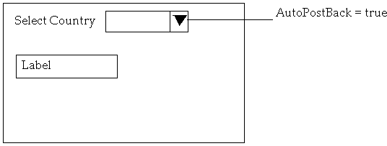
→ Add the namespaces after all ‘using’ statements
using System.Globalization; using System.Threading;

→ Write the following code:
// page_Load
if (Page.IsPostBack == false)
foreach (CultureInfo ci in CultureInfo.GetCultures(CulturesTypes.AllCultures);
{
ListItem li = new ListItem();
li.Text = ci.DisplayName; // Telugu(India)
li.Value = ci.Name; //te-IN
DropdownList1.Items.Add(li);
}
//D.click on DropdownList
→ String Culture = String.Empty();
Try{
Culture = DropdownList1.SelectedItem.Value;
CultureInfo ci = new CultureInfo(culture);
Thread.CurrentThread.CurrentCulture = ci;
Thread.CurrentThread.CurrentUICulture = ci;

lblPreview.Text = “Language: ” + ci.NativeName + “<br>Culture: “ + ci.Name + “<br>Date: ” + DateTime.Now.ToLongDateString() + “<br>Currency: ” + String.Format(“{0:C}”, 12345);
}
Catch(Exception ex)
{
lblPreview.Text = “Error: “
}

Localization:
It is used to project the information on the user interface by reading the values present at the relevant satellite assembly resource file based on the culture assigned for the current processing thread.

Satellite assembly resource files:
These are XML documents which maintains the resource information of the form for specific cultures.
Note:*The contents and filename of satellite assembly resource file is case sensitive.
*In order to support ‘N’ number of cultures by the application then ‘N+1’ satellite assembly resource files should be created.
*The filename for the resource file for a specific culture should be in the following format.
“FileName.xx-XX.resx”
e.g:
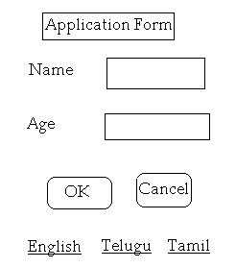
→ Solution Explorer
→ R. click on Application name
→ Add Asp.Net Folder
→ Select ‘App_GlobalResources’
→ R.click on ‘App_Globalresources’
→ Add New Item
→ Under Templates, select ‘ResourceFile’
→ Specify Name: myResource.resx (case sensitive)
→ Click ‘Add’
→ myResources.resx & myResource.en-US.resx
Name | Value
lblHeader | Application Form
lblHeaderColor | Silver
lblName | Name
lblAge
btnok | OK
btncancel | Cancel
→ For Telugu: myResource.te-IN.resx
Name | Value
lblHeader | Darakasthu
lblHeaderColor | Gold
lblName | Peru
lblAge | Vayasu
btnok | Sere
btncancel | Vadhu
→ For Tamil: myResources.ta-IN.resx
Name | Value
lblHeader | Manavi
lblHeaderColor | SeaShell
lblName | Peyar
lblAge | Vayadhu
btnok | Sari
btncancel | Vandum
→ Add New webform
→ Design form as follows:
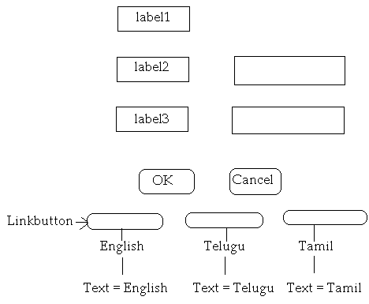
→ Select ‘Label1’
→ Properties
→ ‘Expressions:’ click on ellipse
→ Under ‘Bindable Properties’
→ Select ‘Text’
→ ExpressionType : Resources
→ ClassKey : myResource (without extension)
→ ResourceKey : lblHeader
→ Select ‘BackColor ‘
→ ExpressionType : Resources
→ ClassKey : myResource (without extension)
→ ResourceKey : lblHeaderColor
→ Click ‘OK’
→ Repeat the same steps for all the controls and provide relevant data
→ //For English button click
Response.Redirect(“default.aspx?lid=en-US”);
→ // For Telugu button click
Response.Redirect(“default.aspx?lid=te-IN”);
→ // For Tamil button click
Response.Redirect(“default.aspx?lid=te-IN”);
→ To globalize:
After all using statements:
using System.Globalization;
using System.Threading;
→ Need to Initialize the culture:
→ Above the Page_Load, write the following code:
protected Override void InitializeCulture()
{
String culture = String.Empty();
Culture = Request.QueryString[“lid”];
if (Culture == Null)
Culture = “en-IN”;
CultureInfo ci = new CultureInfo(culture);
Thread.CurrentThread.CurrentCulture = ci;
Thread.CurrentThread.CurrentUIculture = ci;
}
→ Execute
Webform to project Telugu Alphabets:
→ Place a Label on the webform
→ Write the code in Page_Load
//Page_Load
for (int i=3000;i<=3200; i++)
lblPreview.Text = “&#” + i.ToString() + “;” ; //&#3150
→ Execute
Themes, skins and Style sheets:
Theme: It is a collection of Stylesheets and the skin files.
Note:
*A website can have any no. of themes.
*The collection of all themes present within th website should be maintained within App_Themes folder.

Stylesheets: It is used to build the styles for the HTML tags present within the webform.
Note:
*Stylesheets can also be applied for the Webserver controls.

To build a Stylesheet file:-
1) tagName 2) #idName 3) .ClassName
{ { {
//Style(s) //Style(s) //Style(s)
---------- ----------- -----------
---------- ----------- -----------
} } }
→ New website
→ Solution Explorer
→ R.click on the Application name
→ Add
→’ASP.Net Folder’
→ Theme
→ Give name to Theme: myTheme
→ Solution Explorer
→ R.Click on ‘myTheme’
→ Select ‘Add New Item’
→ In Templates window, select ‘Stylesheets’
→ Name: StyleSheet.css’ (css → Cascading Style Sheet)
→ Click ‘Add’
→ body { }
→ Click ‘BuildStyle’
→ ‘Style build’ window
→ Set the properties as required
→ Then automatically, code will be generated
→ .btnclass { }
→ Click ‘BuildStyle’
→ ‘Style build’ window
→ Set the properties as required
→ Then automatically, code will be generated
→ #txtuser { }
→ Click ‘BuildStyle’
→ ‘Style build’ window
→ Set the properties as required
→ Then automatically, code will be generated
→ Save
→ Design the form as follows:
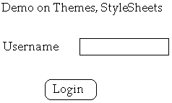
In order to apply the Stylesheets and Themes for the ASP.Net website:
→ Under the properties window: Select Documents
→ Theme: myTheme
→ Select the name of the theme
→ Stylesheet Theme: myTheme
To apply the styles for the server controls:
→ Select the control for which we want to apply
→ Open properties window
→ cssClass: btnclass

Skin Files: It is used to build the styles for the ASP.Net server controls. It is not binded for any control.
Note:
*The extension for the Skin File should be ‘.skin’.
To invoke Skin Files:
→ Solution Explorer
→ R. Click on ‘myTheme’
→ Add New Item
→ Select Template called ‘SkinFile’
→ Name: SkinFile.skin
→ Click ‘Add’
→ Generally, we have to write the HTML code here. Alternatively, in another form drag and drop the control to which we want to apply the skin file, and go to the source code of that control and copy the html code and paste in your Skin file.
→In pasted HTML code, remove any phrases – ‘Id’ and ‘Text’
→Select the relevant theme
o apply the theme for the entire website:
→ Solution Explorer
→ Web.config file
→ Search for the tag ‘<Pages>’
→ Write the code as follows:
<Pages Theme=”myTheme” StyleSheet Theme=”myTheme”/>

Master Pages
Master Pages: It is used to create a template for the website such that all the webforms present within the site can use that template.
Note:
*The webforms which are created based on the MasterPage file is called as ContentPage.
*A website can have any no. of Master Pages.
*The extension for the Master file is ‘.master’.
*Master page can be nested. i.e. one master page can be developed based on other master page.
E.g:
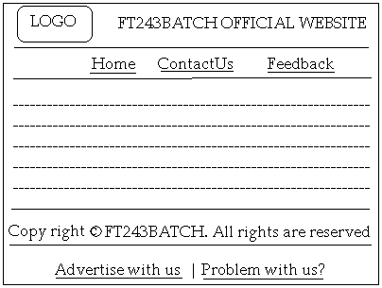
To design the Master Page:
→ Website
→ Add New Item
→ Select ‘Master Page’ Template
→ Name: MasterPage.master
→ By default, one contentpage will be there. Delete it.
→ It will ask the confirmation, click ‘Yes’
→ Take a table (5,2)
→ 1st Row: Allignment: Center
→ Place an ‘Image’ control
→ Resize the image size
→ Go to properties of Image control
→ ImageUrl: (specify the name of the image)
ImageAllign: AbsMiddle
→ Place a Label
→ Provide the text as ‘FT243BATCH OFFICIAL WEBSITE’
→ 2nd Row: Allignment: Centre
→ Place three HyperLink controls side by side
→ HydperLink1:
Text: Home
NavigateUrl: Default.aspx
→ HyperLink2:
Text: ContactUs
NavigateUrl: Contact.aspx
→ HyperLink3:
Text: Feedback
NavigateUrl: Feedback.aspx
→ 3rd Row: Place a ‘ContentPageHolder’ control
→ 4th Row: type the text as required
(For getting the copy right symbol, go to the source code and write the code as: &copy)
→ 5th Row: Alignment: Center
→ Place two ‘HyperLink’ controls
→ Hyperlink1:
Text: Advertise with us
NavigateUrl: mailto:adds@ft243batch.com
→ HyperLink2:
Text: Problem with us?
NavigateUrl: mailto:problems@ft243batch.com
→ After designing, click ‘source’ tab
→ <title>FT243BATCH</title>
→ <body leftmargin=”0” topmargin=”0”>

To design a content page:
→Website menu
→ Add New Item
→ Webform Template
→ Name: ContentPage.aspx
→Check the checkbox: ‘☑ Select the Master Page’
→ Click ‘Add’
→ Select ‘MasterPage.master’
→ Click ‘OK’
→ Design the content page as per the requirement

Converting an existing webform as a ContentPage:
→ Properties window of that webform (e.g: Default.aspx)
→ For Document Properties:
→ Click ‘MasterPageFile’
→ Select the required Master Page (e.g: MasterPage.master)
→ Click ‘source’ tab
→ After ‘---sss
→ Click on ‘content tasks’ of contentPageHolder control
→ Select ‘Create custom content’
→ Design as per the requirement
→ Execute
SiteMap: It is a new feature introduced in ASP.Net 2.0 for providing efficient method for navigating within the website.
Note:
*To create SiteMap, ‘SiteMap’ files are used.
*SiteMap File: It is an XML document which maintains the information of the SiteMap nodes to which the user has to be navigating within the website.
*A website can have maximum of only one SiteMap File.
*The extension for the SiteMap File with will be “.sitemap”.
*In order to consider the SiteMap File as a data source for the site navigation controls then “SiteMapDataSource” should be used.
E.g.:
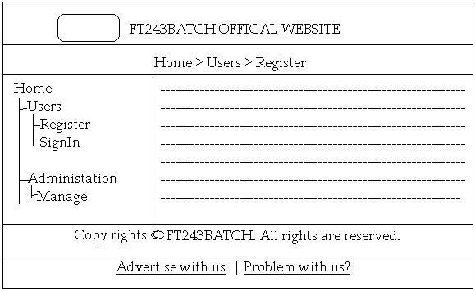
*To create a SiteMap File:
→ Website Menu
→ Add New Item
→ Under the templates, select ‘SiteMap’
→ Name: Web.sitemap
→ Click ‘Add’
→ Remove the code in sitemap file
→ In Web.sitemap, write the following code
<?xml version=”1.0” encoding=”utf-8”?>
<sitemap xmlns=http://schemas.microsoft.com/ASPNet/siteMap-File-1.0>
<SiteMapNode title = “Home” url = “Default.aspx” description = “Welcome to FT243BATCH Official Site”>
<SiteMapNode title = “Users” description = “Welcome to users section”>
<SiteMapNode title = “Register” url = “Register.aspx”/>
<SiteMapNode title = “SignIn” url = “Login.aspx”/>
</SiteMapNode>
<SiteMapNode tilte = “Adminstration” description = “Welcome to Administration section”>
<SiteMapNode title = “Manage” url = “Manage.aspx”/>
</SiteMapNode> </SiteMapNode>
</SiteMapNode>

To create MasterPage:
→ Website menu
→ Add New Item
→ Select ‘MasterPage’ template
→ Click ‘Add’
→ ‘Design’ Tab
→ Place ‘TreView’ control and design the Master Page and relevant content pages as per requirement

Exporting a website as a template:
→ File Menu → Export Template → Project Template
→ Name of the Project: (specify the name of the project)
→ Select Language: (VB / C#) → Click ‘Next’ → Select template icons (.ico)
→ Specify template name to appear → specify description to display
Caching
It is used to maintain the result or output of the webform temporarily such that for any no. of client’s requests the response will be provided from the cache page instead of processing the request.
Note:
*ASP.Net supports two types of caching.
1. Client side caching
2. Server side caching
1. Client side caching:
If the cache page is maintained at the client system temporarily then it said to be client side caching.
Note:
*By default, ASP.Net sets client side caching for all the webforms.
*In order to kill the cache page at the client system then
Response.Expires = -1; should be used.

2. Server side caching:
If the cache page is maintained at the Webserver then it is said to be server side caching.
ASP.Net supports the following server side caching mechanisms.
- Page Output cache
- Page Fragmentation cache
- Substitution cache
- Data cache
Note:
*Server side caching should be used iff the following two features are supported.
1. The contents of the webform should be static.
2. The no. of requests should be more for a specific period of time.

1. Page Output cache:
Whenever the client sends the request for the first time then the page is processed and maintains the entire output of the request as a cache page and provides the page as the response for any no. of further clients’ request.
To Set: <%@ OutputCache Duration=”seconds” VaryByParm=”ControlName|Variable|none” %>

E.g: Table (2,1)
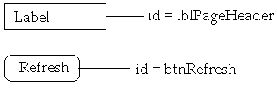
//Page_Load
lblPageHeader.Text = “Page Loaded at “ + DateTime.Now.ToString();

→ Click ‘Source’ tab
→ After Page directive tag, write the following
<%@ OutputCache Duration=”120” VaryByParm=”none”%>
→ Execute
→ Then for different browsers requesting this page, will get the same output.
VaryByParm: If set with the value, then for every unique value assigned for that attribute an individual cache page will be created for every unique values maintained at the server.
E.g:
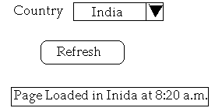
→ Table (3,1)
→ // Page_Load
If (Page.IsPostBack == true)
{
Lblmsg.Text = “Page Loaded “ + txtcountry.Text. + “:” + DateTime.Now.ToString();
}
→ Click on ‘Source’ Tab
→ After Page Directive tag, write the following code:
<%@ Ouputcache Duration=”120” VaryByParam=”txtcountry”%>

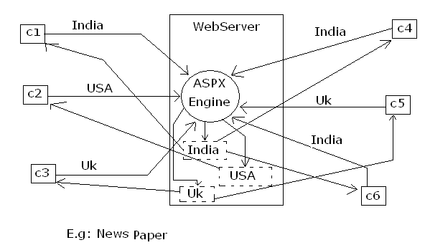

2. Page Fragmentation Cache:
It is used to maintain a part of the webform content as a cache content allows the other part of the webform to be processed.
Steps to design a webform with Page Fragmentation:
    - Add a WebUser control and design the control with the data to be maintained as cache content and write the code as per the requirement.

WebUser control: It is used to design a reusable web component such that the control can be used anywhere within the webforms present within the website.
    - Set the OutputCache for the WebUser control.
    - Add the webform and design the webform as per the requirement and use the WebUser control as a server side control within the form.

E.g.:
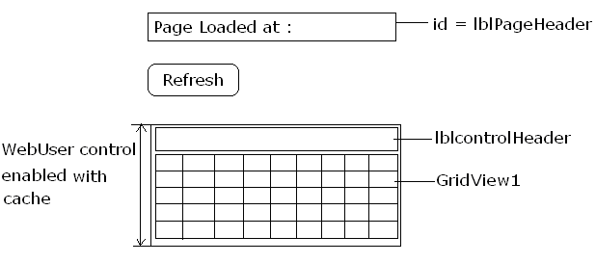
→ Website menu
→ Add New Item
→ Select the template ‘WebUser Control’
→ Name: wuc.ascx
→ Click ‘Add’
→ Click ‘Design Tab’
→ Take Table (2, 1)
→ Design the form as shown in above example
→ {This content can be used from any webform within the website}
→ Write the following code: 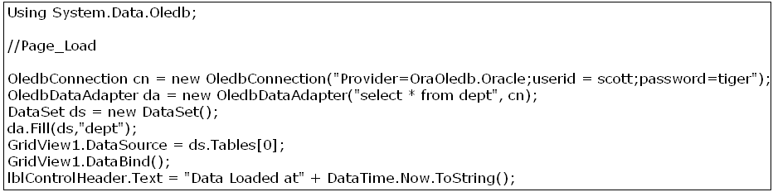
→ Select ‘web.ascx’
→ Click ‘Source’ Tab
→ After control directive, write the following code:
<%@ OutputCache Duration = “120” VaryByParm=”none”%>
→ Website menu
→ Add New Item
→ Webform
→ Design the webform as requirement
→ Solution Explorer
→ Select the required ‘WebUser control file’ {web.ascx}
→ Drap and drop on the form
→ Write the following code:
// Page_Load
lblPageHeader.Text = “Paged Loaded at: “ + DateTime.Now.ToString();
→ Execute

H.w:
i) Put duration for Label header as 200 seconds and WebUser control as 20 seconds and observe the behaviour.
ii) Put duration for Label header as 20 seconds and WebUser control as 200 seconds and observe the behaviour.

3. Substitution cache:
It is a new feature introduced in ASP.Net 2.0 for maintaining a specific part of the webform as dynamic information and to allow the rest of the webform output to be cached.
Note: *To achieve substitution caching, ‘Substitution control’’ is newly introduced.
*In order to achieve substitution cache, the ‘Methodname’ property of the substitution control should be set with ‘Public static’ method.
*The method which is binded with the substitution control should accept ‘Http Context’ class variable as an argument and the method has to return string information.
→ Create a table in the SqlServer as follows:
Create table ft243flashnews
( Msg varchar2(100)
);
→ Insert the values into the table
Insert into ft243flashnews
Values (‘ASP.Net 3.5 LIVE PROJECT CLASSES WILL COMMENCE SHORTLY’)
e.g:
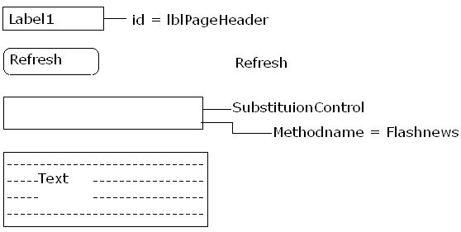
→ Write the code as below:
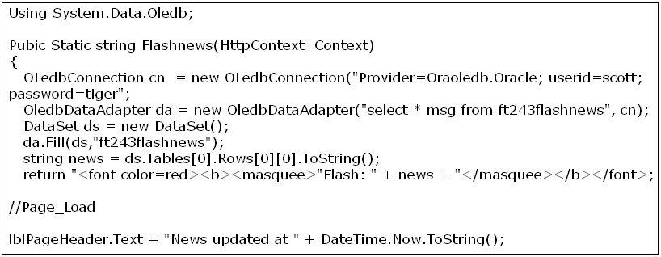
→ Click on ‘Source’ tab
→ After the Page Directive tag, write the following code
<%@ OutputCache Duration = “120” VaryByParm = “none”%>
→ Execute
→ Update the table and execute once again to see the difference.

4. Data Cache: It is used to maintain the memory variable or an object as the cache content.
To set the data cache:
1st method: Cache[“key”] = value;
Note: If the cache has been set using the above method then it is said to be ‘Low Level Cache’.
2nd method: Cache.Insert(“key”, value);
Note: If the data cache has been set using the above methods, it is said to be ‘High Level Cache’.
*To read the value from the cache as an object:
ObjectName = (ClassType) Cache[“key”];
E.g:
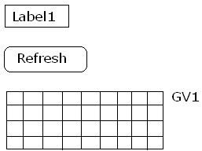
→ Write the following code:
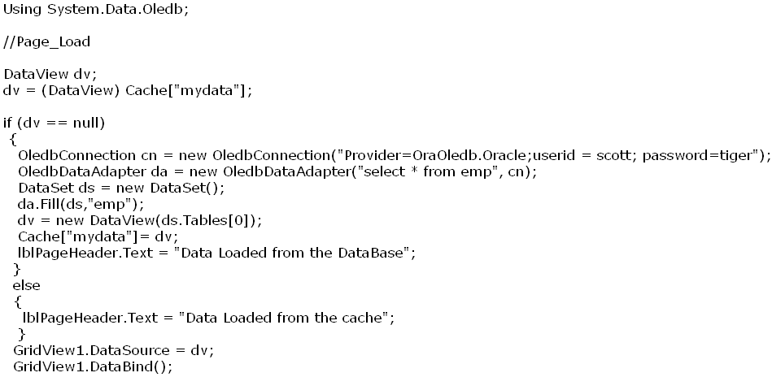
→ Execute
Cache Dependency:
It is used to expire the cache based on the file which has been binded with the cache Dependency object.
Note:
*If the contents of the file are modified then the cache will be expired else the data will be projected from the cache.
*Since, the data cache depends on the file this is also called as file based Cache Dependency.
*In order to set the data cache based on Cache Dependency:
CacheDependency <CDobject> = new CacheDependency(Filename);
Cache.Insert(Key,value,<CDobject>);
→Website menu
→ Add New item
→ XML File
→ Name: emp.xml
→ Write the following in xml file:
<Employees>
<Employee>
<Empno>101</Empno>
<Ename>Giri</Ename>
<Deptno>10</Deptno>
</Employee>
<Employee>
<Empno>102</Empno>
<Ename>Babu</Ename>
<Deptno>10</Deptno>
</Employee>
</Employees>
→ Save the XML document
→ Add a webform
→ Design the form as follows:
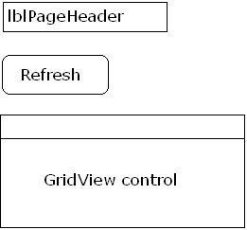
//Page_Load
DataView dv;
dv = (DataView) Cache[“myxmldata”]
if (dv == null)
{
DataSet ds = new DataSet();
Ds.Readxml(Server.MapPath(“emp.xml”);
dv.new DataView(ds.Tables[0]);
CacheDependency cd = new CacheDependency(Server.MapPath(“emp.xml”)
Cache.Insert(“myxmldata”, dv,cd);
lblPageHeader.Text = “Data loaded from the XML document.”;
}
else
{
lblPageHeader.Text = “Data loaded from the cache”;
}
GridView1.DataSource = dv;
GridView1.DataBind();

Using CacheDependency with respective to the database:
→ Website menu → Add New Item → Text File
→ Name: log.txt
→ If you take a new webform design the same:
→ Using System.Web.Caching; Using System.Data.Oledb;
//Page_Load
DataSet ds;
ds = (DataSet) Cache[“myoradata”];
if (ds == null)
{ OleDbConnection cn = new leDbConnection(“provider=OraOledb.Oracle; user id = scott; password = tiger”);
OleDbDataAdapter da = new OleDbDataAdapter(“select 8 from emp”, cn);
ds = new DataSet(); da.Fill(ds,”emp”);
CacheDependency cd = new CacheDependency(Server.MapPath(“log.txt”));
Cache.Insert(“myoradata”,ds,cd);
lblPageHeader.Text = “Data Loaded from the database”;
}
else
lblPageHeader.Text = “Data loaded from the Cache”;
GridView1.DataSource = ds.Tables[0];
GridView1.DataBind();
Time Base Cache Expiration:
It is used to expire data cache based on the absolute timestamp.
Syntax:
Cache.Insert(key,value,CDobject,ExpirationDateTime,Silding Time Span);
E.g:
Cache.Insert(“myoradata”, ds, cd, DateTime.Now.AddMinutes(20), TimeSpan.FromMinutes(5));

Limitation:
The above file base cache dependency and time base cache dependency will work based on the file binded with the cache dependency object but if the data base tables are modified then the cache dependency will not work.

SqlCacheDependency:
It is used to send the cache based on the data base tables.
Note:
*If SqlDataSource is used for projecting the data then implicitly the data will be cache using SqlCacheDependency.
*SqlCacheDependency is currently supported for SqlServer data base only.
*If SqlServer 7.0 or SqlServer 2000 is used then SqlCacheDependency will not work if the database table rows are affected the cache dependency is supported if and only if data base table definitions are modified.
*SqlCacheDependency work efficiently on SqlServer 2005 onwards. That is, if SqlServer 2005 data table rows are modified then implicitly the data cache will be expired.
Navigation:
→ App_Data
→ R.click
→ Add New Items
→ From the templates window
→ Select SQL Server Data Base
→ Name of the Data base: cache.mdf
→ Click ‘Add’
→ Server Explorer
→ Database Diagrams
→ Tables
→ Add New table
eno int (primary key)
ename varchar(50)
sal money
deptno int
Name of the table: emp
→ Click ‘OK’
→ R.click on the table name
→ Show table data
101 Giri 1000 10
102 Kalyan 2000 20
103 Anil 3000 20
→ In web.config file
<ConnectionStrings>
<add name = “Cache” ConnectionSrings = “DataSource = .\SQLEXPRESS;AttachDbFileName= |DataDirectory|\Cache.mdf;
integrated security = true; user Interface = true”
provdername = “System.Data.SqlClient”/>
</ConnectionStrings>
→ Write the code as follows:
Using System.Data.SqlClient;
Using System.Web.Caching;
//Page_Load
DataSet ds;
ds = (DataSet) Cache[“mysqldata”];
if (ds == null)
{
SqlConnection cn = new SqlConnection(ConfigurationManager.ConnectionStings[“Cache”].ConnectionSting);
SqlCommand cmd = new SqlCommand(“select * from emp”, cn);
SqlDataAdapter da = new SqlDataAdapter();
da.SelectCommand = cmd;
ds = new DataSet();
da.Fill(ds,”emp”);
SqlCacheDependency scd = new SqlCaheDependency(cmd);
Cache.Insert(“mysqldata”, ds, scd);
lblPageHeader.Text = “Data Loaded from the database”;
}
else
lblPageHeader.Text = “Data Loaded from the Cache”;
GridView1.DataSource = ds.Tables[0];
GridView1.DataBind();
Security
It is used to provide the security for the application.
Note: ASP.Net supports the following security features.
- Forms Authentication
- Windows Authentication (Default)
- Passport Authentication

Forms Authentication:
It is used to provide the security for the Intranet and Internet based applications.
To set the Forms Authentication as the security for the ASP.Net website, configure ‘<authentication>’ and ‘<authorization>’ tags present at the web.config file.
<authentication>: It is used to specify the authentication mode to be used by the ASP.Net website and also used to specify the password format to be used for encrypting the passwords and also it acts like a database for storing the user information.
Syntax: (Case sensitive)
<authentication mode = “Forms”>
<forms loginUrl = “______”>
<credentials password format = “MD5|Sha1|Clear”>
<user name = “ “password = “ “/>
-----------------------
-----------------------
</credentials>
</forms>
</authentication>
→Where ‘MD5’ means ‘Master Digit 5 and
‘Sha1’ means ‘Secured Hash Algo 1’
<authorization>: It is used to allow or deny the user from accessing the webforms present within the website.
Syntax: 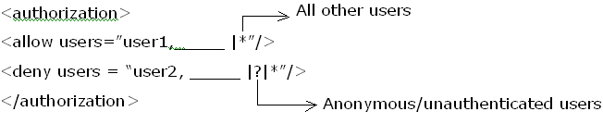
In order to set Forms Authentication programmatically ‘System.Web.Security.FormsAuthentication’ class should be used.

Authentication(username, password):
It accepts the user credentials and validates the user information and returns true if the provided information belongs to a valid user else the method returns false.
RedirectFromLoginPage(username,booleanvalue):
It is used to redirect to the requested page from the login page.
Note: If ‘true’ is passed as the Boolean value then user information is stored permanently at the client system as an Http Cookie and if ‘false’ is passed as the Boolean value then user information is stored temporarily.
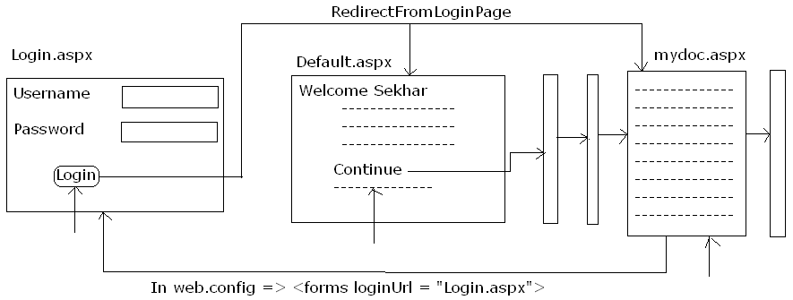

Note:
*Whenever the requested page and the login page are different then RedirectFromLoginPage will redirect to the requested page.
*If the requested page and the login page are same then the RedirectFromLoginPage will redirect to ‘Default.aspx’ page.
*If ‘Default.aspx’ page is not present within the website then ASP.Net runtime will raise an error.

HasPasswordForStoringInConfigFile(passwordsting, “Sha1|Md5”):
It is used to encrypt the password string in Sha1 or Md5 format.
SignOut(): It is used to logout the user from the website.
‘User.Identity.Name’ property: Returns the name of the user logged within the website.
e.g:
→ File menu → New → Website → Security → Click ‘OK’
→ In web.config file, search for tag called ‘<authentication>
→ Below that tag write the following code:
<authentication mode = “Forms”>
<forms loginUrl = “Login.aspx”>
<credentials passwordFormat = “clear”>
<username = “Ram” password = “Prasad”/>
<username = “surya” password = “suresh”/>
</credentials>
</forms>
</authentication>
<authorization>
<allow users = “Ram”/>
<deny users = “*”/>
</authorization>
→ Add a new webform
→ Name: Login.aspx
→ Click ‘OK’
→ Design the Login form
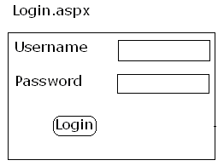
→ Using System.Web.Security;
→ // Login Button Click
If (FormAuthentication.Authenticate(txtuser.Text, txtpwd.Text) == true)
{ FormsAuthentication.RedirectFromLoginPage(txtuser.Text, CheckBox.Checked);
}
else { Lblerror.Text = “Invalid user name or password”; }
→ Design the form as follows for Default.aspx
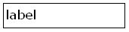
//Page_Load (Default.aspx)
string usr;
usr = User.Identiy.Name;
lblHeader.Text = “Welcome <font color=red>” + usr + “</font>”;

A webform for encrypting the password:
→ Take a new webform
→ Design the form as follows:
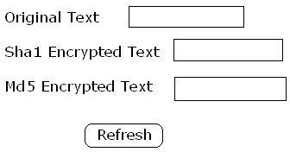
→ Using System.Web.Security;
//Encrypt button click
txtsha1.Text=FormsAuthentication.HasPasswordForStoringInConfigFile(txtoriginal.Text,“Sha1”);
txtMd5.Text=FormsAuthentication.HashPasswordForStoringInConfigFile(txtoriginal.Text, “Md5”);

A webform for understanding the structure of web.config file:
→ Design the form as follows:
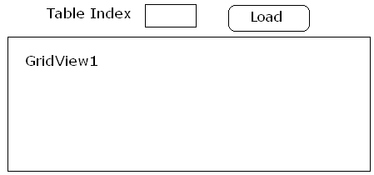
→ // Load_Button_Click
DataSet ds = new DataSet();
ds.Readxml(Server.MapPath(“web.config”));
int index;
tindex = int.Parse(txttableindex.Text);
GridView1.DataSource = ds.Tables[tindex]; GridView1.DataBind();
e.g: Registration Form
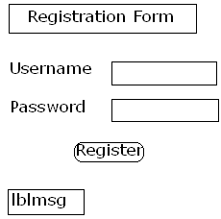
// Register_button_click
Using System.Web.Security;
try {
DataSet ds = new DataSet();
ds.Readxml(Server.MapPath(“./../web.config”));
DataRow row;
row = ds.Tables[0].NewRow();
row[0] = txtuser.Text;
row[1] = formsAuthentication.HashPasswordForStringConfigFile (txtpwd.Text,”Md5”);
row[2] = 0;
ds.Tables[11].Rows.Add(row);
row = ds.Tables[13].Rows[0];
row.BeginEdit();
row[0] += “,” + txtuser.Text;
row.EndEdit();
ds.Writexml(Server.MapPath(“web.config”));
lblmsg.Text = “User Registered”;
}
catch(Exception ex)
{ Lblmsg.Text = “Error: “ + ex.Message;}
Note: If still the registration form cannot be displayed, we have to create a folder and should place this form in that folder.
→ R.Click on application name
→ Click ‘New Folder’
→ Name: UnrestrictedPages
→ Drag and drop the forms into this folder which users can access directly
→ R.click on UnresrictedPages
→ Select ‘Add New Item’
→ Select ‘Webconfiguration File’
→ Click ‘Add’ (we can have any no. of web.config files )
→ within the tag called <System.web>
<authorization>
<allow users = “*”/>
</authorization>

Limitations of Forms Authentication:
*Since the user information is maintained within the web.config file, if the no.of users are more then the performance of the site will be decreased.
*Maintaining user information using Forms Authentication 1.x feature is very complex.

→ ASP.Net 2.0 has introduced the following new controls to support Forms Authentication.
1. LoginView: It is a collection of templates which is used to provide different view for the webform based on the user credentials supplied.
→Templates present in LoginView are:
*Anonymous template
*LoggedIn template
2. LoginName: It is used to return the name of the use logged within the application.
Note: It is same as ‘User.Identity.Name’.
3. LogiStatus: It is used to return the status of the user and allow the user to logon or logout based on the status of the user.
4. Login: It is used to provide the login form.
5. CreateUserWizard: It is a wizard control used to provide the registration form.
6. ChangePassword: It is used to update the user password with the new password after validating the user credentials.
7. PasswordRecovery: It is used to obtain the user password with the new password after validating the user security information and also sends an email to the email Id specified at the time of user registration.
E.g:
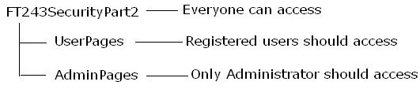
→ File Menu → New
→ Website
→ ASP.Net Website
→ Name:FT243SecurityPart2 → Solution Explorer
→ R.Click on application name (FT243SecurityPart2)
→ Select ‘New Folder’ → Name: UserPage
→ Similarly, follow the same navigation to add other folders
→ Add the one more folder Name: AdminPages
→ Click ‘ASP.Net Configuration’ Tab
→ ASP.Net configuration website tool will be displayed
→ Click on ‘Security’ Tab
→ Click ‘User Security Setup wizard to configure security step by step’
→ Step1: Welcome message will be displayed
→ Click ‘Next’ directly
→ Step2: Select Access Method
→ Select the RadioButton ‘From the internet’
(This is for Forms Authentication)
→ Click ‘Next’
→ Step3: Data Store
→ Click ‘Next’ directly
→ Step4: Define Roles
→ Check the checkbox:
☑ Enable roles for this website
(Wait up to getting the refreshed page)
→ Click ‘Next’
→ Specify New Role Name: RegisteredUsers
→ Click ‘Add’
→ Specify New Role Name: Administrator
→ Click ‘Add’
→ Similarly, add required roles
→ Click ‘Next’

→ Step5: Add New Users
→ User Name : Administrator
→ Password : admin123#
→ Email : admin@ft243.com
→ Security question : My role
→ Security answer : Master
→ Click ‘Create User’
→ Click ‘Next’
→ Step6: Add New Access Rules
→ For FT243SecurityPart2:
Permission Users and Roles
Allow
→ For AdminPages:
Permission Users and Roles
Allow Administrator (Role)
Deny
→ For UserPages:
Permission Users and Roles
Allow Administrator (Role)
Allow RegisteredUsers (Role)
Deny
→ Click ‘Next’
→ Step7: Complete
→ Click ‘Finish’ directly then we will go to the home page
→ Under ‘Users’ heading, click on ‘Manage Users’
→ Click ‘Edit Roles’ for the AdminUser
→ Check ☑ Administrator
→ Click ‘Back’ and then we will go the home page
→ Click ‘Application’ Tab
→ Under ‘SMTP settings’, click ‘Configure SMTP email setting’
→ Sever Name : TIGER → Port : 25 (default for SMTP Settings)
→ From : support@tiger → Click ‘Save’
→ Click ‘OK’
Note: The above steps will configure the ASP.Net website for using Forms Authentication and also creates roles and membership information and also it creates the database tables and stored procedures needed for supporting the security.
Sample Website to demonstration of Forms Authentication:
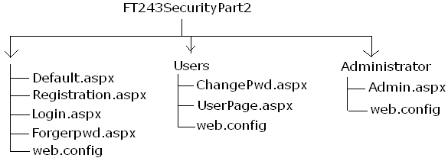
Design the website:
Default.aspx:
→ Place LoginTab control and LoginView control
→ Click on ‘LoginView’ tasks
→ Select the Views : Anonymous template
→ Within a LoginView: Take a table
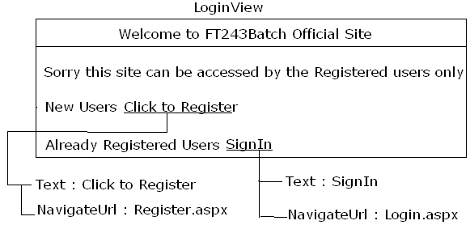
→ LoginView Tasks
→ Select : Views: LoggedIn Template 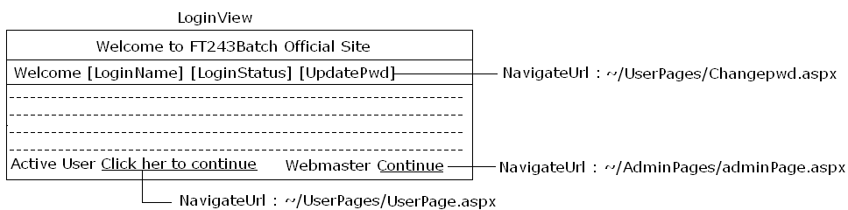
Register.aspx:
→ R.click on application name
→ Add New Item → Select Webform
→ Name : Register.aspx
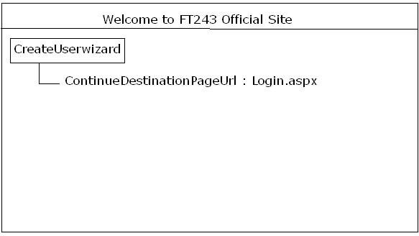
Login.aspx:
→ R.click on Application name
→ Add New Item
→ Webform : Login.aspx
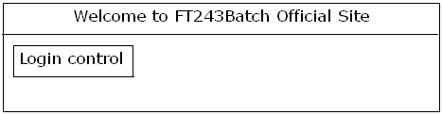
Login control properties:
DestinationPageUrl : Default.aspx
PasswordRecoveryText : Forgotpassword?
PasswordRecoveryUrl : Forgotpwd.aspx
Forgotpwd.aspx:
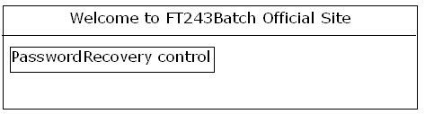
Properties to set:
→ Expand ‘MailDefinition’
→ From : support@ptpl
→ IsBodyHTML: False
→ Priority : High
→ Subject : Your new password for FT243Batch site
→ SuccessPageUrl : Login.aspx

ChangePwd.aspx:
→ R.click on UserPages
→ Add New Item
→ Webform : ChangePwd.aspx
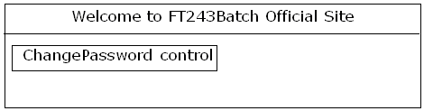
Properties: ContinueDestinationUrl : Login.aspx

UserPage.aspx:
→ R.click on UserPages
→ Add New Item
→ Webform : UserPage.aspx
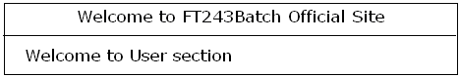
AdminPage.aspx:
→ R.click on AdminPages
→ Add New Item
→ Webform : AdminPage.aspx
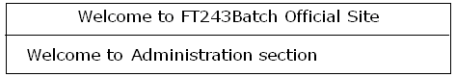
H.w: Design the same with MasterPages.
Note:
*The information stored using the above concept will be maintained at the aspnet ‘usersaspnet_users’ and ‘aspnet_membership’ tables.
*By default, the data will be stored at the SqlServer Express Edition.
*In order to configure SqlServer 2000 or above versions for storing user information:
→ In .Net Command prompt:
→ C:\>aspnet_regsql
→ ‘Welcome to ASP.Net SqlServer Setup Wizard’ will be displayed
→ Click ‘Next’
→ Select the radiobutton : ‘Configure SqlServer Application’
→ Click ‘next’
→ Server : TIGER
→ Select the required authentication (either windows / Sql Server)
→ Spcify the database (default is ‘ASPNET_DB’)
→ Click ‘Next’
→ Click ‘Next’
→ Click ‘Finish’

*To specify a custom database as the default database for ASP.Net:
→ Start → Run → inetmgr → Internet Information Services
→ Under ‘Server Name’ Select ‘Default Website’
→ Under this we will find : Name and connection Parameters
→ R.click and Select Properties
→ Click ‘ASPNET’ tab
→ Click ‘Edit Configuration’
→ Select the option which is available: Local System
→ Click ‘Edit’ → Replace the Connection String of the Server
Note:
*In order to handle roles and memberships programmatically:
Membership.Mehthodname([arginfo]) and
Roles.Methodname([arginfo]) should be used.
e.g:
Membsership.CreateUser(Username, Password, Email, PasswordQuestion, PasswordAnswer, isApproved, Status);
Roles.AddUserToRole(username, rolename);

Windows Authentication:
It is the default authentication used by the ASP.Net for providing the security for the intranet based websites by validating the user credentials registered within the network.
To set windows authentication as the security:
<authentication>
<allow Users = “Domain\username, ….|*”/>
<deny Users = “Domain\username, …. |?|*”>
</authorization>

Note:
*Whenever the user logged in the system is one among the users present at the allow users list and if that user sends a request then the requested page will be provided as the response without any login.
*Whenever the user logged in the system is not among the users present at the allow users list and if that user sends a request for the website then ASP.net runtime will invoke the network login window and iff the user supplies a valid credentials the response will not be provided.
*Windows authentication is managed by the IIS Webserver and hence if FileSystem is used as the location for the ASP.Net website then the network login window will not be displayed instead the user will get ‘Access Denied’ page as the response.
*The string at the user credentials, at the time of login and allowing the users to access the website is called as ‘Impersonation’.
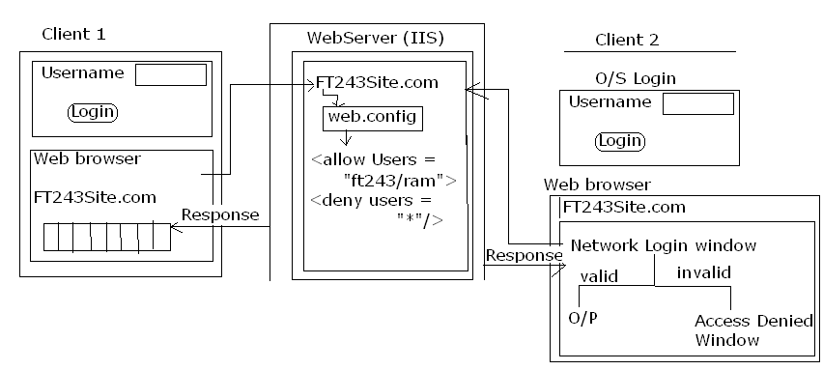
→ New Website
→ Location: Http
→ In web.config find the tag ‘authentication
<authorization>
<allow users = “ptpl\peers”/>
<deny users= “*”/>
Note:
*Windows authentication supports three types of authentications.
1. Basic authentication:
If used then the user credentials will be supplied as a clear text across the network.
Note: Performance will be very fast but not advisable to use.
2. Digest Authentication:
It is a special authentication type used for validating the Domain Network user credentials.
Note: If the network belongs to workgroup environment then this option will be disabled.
3. Integrated windows authentication:
It is the default authentication type used by the windows authentication mode in order to provide the security for the website. If used then the user credentials will be passed as a stream across the network.
Note:
*More than one authentication type can be enabled.
*To enable:
→ Start
→ Run
→ Type ‘Inetmgr’
→ Under ‘Internet Information Services’
→ We can find ‘Server Name’
→ Under this ‘Default website’
→ R.click
→ Select ‘Properties’
→ Select ‘Directory Security’
→ Under this we find ‘Anonymous Access and authentication control’
→ Click on ‘Edit’
→ Under ‘Authenication Access’ check the all the check boxes
Digest Authentication
Basic Authentication
Integrated Windows Authentication
→ Click ‘OK’

3. Passport Authentication:
It is used to maintain the same user credentials across all the partner websites which uses .Net Passport Accounts.
To Set:
In Web.config file:
<authentication mode=”Passport”>
<Passport redirectUrl = “URL|Internal”/>
</authentication>

Note:
* In order to use Passport Authentication, it is mandatory that the web server should be installed with .Net Passport software Development Kit (SDK).

Tracing
It is used to trace the flow of the application.
*ASP.net supports two types of tracing.
1. Page Level Tracing
2. Application Level Tracing

1. Page Level Tracing:
It is used to enable or disable the tracing information for any webform present within the website.
To Set:
<%@Page Language = “C#” Trace = “true|false” ........%>

2. Application Level Tracing:
It is used to enable or disable the tracing information for all the webforms preset within the website.
To Set:
In Web.config file:
<trace enabled = “true|false” requestLimt = “10” PageOutput = “true|false”/>

Methods to support tracing:
Trace.Write: It is used to write the data at he tracing information section of the trace details.
Trace.Warn: It is same as Trace.Write but the difference is the fore colour will be in red.
E.g: Place a gird view control on form


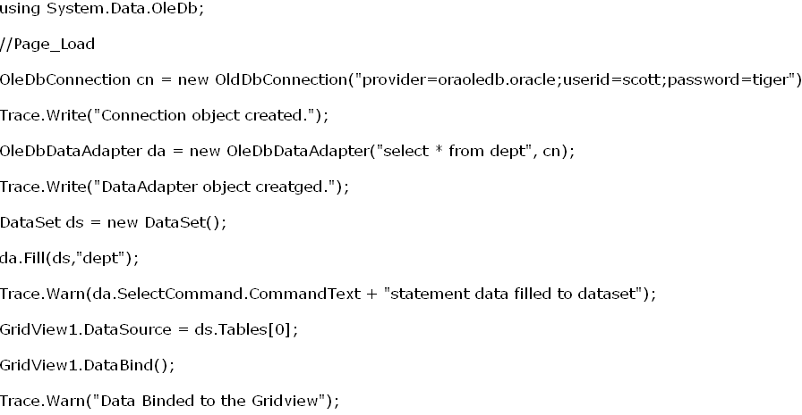
- Whenever application level and page level tracing has been set then the preference will be given to the page level tracing.
- It is advisable to disable the tracing and debugging options for the webforms for better performance.
To Set: At Page Level: Trace = “false” Debug = “false”

----------------

State Management
It is used to maintain the state of the user within the webform, across the webforms present within the website ad also used to maintain the state of all the users accessing the website.
Note:
*ASP.Net supports three types of State Management.
1. Page Level state management
2. Session Level state management
3. Application Level state management
1. Page Level State Management:
It is used to maintain the state of the controls while submitting the data to the server.
To achieve the Page Level state management ‘ViewState’ should be used.

E.g:
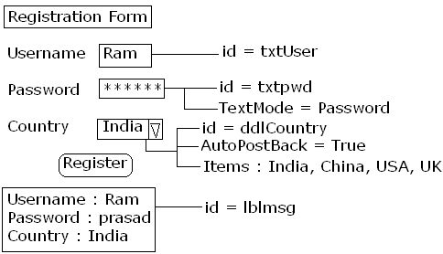
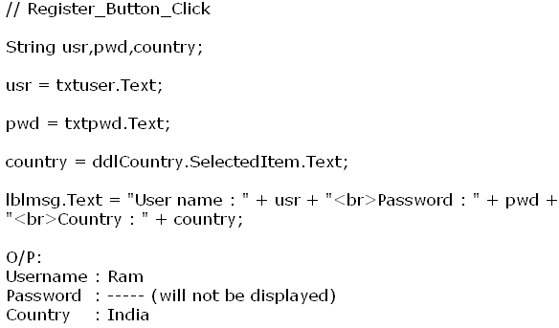
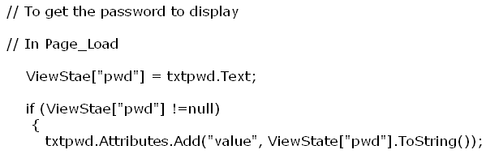

Note: Whenever the information is maintained within the ViewState then the value will be maintained within the HTML hidden field where the name of the element is “__ViewState”

2. Session Level State Management:
It is used to maintain the state of the user across the webforms present within the website.
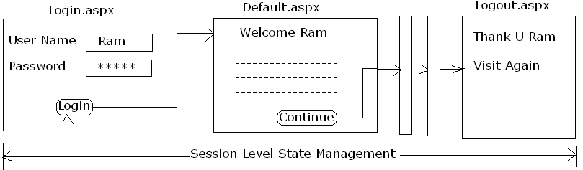
Note:
*Session Level State Management can be achieved using “session” and “Cookie”.
Session: It is used to maintain the user information across the webforms present within the website by storing the user data at the server side and identifying the relevant client using an unique identifier called as “sessionId”.
Enhancements:
- ASP.Net sessions can be either a Cookie based or CookieLess Sessions.
- ASP.Net sessions can be enabled or disabled in any webform as per the requirement.
- Session information can be maintained as an Inprocess data within the webser and also it can be maintained as a Output Process the data within the state server or SqlServer.
- To Set the Session:
Session[“variable”] = value;
Where the ‘value’ can be either a string or an object.

Note:
- If value is string then the information will be maintained by the contents collection and if and object is signed as the value then the information i.e. an object is assigned as the values then the information maintained by the ‘State Objects Collection’.
- By default, the session’s information is maintained as an Inprocess within the Webserver and cookies are used at the client system for maintaining the sessionId.
- The default expiration time for the session will be 20 minutes.
To get the value from Session:
Variable = session [“variable”].ToString90;
(Or)
Objectname = (Object Type) Session [“variable”];
E.g.:
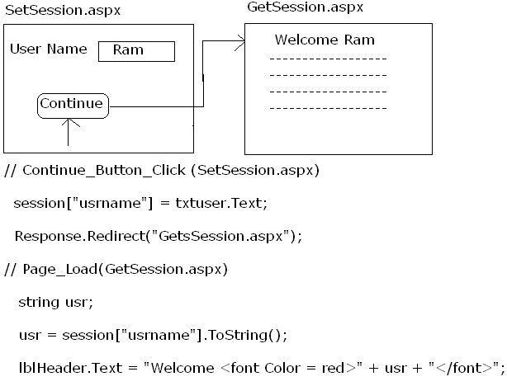
Storing Database Objects in Session:
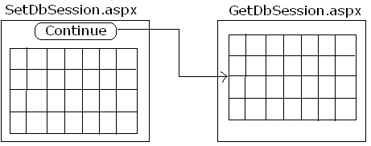
*Caching is for all the users where as Session is only for a particular user.
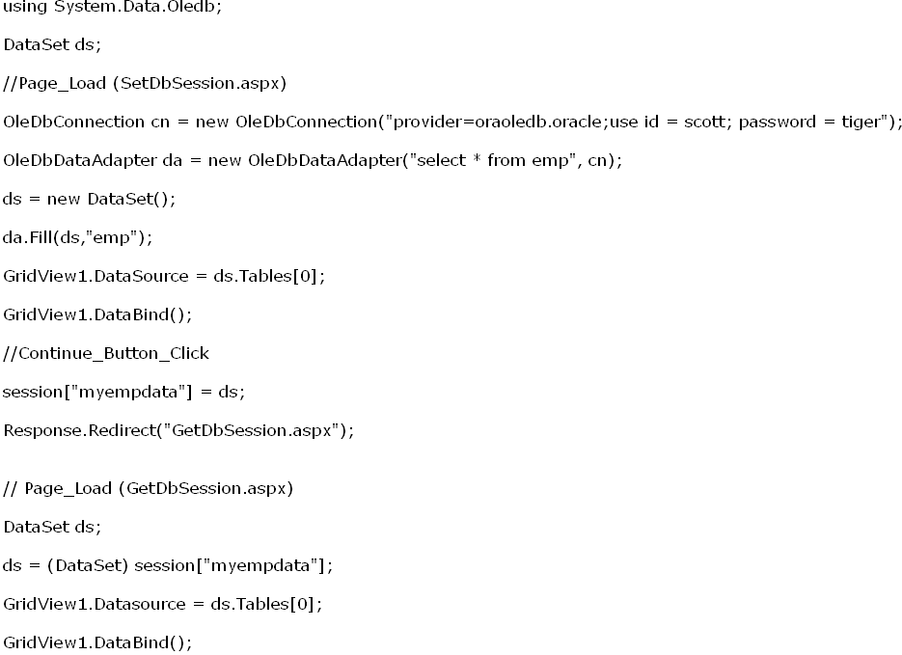

Cookie Based Session:
E.g:
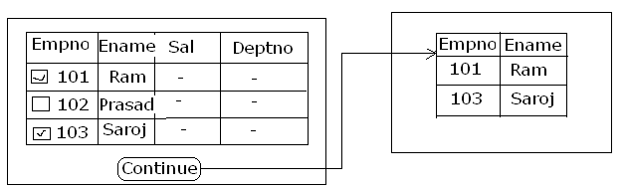
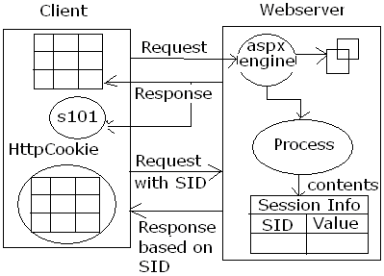

Limitation of Cookie Based Session:
*Web browsers are having the capability of blocking the cookies and if a browser has blocked the cookies then the websites which uses cookie based sessions will not function properly.
Cookie less Session: If used then instead of maintaining the session id as a HTTPCookie at the client system the session Id of the client will be passed with all the requested URL by the client.
To Set Cookie Less Session: In Web.config file:
<SessionState Mode = “InProc” CookieLess = “true”/>
[ Inproc → Inprocess]
Advantage: Websites will function properly irrespective the browser has been enabled with cookies or the has blocked the cookies.
Note: *Since the session Id is passed to all the requested URLs. If the website maintains any confidential data or secured information, it is not advisable to use Cookie Less sessions.
*Cookie Less Sessions are always faster than the Cookie based sessions.
Enabling or disabling the session:
To Do: <%@Page Language = “C#” EnableSessionState = “true|false”%>
Note:
*If EnableSessionState is set to false then sessions are disable for that form and if true is assigned then the sessions are enabled for the form.
*Default sessions are enabled for a webform.
*If sessions are disabled in any form, then in the webform session object should not be used. If used then ASP.Net Runtime will raise an error.
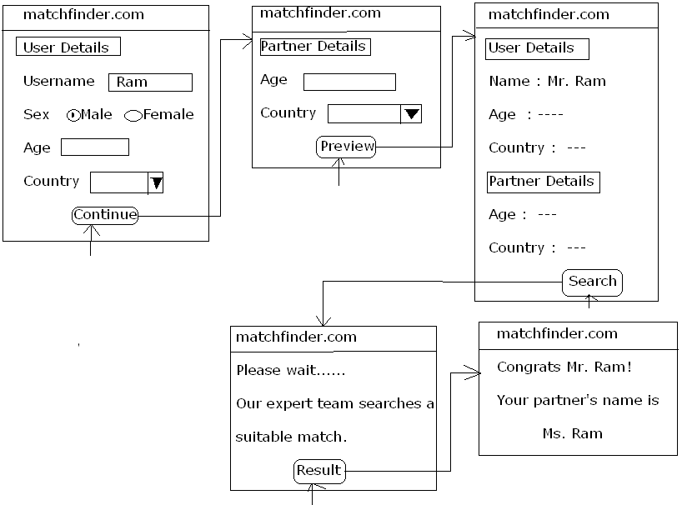
Limitation of storing the session information as an Inprocess data within the Webserver:
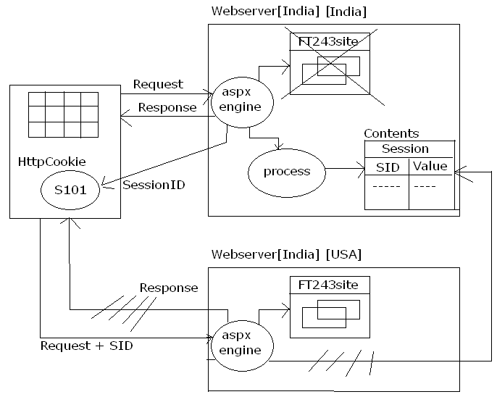
Note: Whenever the website is maintained in more than one Webserver and if the session information is stored as a InProcess data and in the server which maintains the data has been crashed then inspite the other Webserver has the website the session information can’t be read. And hence, response will not be provided.

*In order to solve the above limitation ASP.Net has introduced a new method for storing the data as an OutProcess.

Maintaining the session information as an OutProcess data:
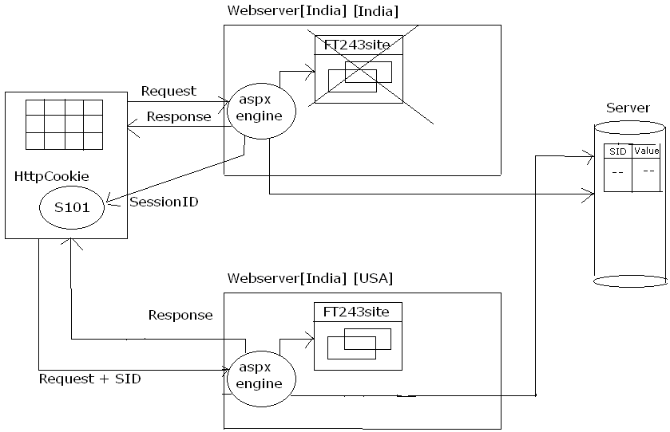
*we can store the session data within SqlServer Database only.
Maintaining the session information within SqlServer Database:
To Do: Start the SqlServer Agent Service
→ Start
→ Run
→ servicesmsc
→ Under ‘Server Name’, we find ‘Name’
→ Under ‘Name’
→ Select ‘SqlServer Agent’
→ R.click
→ Select ‘Start’

Create a database and tables needed for storing the session information:
To Do:
→ Start
→ Run
→ Sqlwb
→ Select appropriate authentication
→ Click ‘OK’
→ File Menu
→ Open
→ Follow the below path and select the file: c:\windows\microsoft.net\framework\vx.x.xxxxx\InstallSqlState.Sql
→ Press F5

Configure ASP.Net website for using the SqlServer for storing the data:
In web.config file:
<sessionstate mode = “SQLServer” SqlConnectionString = “userid=sa; password=;Data Source=ptpl”/>

To verify: In SqlServer query:
USE TEMPDB
SELECT * FROM ASPSTATETEMPSESSIONS
→ Press F5

StateServer:
It is the service which is used to point the memory block where the session data is maintained.

Maintaining session information within the StateServer:
*Start the ASP.Net State Service (Windows Service)
→ Start
→ Run → Services.msc
→ Under ‘Sevices’ and ‘Name’
→ Select ‘Asp.Net State Service’
→ R.click and select ‘Start’

Configuring ASP.Net website for storing session information within State Server:
In web.config file:
<sessionstate mode = “StateServer” StateConnectionstring = “tcpip=127.0.0.1:42424”/>

Note: * Performance wise: Webserver > State Server > Sql Server
* Consistency wise: Webserver < State Server < Sql Server

Note: * In order to terminate the user session “Session.Abandon()” should be used.
* In order to retrieve the session Id of the client “session.sessionId” should be used.

Cookie:
It is used to maintain the state of the user across the webform present within the website.
Note:
Cookies are of two types.
- Client side cookies.
- Server side cookies.
1. Client side cookies:
If the cookie information is set using any client side scripting languages such as JavaScript or VBScript within a HTML page then it is said to be client side cookies.
2. Server side cookies:
Whenever any server side technology is used to set the cookies then it is said to be server side cookies.
*ASP.Net supports two types of server side cookies.
1. Immemory cookie or Temporary cookie or Non-Persistent cookie:
Whenever the cookie information is stored within the memory allocated for the web browser then it is said to be temporary cookie.
2. Persistent cookie or Permanent cookie:
Whenever the cookie information is stored at the client system permanently within a file then it is said to be Persistent cookie.
To Set :
1st method:
Response.Cookies[“cookiename”].Value = value;
2nd method:
Httpcookie <cookieobject> = new Httpcookie(key, value);
Response.Cookies.Add(cookieobject);
(or) Response.AppendCookie(cookieobject);

Note:
*Cookies can store string information only. That is, objects cannot be assigned as values for the cookies.
*The default expiration period for the cookies will be 30 minutes.
*To set the expiration period for the cookie:
Response.Cookies[“cookiename”].Expires = DateTime;
(or)
Cookieobject.Expires = DateTime;
*If a cookie object is defined without an expiration period then it is said to be Inmemory cookie and if a cookie object is created with expiration period then it is said to be Persistent cookie.
*Cookie values are browser dependent.
*To read the value from the cookies:
Variable = Request.Cookies[“cookiename”].Value;

E.g:
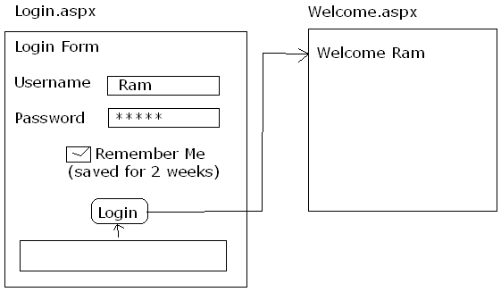

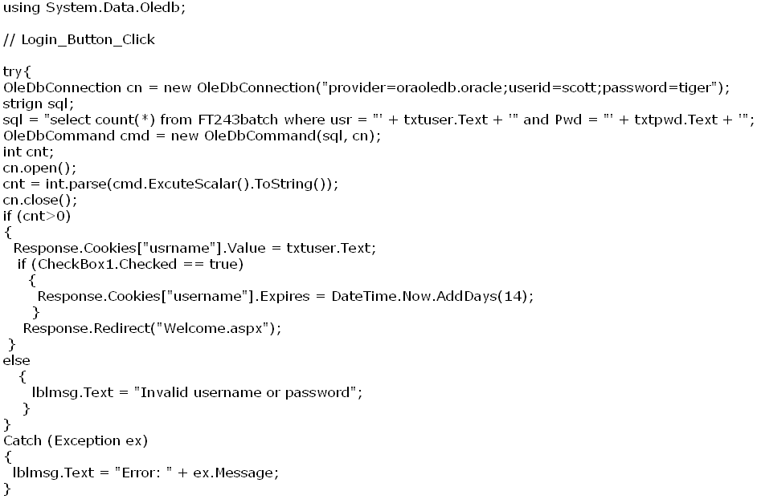
→ Add webform : Welcome.aspx
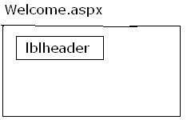
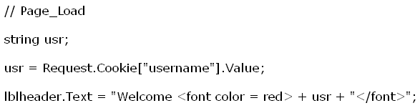
Note: Whenever the persistent cookie is created the information about the cookie can be retrieved from the following path:
“C:\Documents and Setting\peers\cookies”

Limitation of Cookies:
- Cookie information are stored on the client machine and hence security for the data will not exist.
- Browsers are having the capability for blocking the cookies and if a web browser blocks the cookies then the website which uses the cookies will not function property.
Conclusion:
*Whenever a huge string information has to be maintained for longer period of time then cookies should be used.
* If small data has to be maintained for short period of time then sessions should be used.
* If data should be confidential and if an object should be used across the web forms present within the site then session object should be used.

Application Level State Management:
It is used to maintain the state of all the users accessing the website.
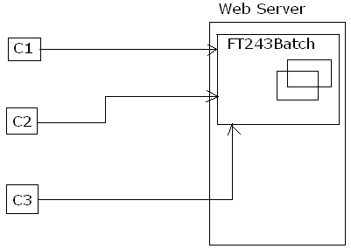
To maintain the information of:
Single user → Session Level State Management
All users → Application Level State Management

*To set the Application Object:
Application[“variable”] = value;
Where the value can be either a string or an object.
*The information set within the application object can be accessed in all the webforms and also the data will be shared for all the users accessing the website.
*The information maintained within the application object will exist till the Webserver is restarted.
*To read the string value from the application object:
Variable = Application[“variable”].ToString();
*To read an object as the value from the application object:
Objectname = (ObjectType)Application[“variable”];
*Since the information stored within the application object will be shared among all the users accessing the website, it is essential that the application object should be locked and unlocked as per the requirement.
*To lock the application object: Application.Lock();
*Whenever the application object has been locked then the application object can’t be accessed by other users till the lock is released and the other user request will be set in queue.
*The defined on the application object will be unlocked implicitly once the complete page has been processed.
*To unlock the application object explicitly: Application.Unlock();

Global Application Class (Global.aspx) File:
It is a collection of event handlers which will be used to execute the code written within the event handlers based on the task performed on the application object.
Event handlers present within Global.aspx File are:
Application_Start | Executes the code only once when the application is started
Application_BeginRequest | Executes the code for all the webforms requested before processing the code written within page load.
Application_EndRequest | Executes the code for all the webforms requested before processing the code written with page unload.
Application_Error | Executes the code if any exception is raised in any of the webform and if the exception is not handled within the form.
Application_AuthenticateRequest | Executes the code while ASP.Net Runtime authenticates the user credentials
Application_End | Executes the code only once whenever the site is stopped
Session_Start | Executes the code whenever a new session has been created at the server
Session_End | Executes the code whenever the session of the user has been terminated

Note: *The code written within the Session_End will not be executed if the user session data is started at the StateServer or at the SqlServer database.
*ASP.Net website can have a maximum of only one Global.aspx File.

E.g:
→ Website menu
→ Add New Item
→ Select ‘Global Application class
→ Click ‘Add’
→ Write the following code:
// Application_Start
Application.Lock();
Application[“tusers”] = 0;
Application[“msgs”] = “”;
Application.Unlock();

// Session_Start
int tusers;
Application.Lock90;
Tusers = int.Parse(Application[“tusers”].ToString());
Application[“tusers”] = tusers + 1;
Application.Unlock();
→ Add New webform
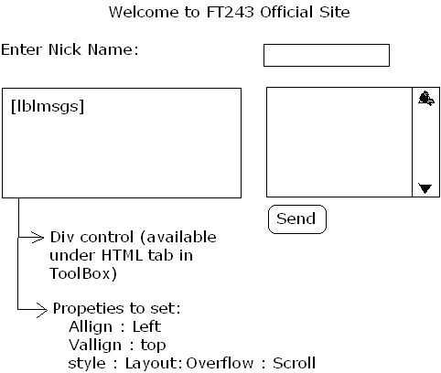
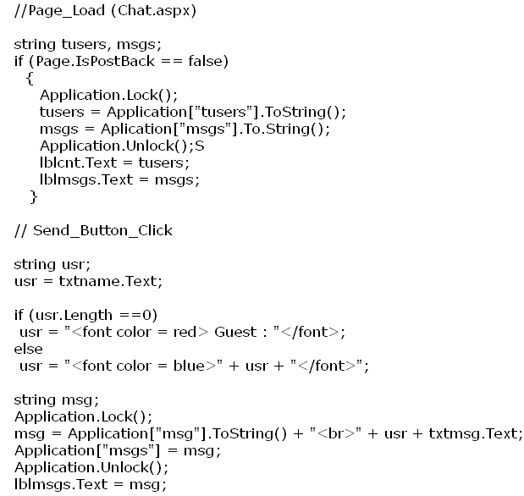

Crystal Repots
It is used to generate the reports in an efficient manner where a report can be considered as any formatted information that projects the data with a better look and feel and helps the user to analyze the data easily.
Steps to generate a basic Crystal Report:
For Windows Application:
Step-1: Add Crystal Report:
→ Project Menu
→ Add New Item
→ Select the Category: Reporting
→ Under the templates: Crystal Report
→ Name: CrystalReport.rpt
→ Click ‘Add’
*the name of the crystal report will be considered as a class name for which an object should be created in order to use the crystal reports programmatically.
→ Accept the license and click ‘OK’
Step-2: Create a new crystal report document using the report wizard:
→ Choose an Expert: Standard
→ Click ‘OK’
Step-3: Specify the database connectivity information:
→ Select ‘Create New Connection’ under ‘Available DataSources’
→ D.click on ‘oledb(ADO)’ from the list of all providers
→ Under the provider: Select the oledb provider
→ Click on ‘Next’
→ Give: Data Source: Specify server (Sever), user id (Scott), Password(tiger).
→ Click ‘Next’ and then ‘Finish’
Step-4: Select the tables needed for the crystal report:
→ Under the Available Data Sources: server → Scott → Tables
→ Select the table: emp → click ‘Next’
Step-5: Select the Data fields that has to be displayed in the report:
→ Select the fields from the available list
Step-6: Follow the instructions as per the wizard and select a style sheet for the crystal report and click on ‘Finish’ to configure the crystal report.
*The above steps will create a basic crystal report.

Using the crystal report from Windows Application:
→ ToolBox → Under ‘Reporting’ tab
→ Drag and drop ‘CrystalReportViewer’ control
→ Go to the properties of ‘CrystalReportViewer’
→ Report Source = Select the crystalReport1

Using Crystal Report programmatically:
→ Place ‘CrystalReportViewer’ control on the windows form
// Form_Load
Dim report As New CrystalReport1
Report.SetDatabaseLogon(“scott”, “tiger”)
CrystalReportViewer1.ReportSource = report
CrystalReportViewer1.RefreshReport()

Using crystal report from ASP.Net website:
→ Select ‘ASP.Net Website’
→ Follow the same steps to create a crystal report which followed earlier.
→ After creating a basic crystal report :
→ Place ‘CrystalReportViewer’ control on the form
→ Click ‘Crystal Report Tasks’ → Select ‘Configure Report Source’
→ Select Crystal Source: CrystalReport.rpt
→ Click ‘OK’ → Click ‘CrystalReportViewer Tasks’
→ Choose Report Source: CrystalReport1 → Execute
Customizing crystal report for grouping and Aggregations:
*To group after selecting the data fields in the crystal reports:
→ After selecting the field, select the columns on which the group has to be created.
e.g: Select ‘Deptno’ ➔ going to group the data based on ‘deptno’
→ Click ‘Next’
→ Add the summary for the data columns as per the requirements
→ Specify: £ Salary
→ Click ‘Next’
→ Select the data column on which the data should be sorted
→ Click ‘Next’
→ Optional Step: If the crystal report needs a chart then include a chart on the report. E.g.: Barchart
→ Click ‘Next’
→ Click ‘Next’
→ Select the style for crystal report
→ Click on ‘Finish’.

Creating parameterized crystal report:
*After creating the basic report:
→ Field Explorer
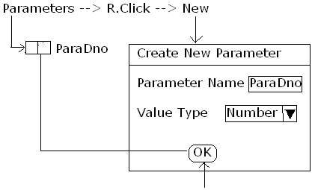

→ After adding the parameters as per the requirements: Bind the parameter field with the Report filed.
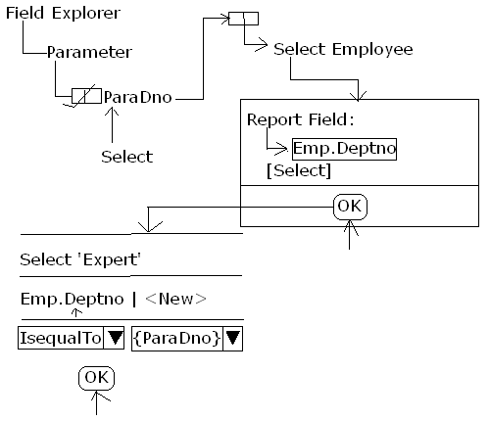
Once we click on ‘OK’ we will get a tick mark on the parameter name of Field Explorer which means that it has been bounded. If we have more than one parameter, the same steps have to be followed.
The steps will create a parameterized crystal report.
→ Design New Form → Windows form to pass parameters to the crystal reports:
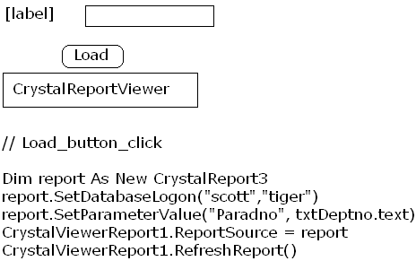
Microsoft Reports
It is an alternative tool for crystal reports provided by Microsoft in order to generate the reports efficiently.
To Create a Microsoft report:
→ Project Menu
→ Add New Item
→ Select Category ‘Reporting’
→ Select ‘Report Wizard’
→ Name: report1.rtlc
→ Click ‘Add’ and it displays ‘Welcome Wizard’
→ Click ‘Next’
→ Choose a DataSource Type: E.g: SqlDataBase
→ Choose DataConnection
→ Save the connection string
→ Choose the Database object
→ Expand the table and select the columns
→ DataSet Name: PubDataSet
→ Click ‘Finish’
*the above steps will create a typed dataset based on the specified information.
→ Select ‘DataSource’
→ Click ‘Next’
→ Select the Report Type: either ‘Tabular’ or ‘Matrices’
→ Click ‘Next’
→ Choose the Table layout
→ Click ‘Next’
→ Choose the Table style
→ Click ‘Next’
→ Completing the Report Wizard:
→ Report Name: authorsReport
→ Click ‘Finish’
*the above steps will create a Microsoft report.

Using Microsoft Report from .Net Application:
→ Add New Windows form
→ Place ‘MicroSoftReportViewer’ on to the form
→ Click on ‘ReportViewer Tasks’
→ Choose ‘Report: authorsReport.rtlc’
→ Click ‘Docking Parent Container’
→ Execute

Sending Email using ASP.Net 2.0:
To send an Email, .Net 2.0 has provided a namespace called as ‘System.Net.Mail’.
SMTPClient: It is a class which is used to specify the SMTP sever used for sending mails and also it is used to send the emails.
Properties:
Host | Specify the server name
Port | Specify the port number to be used for sending the mail.
Method:
Send | Used to send an email
MailMessage | It is a class which is used to compose and email
MailAddress | It is used to define an object for the mailing address
MailPriority | It is used to specify the priority for sending the email
→ Add New webform
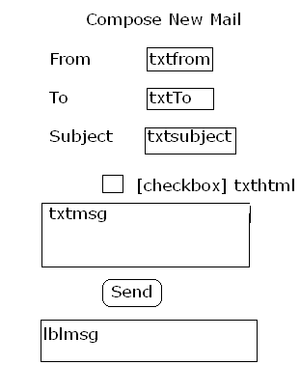
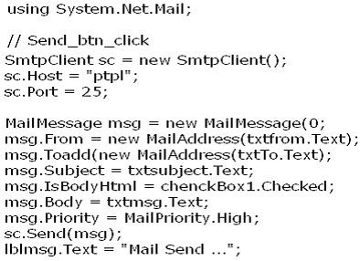
Note: Whenever the mail has been send using the above concept in a local system, then the mail will be delivered to the following path: “c:\InetPub\Mail\Root\Drop”
HTML Screen Scraping:
It is used for reading the contents present in any website based on the specified URL and used to project the information as if it belongs to the same site.
Note: *Data can’t be submitted using screen scraping.
* In order to scrap the HTML contents, the class ‘System.Net.WebClient’ should be used.
→ Add New webform as follows:

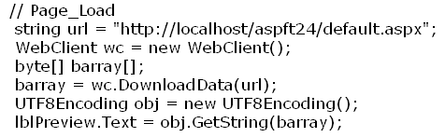

.Net Remoting
Various types of Application developments:
- Single Tier Application:
Whenever the presentation login (design) and the business logic (code) are written within a single application then it is said to be Single Tier Application.
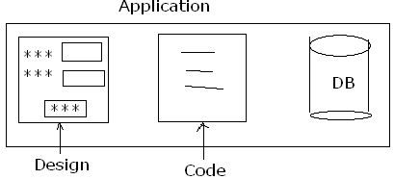
Limitation: Since the data is binded with the application the data has to be duplicated with all the applications and hence data redundancy and data inconsistency will occur.
Solution: Two Tier Application.

- Two Tier Application:
If the application will contain only the code and the design will be separated from the application then such type of applications are called as Two Tier Application.
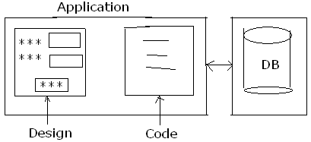
Limitation: Since the business logic is binded with the application if the same business logic has o be used by multiple then the code has to be duplicated.
Solution: Three Tier Application
- Three Tier Application:
Whenever the design, the code and the data is separated into different layers then it is said to be Three Tier Application.
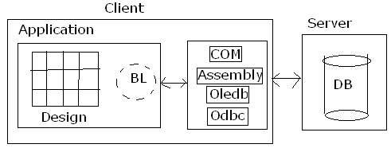
Note: Whenever an application contains only the design then it said to be “Thin Client” and if the application contains the design and the partial business logic then it is said to be “Thick Client”.
Limitation: The application and the middle tier should exist in the same system.
Requirement: A technology such that the code present in one system should be accessed from the application present in other systems connected within the network.
Solution: Distributed Technologies.

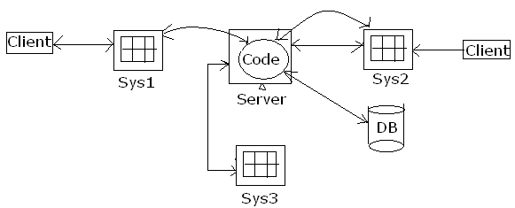

Solution for the Distributed technology from .Net:
.Net Remoting:
Communication between a .Net assembly from one system with a .Net assembly present in other system connected within the network is called as .Net Remoting.
Points to remember about .Net Remoting:
*.Net Remoting Architecture
*Channels to be used for communicating between the systems involved in remoting.
*How to send a request to her server.
*How does the server should provide the response to the clients.
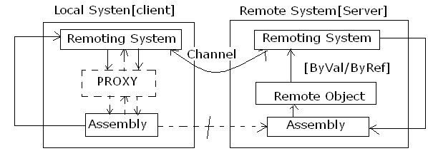
Whenever a client uses a .Net assembly definition present in other system then a request will be send to the remoting system of the client.
Remoting system of the client accepts the request and defines a proxy where the proxy act like an interface between the remoting system and the assembly.
Once the proxy is generated then it well send a request to the assembly requesting its requirement and the collected information will be provided to the remoting system of the client.
Once the remoting system of the client gets the details then it will send a request to the remoting system of the server using channels.
Remoting system of the server accepts the request and identifies the assembly for which an object will be created at the remote system where that result will be provided as the value or reference to the remoting system of the client from the server using the channels. The collected information will be provided as the result to the assembly with the support of proxy.
Channels:
These are the physical communication media used by the .Net remoting system in order to communicate between the systems involved in the remoting infrastructure.
Note: >net remoting supports two types of channels.
1. TCP Channel
2. HTTP Channel
TCP Channel | HTTP Channel
It is used for intranet based applications. | It is used for internet based applications.
A port has to be explicitly created in order to used TCP Channel. | It can use the default port number of the webserver and also a port can be explicitly created and can be used for HTTP Channel.
If the network is enabled with proxy server or Firewalls then the data will not pass through the network. | Data can pass through the network if it is enabled with the Firewalls or Proxy server.
In built security is not available and hence user has to provide the security explicitly. | It can use the default security of the webserver and also it can use SSL (Secured Socket Layers) for transferring the data.
Performance will be faster. | Performance will be slow when comparing with the applications using TCP Channel
In order to use, create an object for “System.Runtime.Remoting.  Channels.TCP.TCPChannel” class. | In order to use create an object for “System.Runtime.Remoting. Channels.Http.HtpChannel” class.

Note:
* In order to register a channel:
Syntax: ChannelServices.RegisterChannel(<channelobject>);
*In order to unregister a channel object”
Syntax: ChannelServices.UnRegisterChannel(<channelobject>);
*In order to work with .Net Remoting it is mandatory that the channel object should be registered in all the systems connected within the network.
* A client application can send a request to the server by using two methods.
1. Client Activated Object method (CAO):
If used then iff the remote object members are invoked a request will be given to the remoting system of the client for further processing.
To send a request using CAO method:
RemoteConfiguration.RegisterWellKnownClientType(GetType( namespaceHierarchy.Classname), objecturi);
Uri → Universal remote identifier
Url → Universal resource locator
2. Server Activated Object method (SAO):
If used then if an object is created for the remote class then a request will be given to the remoting system for further processing.
Note: SAO method is of two types.
- SingleCall method
- SingleTon method.

SingleCall Method:
If used to send a request to the server then once the remoting system of the server provides the response to the client. The remote object created at the server will be garbage collected. That is, remote object will serve only one request and then object is destroyed.

SingleTon method:
If used then for the first client request remote object will be defined at the server and the same object will be used to serve any no. of further client requests.

*To send a request using SAO method:
RemotingConfiguration.RegisterWellKnownClientType(GetType (namespaceHirarchy.classname), objectUri, <SingleCall | SingleTon);

Server can provide the response to the client in tow ways:
1. CallByValue 2. CallByReference
Note:* If a class is defined using Serializable attribute the objects created for that class will be provided as a value to the client.
*If a class inherits ‘MarshalByRefObject’ class then the objects created for that remote class will be provided as a reference.
Steps to create Server Application:
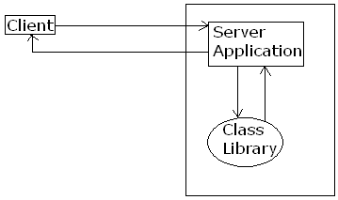
Step-1: Import all the name spaces needed for supporting .Net Remoting.
Step-2: Create an object for channel class.
Step-3: Register the channel class object with the server.
Step-4: Create an object for the remote class.
Step-5: Marshal the object.
Note: The above steps will create a server and Register the server.
Step-6: Disconnect the Remote object from the Remoting Services.
Step-7: Unregister the channel object.
Note: The above two steps (6 & 7) are to disconnect the server.
Steps to create a Client Application:
Step-1: Import all the namespaces needed for supporting .Net Remoting.
Step-2: Create an object for channel class.
Step-3: Register the channel class object with the server.
Step-4: Send a request to the server using CAO method or SAO method.
Step-5: Create an object for the Remote Class and access the members using that object.
Step-6: Unregister the channel object.
E.g:
→ Select Class Library
→ Name: RemoteClassLibrary
→ Click ‘OK’
→ Write the following code:
Imports System
Imports System.Data
Imports System.Data.Oledb
Public Class RemoteClass
Inherits MarshalByRefObject
Sub New()
Console.WriteLine(“Remote class object created..”)
End Sub
Public Function Hello(ByVal name As String) As String
Console.WriteLine(“Hello Method is being processed…”)
Return “Hello” & name
End Function
Public Funtion ShowData(ByVal cs As String, ByVal stmt As String) As DataSet
Dim da As New OldDbDataAdapter(stmt,cs)
Dim ds As New DataSet
Da.Fill(ds, “temptable”)
Return ds
End Function
End Class
→ Build the Solution

Server Application:
→ Console Application → Name: ServerApplication
→ Add the reference of System.Runtime.Remoting.dll and RemoteClassLibrary.dll.
→ Project menu → Add reference
→ Write the following code:
Imports System
Imports System.Runtime.Remoting
Imports System.Runtime.Remoting.Channels
Imports System.Runtime.Remoting.Channels.Http
Module Server
Sub Main()
Dim ch As New HttpChannel(1111)
ChannelServices.RegisterChannel(ch,False)
Dim remoteobject As New RemoteClassLibrary.RemoteClass
RemotingServices.Marshal(remoteobject, “xyz”)
Console.WriteLine(“Server started at http://localhost:1111/xyz”)
Console.WriteLine(“Press Enter to stop the server..”)
Console.ReadLine()
RemotingServices.Disconnect(remoteobject)
ChannelServices.UnregisterChannel(ch)
End Sub
End Module
→ Make as ‘Server’
Client Application:
→ Console Application
→ Name: ClientApplication
→ Add the reference of System.Runtime.Remoting.dll and RemoteClassLibrary.dll.
→ Project menu → Add reference
→ Write the following code:
Imports System
Imports System.Runtime.Remoting
Imports System.Runtime.Remoting.Channels
Imports System.Runtime.Remoting.Channels.Http
Module Client
Sub Main()
Dim ch As New HttpChannel(0)
ChannelServices.RegisterChannel(ch,False)
RemotingConfiguration.RegisterWellKnownClientType (GetType( RemoteClassLibrary.RemoteClass), “http://localhost:1111/xyz”)
Dim obj As New RemoteClassLibrary.RemoteClass
Console.WriteLine(obj.Hello(“sekhar”)
ChannelServices.UnRegisterChannel(ch)
End Sub
End Module

*Designing the windows application as a client application:
→ Add new windows application
→ Name: WebClientApplication
→ Add the reference of System.Runtime.Remoting.dll and RemoteClassLibrary.dll.
→ Design the form as follows:
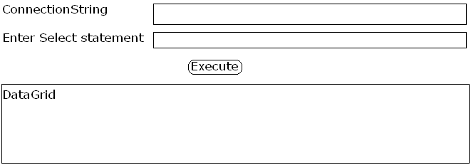
Code:
Imports System
Imports System.Runtime.Remoting
Imports System.Runtime.Remoting.Channels
Imports System.Runtime.Remoting.Channels.Http
// Execute button click
Dim ch As New HttpChannel(2222)
RemotingConfiguration.RegisterWellKnownServiceType( GetType(RemoteClassLibrary.RemoteClass), “http://localhost:1111/xyz”, WellKnownObjectMode.SingleCall)
Dim obj As New RemoteClassLibrary.RemoteClass
Dim ds As New DataSet
ds = obj.ShowData(txtcs.Text, txtstmt.Text)
DataGridview1.DataSource = ds.Tables[0]
ChannelServices.UnregisterChannel(ch)
Requirement:
A technology to use the code present in one system from the application present in other system connected within the network.
Solution: Distributed Technology.
Distributed Technology | Client | Server | Platform | Protected | Internet Support
DCOM | VB/VC++ | VB/VC++ | WINDOWS | RPC | X
.NET REMOTING | ANY .NET LANGUAGE | ANY .NET LANGUAGE | WINDOWS | HTTP/TPC | √
RMI | JAVA | JAVA | ANY | RMI | X
EJB | JAVA | JAVA | ANY | JNDI | √
CORBA | JAVA | C++ | UNIX | IIOP | X

Limitation of Distributed Technologies:
All the above technologies will target to their native platforms and hence, the code present in one technology can’t be used from the applications developed using other technologies.
Solutions: Web Services

Web Services
It is a specification for achieving cross language, cross platform and cross device integration. That is, A web service can be considered as a class definition maintained on the Webserver as a service such that the definition can be used from the applications developed using any technology for any platform or any device any where any time.
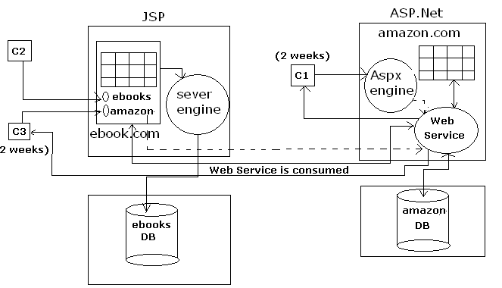
- Web service specification is developed with a collaboration of many large and small software vendors.
- Web Service specification is implemented by IBM corporation and they called it as ‘Web Services’.
- Sun Micro System : Java Web Services
- Oracle Corporation : PL/SQL Web Services (Oracle 10g onwards)
- Microsoft : ASP.Net Web Services (XML Web Services)

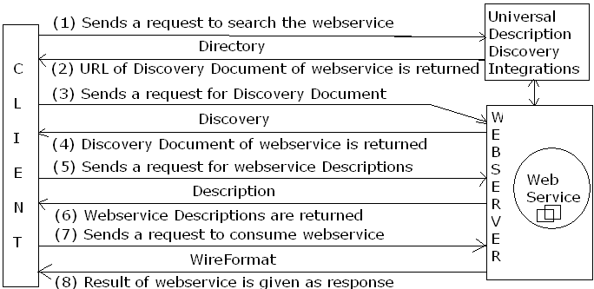

UDDI: It is used to provide the guidelines for publishing the webservices.
*The rules for ASP.Net webservices can be retrieved from:
http://uddi.microsoft.com
Directory: It acts like a repository for maintaining the information of the webservices.
Discovery: It is a process to search the presence of webservice within the Webserver.
Note: A Directory can also be a webservice which can be used to search the other webservice programmatically.
*ASP.Net webservice supports two types Discovery documents.
1) .disco file 2) .vsdisco file
1).disco file: It is used to search the webservice using the absolute path of the webservice.
* .disco file doesn’t follow the industry standards and it is supported only by ASP.Net webservice.
2).vsdisco file: It is a Discovery document which is used to search the webservice based on the relative path of the webservice.
* .vsdisco file follows the industry standards and hence, it is supported by all the webservices.
Descriptions: It is used to provide the complete information of the webservice such as the method, signatures, attributes and properties used within the webservice.
*Description of a webservice will be written using WSDL (WebService Description Language).
WSDL: It is an XML based language which is used to provide the Descriptions for the webservice.
WireFormat: These are the standard protocols used by the webservice in order to send a request and receive the response.
*The standard protocols which are supported by the webservice are:
1. HTTP 2. SOAP
1. HTTP: (Hyper Text Transfer Protocol)
It is a standard protocol which is used to send a request and receive the response.
*HTTP uses HTTP-GET or HTTP-POST for submitting the data.
E.g:
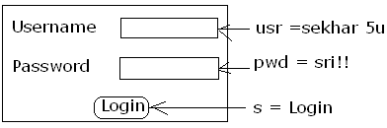
The data present at the client system will be submitted to the server based on the following standards.
*Combines all the names and values as pairs using “=”.
e.g: usr=sekhar 5u
pwd=sri!!
S=Login
*Combines all the names and values pairs a single expression using “&”.
e.g: usr=sekhar 5u&pwd=sri!!&s=Login
*Replaces all the non-alpha numerical values with its equivalent hexa decimal value prefixed with “%”.
e.g: usr=sekhar 5u&pwd=sri%21%21&s=Login
*Replaces all the blank spaces within the expression using “+”.
e.g: usr=sekhar+5u&pwd=sr%21%21&s=Login
Note:
*The above data will be submitted as a query string if HTTP-GET is used for submitting the data and uses streams for submitting the data if HTTP-POST method is used for submitting the data.
2. SOAP: (Simple Object Access Protocol)
It is a formatting protocol which is used to format the incoming messages and the outgoing messages.
*SOAP protocol consists of four parts.
1. SOAP Header/SOAP Envelopes/SOAP Addresses:
It is used to specify the address to which the request has to send or the response to be given.
2. SOAP Body: It is the actual message which has to be formatted.
3. The 3rd part of SOAP protocol is used to specify the data standards to be followed for formatting the SOAP messages.
4. The 4th part of SOAP protocol is used to specify the data bindings needed for the HTTP and the SOAP protocol.
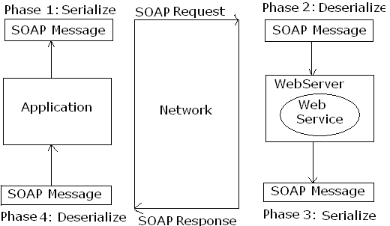
Creating ASP.Net WebService:
Step-1:
→ File menu
→ New → Website
→ Select ‘ASP.Net WebService’ template
→ Location: HTTP → Name: “http://localhost/ft243WebService”
→ Click ‘OK’
Step-2:
→ Write the code as per the requirement
using System.Xml.Serialization;
using System.Data;
using System.Data.Oledb;
[to enable Ajax support:: using System.Web.Script.Services;]
Public class Service: System.Web.Services.WebService
{
[WebMethod]
Public int add(int a, int b)
{
return a+b;
}
[WebMethod]
Public DataSet ShowData(string cs, string query)
{
try{
OleDbDataAdapter da = new OleDbDataAdapter(query, cs);
DataSet ds = new DataSet();
da.Fill(ds, “temptable”);
return ds;
}
Catch(Exception ex)
{
DataSet ds = new DataSet();
ds.Tables.Add(“Error Table”);
ds.Tables[0].Columns.Add(“Error Messages”);
DataRow row;
row = ds.Tables[0].NewRow();
row[0] = ex.Message;
ds.Tables[0].Rows.Add(row);
return ds;
}
} }
→ Execute and we will get a URL: http://localhost/ft243WebService/Service.aspx

Consuming the WebService from VB.Net Windows Application:
→ Select Windows forms application template from VS.Net
→ Add the WebService as a service reference
→ Project Menu → Add Reference
→ Address: http://localhost/ft243WebService/Service.aspx
→ Click ‘Add’
→ We can get the service name, tasks within it which created earlier using C#
→ Click ‘OK’
→ Design the form as per the requirement.

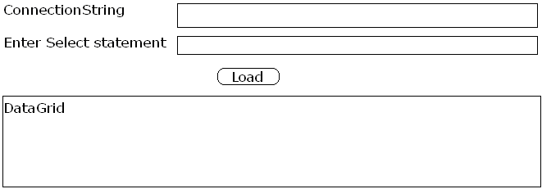
//Load_Button_Click
Dim obj As New ServiceReference1.ServiceSoapClient
Dim ds As New DataSet
ds = obj.ShowData(txtcs.Text, txtquery.Text)
DataGridView1.DataSource = ds.Tables[0]
→ Execute
*Attributes for WebMethod:
BufferResponse | If set to ‘true’ then the response will be provided once the total WebService method is processed and if set to ‘false’, the response will be given to the client as a chunks of data (piece by piece)  *BufferResponse by default it is set to ‘true’.  E.g: [WebMethod(BufferResponse = true)]
CacheDuration | It is used to specify the duration to be used for maintaining the result of the WebService method as a cache within the WerServer.  E.g: [WebMethod(CacheDuration = 120)]
Description | It is used specify the description for the WebService method.  E.g: [WebMethod(Description = “Accepts two nums and returns its sum”)]
EnableSession | If set to ‘true’ then the result of the WebService method will be set as a session content such that the result can be used from any webforms present within the site.
MessageName | It is used to provide an alias names for the WebService method.  E.g: [WebMethod(MessageName = “Add Nums”)]
Note: * The security concepts used for the ASP.Net website such as Forms Authentication and Windows Authentication can be used to provide the security for the ASP.Net WebService.
Profiles
It is used to maintain the user information permanently by storing the user data within SqlServer database.
*Profiles can maintain only string information.
*The information stored in the profile will be maintained in “aspnet_profiles” table.
*The data of the profiles will be saved within the table iff th profile information is modified.
E.g.:
→ New ASP.Net website
→ In web.config file, after <System.Web> tag
<Profile>
<properties>
<add name = “FullName” default value = “Guest” allowAnonymous = “true”/>
</Profile>
<anonymousIdentification enabled = “true”/>
{This should be written if anonymous users are allowing}
→ Save the web.config file.
*Once the profile configuration has been set within the web.config file:
→ To set profile property programmatically:
Profile.PropertyName = value;
→ To read the profile property value programmatically:
Variable = Profile.PropertyName;
→ Design the form as follows:
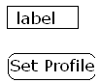

→ // Page_Load (Default.aspx)
if (Page.IsPostBack == false)
lblHeader.Text = “Welcome <font color = red>” + profile.FullName + “</font>”;
→ // Set Profile_click
Response.Redirect(“SetProfile.aspx”);
→ Add New
→ Webform
→ Name: SetProfile.aspx
→ Click ‘Add’
→ Design the form as follows:
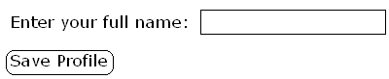
→ // Page_Load (SetProfile.aspx)
if (Page.IsPostBack == false)
txtFullname.Text = Profile.FullName;
→ // Save Profile_Click
Profile.FullName = txtFullName.Text;
Response.Redirect(“Default.aspx”);

WebParts
It is used to design the website logically into many small blocks which are called as WebParts such that the contents can be added, modified, removed or moved from one place to other.
*ASP.Net 1.x WebParts are supported only by SharePoint portals.
*From ASP.Net 2.0 onwards the WebParts are supported in SharePoint portals and also in ASP.Net websites.
*ASP.Net 2.0 has introduced the following controls for WebPart management.
1. WebPartManager: It is a class which is used for managing all the web parts present within the webform.
*A webform can have a maximum of only one WebPartManager control.
*WebPartManager should be the first control to be used within the webform.

2. WebPartManagerProxy: It is used to provide the WebPartManager functionality within the content page.
*WebPartManagerProxy should be used only within the content page provided WebPartManager is present within the Master Page.

3. WebPartZone: It is a collection of web parts.

4. CatalogZone: It is a collection of web parts which are used for adding the content to the WebPartZone.

5. DeclarativeCatalogPart: It is used for maintaining the data or the controls to be added dynamically at the runtime.
*CatalogZone maintains a collection of DeclarativeCatalogPart where DeclarativeCatalogPart is a web part.

6. EditorZone: It is a collection of web parts which are used for modifying the web parts present within the WebPartZone.
*The web parts which are used to support modifications of other webparts are:
AppearanceEditorPart; LayoutEditorPart; BehaviourEditorPart; PropertyGridEditorPort.
E.g.:
→ Design the form:
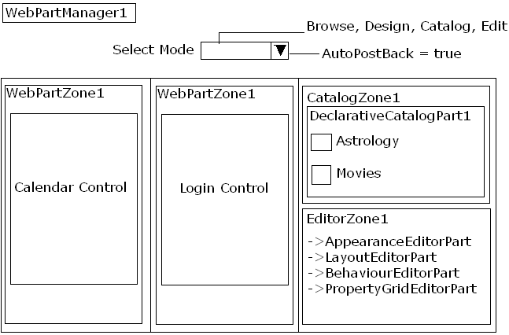
→ //D.click on Select Mode
Switch (DropDownList1.SelectedIndex)
{
Case 0: // Browse
WebPartManager1.DisplayMode = WebPartManager.BrowseDisplayMode:
Break;
Case 1: // Design
WebPartManager1.DisplayMode = WebPartManager.DesignDisplayMode:
Break;
Case 2: // Catalog
WebPartManager1.DisplayMode = WebPartManager.CatalogDisplayMode:
Break;
Case 3: // Edit
WebPartManager1.DisplayMode = WebPartManager.EditDisplayMode:
Break;
}

Smart Device Applications:
It is used for developing the applications for the smart devices like mobile phones, PDAs, PalmTops etc.
→ To design a Smart Device Application:
→ File → New → Project
→ Under Project types select ‘Smart Device’
→ Under templates select ‘Smart Device Project’
→ Specify the name for the application
→ Click ‘OK’
→ Select ‘Targer Platform’ and ‘Frame Work’ appropriately.
→ Click ‘OK’
→ Design the screen saver (for example)
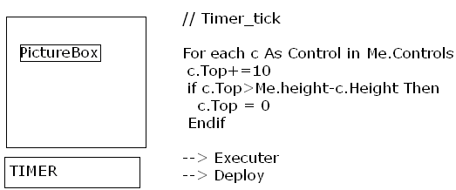

Language Enhancements in .Net 3.5:
1. Object Initializers:
It is used to initialize the members of the class with support of implicit constructors.
Console application:
Module ObjectInitializersDemo
Class Employee
Public empno As Integer
Public ename As String
Public deptno As String
End Class
Sub Main()
Dim emp As New Employee with {.empno = 101, .ename= “sekhar”, .deptno = 10}
Console.WriteLine(“{0},{1},{2}”, emp.empno, emp.ename, emp.deptno)
End Sub
End Module
2. Anonymous Types:
.Net 3.x has a capability to set the data type based on the values present at the right hand side of the expression. But, if the .Net technology cannot understand the type then implicitly it defines a new complex type which is called as ‘Anonymous Type’.
E.g:
Module AnonymousTypeDemo
Sub Main()
Dim i = 10 Dim d = 105.5 Dim s = “Vb.bet”
Dim emp = New with with {.empno = 101, .ename= “sekhar”, .deptno = 10}
Console.WriteLine(“{0},{1},{2}”, emp.empno, emp.ename, emp.deptno)
End Sub
End Module
LINQ (Language Integrated Query)
It is used to define the queries for retrieving the information from the objects from the database and xml documents.
E.g:
Imports System
Module LINQ2Array
Sub Main()
Dim arr() As Integer = {10,20,2,30,6,40,7}
Dim newarr = From no In arr_
Where no<10 (‘_’ means Continuation)
Select no
For each no In newarr
Console.WriteLine(no)
Next
End Sub
End Module
Using LINQ for retrieving the data from the objects:
Imports System
Module LINQObjects
Class Employee
Public empno As Integer
Public ename As String
Public sal As Double
End Class
Class Company
Public Share Sub Main()
Dim emps As New List(of Employee)
Emp.Add(New Employee with {.empno = 101, .ename= “sekhar”, .sal = 15000}
Emp.Add(New Employee with {.empno = 102, .ename= “srinivas”, .sal = 5000}
Emp.Add(New Employee with {.empno = 103, .ename= “sri”, .sal = 6000}
Emp.Add(New Employee with {.empno = 104, .ename= “sridhar”, .sal = 4500}
Dim lessSalraryEmps = From emp In emps_
Where emp.sal<5000
Select emp
For each emp In lessSalraryEmps
Console.WriteLine (“{0},{1},{2}”, emp.empno, emp.ename, emp.sal)
Next
End Sub
End Class
End Module
Using LINQ for retrieving the data from the SqlServer: (only from SqlServer)
→ Project
→ Add New Item
→ Under templates, select ‘DataSet’
→ Drag and drop ‘Table Adapter’
→ Establish the connection to SqlServer
→ Save
→ Project menu
→ Add New Item
→ Select ‘LINQ SQL Classes’
→ Click ‘Add’
→ Click ‘Server Explorer’
→ Drag and drop employee table
→ Save
→ Add a windows form
→ Place DataGridView control on form
→ //form_Load
(Write the query to retrieve the data)
→ Place ‘LinkDataSource’ control on form
→ Configure DataSource
→ Name: DataClassDataContext
→ Next
→ Finish
→ Click on GridView tasks
→Choose DataSource : LinkDataSource1
→ Execute

WCF (Windows Communication Foundation)
It is a new framework introduced in .Net for achieving service oriented architecture based applications.
Limitations of remoting:
* .Net remoting supports only .Net applications with a support of Http and TCP channel and other technologies and other channels doesn’t support .Net remoting.
Limitation of WebService:
*WebService is not a product of MicroSoft. It is a specification provided by a group of companies and WebServices supports only the technologies which support Http protocol.
Solution: To solve the problem in Service oriented architecture : WCF
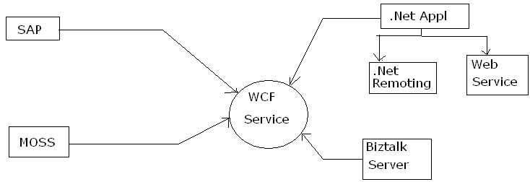

Creating a WCF service:
→ New → Website
→ Under templates, select ‘WCF Service’
→ Language: C# and Loaction: “http://localhost/FT243WCFService”
→ Click ‘OK’
→ Under ‘App_Code’, d.click on ‘iservice.cs’
→ Write the following code:
Using System.Data;
Using System.Data.Oledb;
[ServiceContract]
Public interface IService
{
[OperationContract]
int add(int a, int b);
[OperationContract]
DataSet ShowData(String cs, String query);
}
→ Save
→ App_code
→ D.click on ‘Service.cs’
→ Write the following code
Using System.Data;
Using System.Data.Oledb;
Public class Service: IService
{
Public int add(int a, int b)
{
return a+b;
}
Public DataSet ShowData(string cs, string query)
{
OleDbDataAdapter da = new OleDbDataAdapter(query, cs);
DataSet ds = new DataSet();
da.Fill(ds,”temptable”);
return ds;
}
}

→ Service.svc file:
<%@Service Host Language = “C#” Debug = “true” Service = “Service”
Code Behid = “~/App_Code/Service.cs”%>
*The above steps will create a Windows Communication Foundation at the following location.
“http://localhost/FT243WCFService/Service.svc”

Consuming WCF Service:
→ Select windows application from vs.net
→ Add the service reference
→ Project menu
→ Add Service Reference
→ Click ‘OK’
→ Specify the path of the service
→ Click ‘Go’
→ Namespace name: ServiceReference1
→ Click ‘OK’
→ Design the form as follows:
// Load_Button_Click
Dim obj As ServiceReference1.ServiceClient
Dim ds As New DataSet
ds = obj.ShowData(txtcs.Text, txtquery.Text)
DataGridView1.DataSource = ds.Tables(0)
→ Execute
Windows Workflow
It is a new framework introduced for designing an application for supporting a proper hierarchy while executing the application.
Designing a sequential workflow application:
→ New → Project
→ Select ‘Workflow’
→ Select ‘Sequential workflow console application’
→ Click ‘OK’
→ Drag and drop ‘Code’
→ Specify the name of code activity: AcceptValues
→ D.Click on ‘AcceptValues’
→ Above the AcceptValues method: Dim a, b As Integers
// AcceptValues
Console.WriteLine(“Enter values for ‘a’: “);
a = Console.ReadLine;
Console.WriteLine(“Enter values for ‘b’: “);
b = Console.ReadLine;
→ Drag and drop ‘IfElse’ and place in appropriate place
→ Select the properties under condition ‘Code Condition’: mycondition and d.click
//mycondition
e.Result = a>b
→ Success: code activity properties ‘Execute Code’ and d.click
//If code
Console.WriteLine(“A is greater that B”)
→ Drag and drop code activity: ExecuteCode: IFElse and d.click
// Else code
Console.WriteLine(“B is greater that A”)

Windows Presentation Foundation (WPF)
It is a new framework introduced in .Net 3.5 for developing the .Net applications with a high end graphics, animations with a complete audio, video support.
*WPF uses XAML (eXtensible Markup Language) which pronounced as ‘Zammel’.
E.g:
→ New → Project
→ Select ‘WPF Application’
→ Click ‘OK’
→ R.click on ‘ToolBox’
→ Click ‘Choose Items’
→ Click on ‘WPF Components’ Tab
→ Select control ‘InkCanvas’
→ Click ‘OK’
→ Place the ‘InkCanvas’ on the window
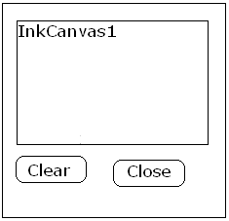
// Clear_button_click
InkCanvas1.Strokes.Clear();
// Close_click
End
--------

