SSIS [Sql Server Integration Service]

Introduction

It is used for building high performance data, which include extraction, transfermation, and Load(ETL) for date warehousing. It is used for automating Sql Server.ETL is a task of Importing to or Exporting from a database.
We can access data using ssis for
• Microsoft Access Database
• Microsoft Excel Worksheet
• Sqlserver Database
• OLE Db Providers and
• Flat Files

Export and Import

You can use Import and Export in Sql server by using the following steps.
• Open Sql Server Management Studio and
• Right Click your database name and click task
• In task click Export or Import option
• You will get an sql server import and export wizard
• Click next and choose your data source and click next
• click destination server and give your input server details and click next
• Select copy data from one or more tables or views and click next
• select your table from table list and click next
• Click Run immediate option for normal transaction and click next
• Click finish
Expand the table nodes to verify that the created table is in your table list.

SSIS Steps to Export or Import

Now we are going to implement the same using SSIS package which we can execute when ever we need this steps to be done.

This article explains the basic steps of creating a package and managing and executing package.

• Open SQL Server Business Intelligence Management Studio Create a package.dtsx
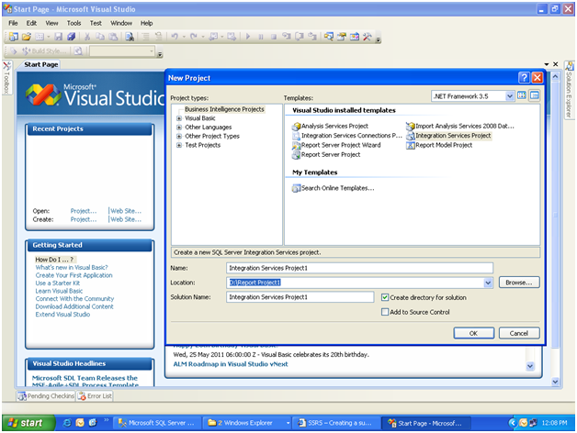

opening the SSIS project
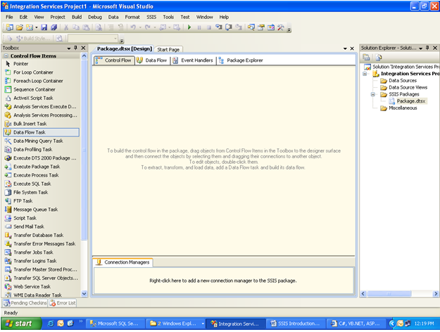

After opening the SSIS project drag and drop a data flow task from control flow and double click the dataflow task

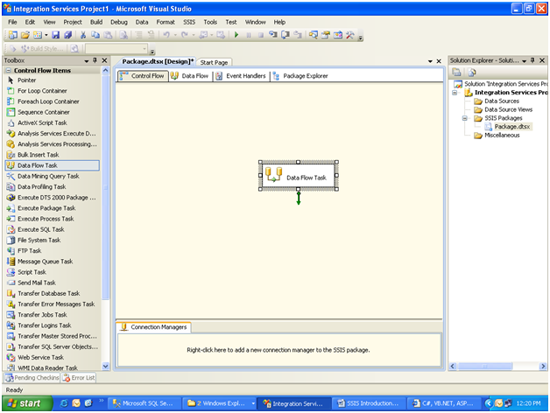
After opening the data flow task from control flow and double click the Ole db Source from data flow sources.
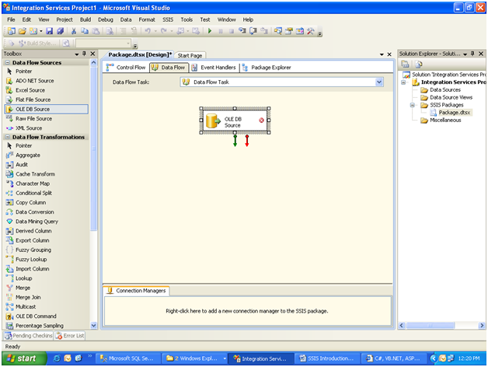

Double click the Ole db Source or click edit to select the data source and give source server and database and tables.
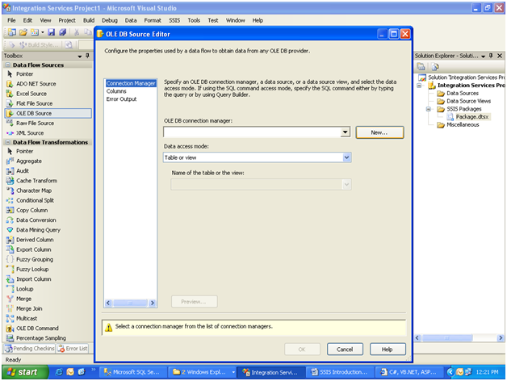
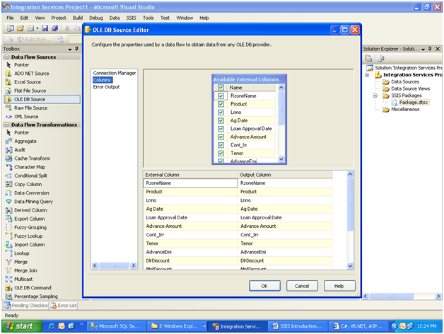
click on the column tab for selecting fields for table.
Drag and drop the Aggregate function.
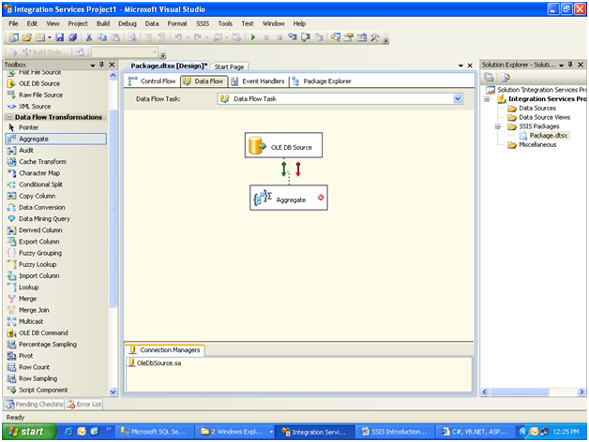
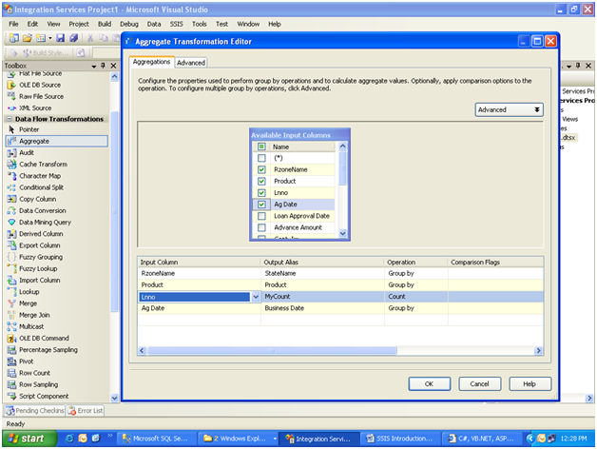
Select the fields and aggregate fields it may be sum, count,etc.
Select OleDB destination from data flow destinations and drop it after aggregate function.
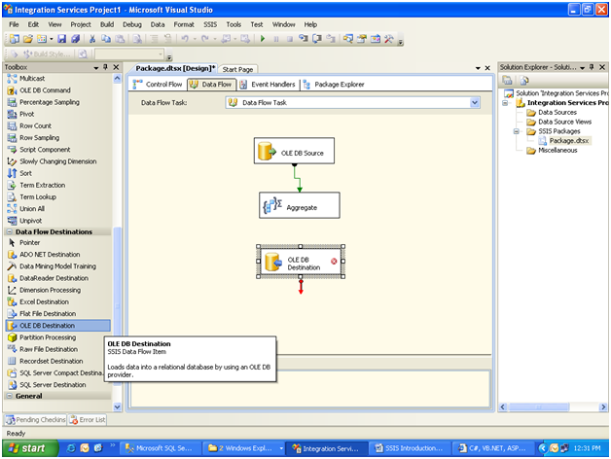
Select OleDB destination database and create destination table.
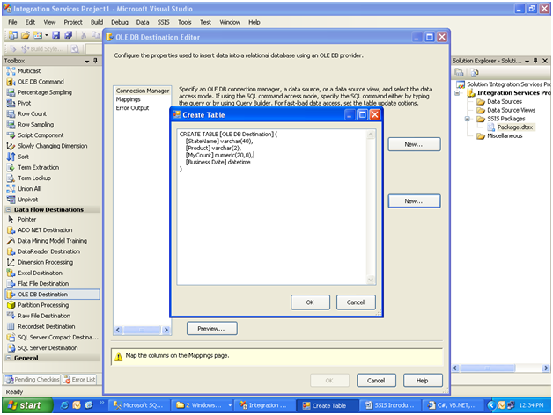
After that do mappings for the fields.

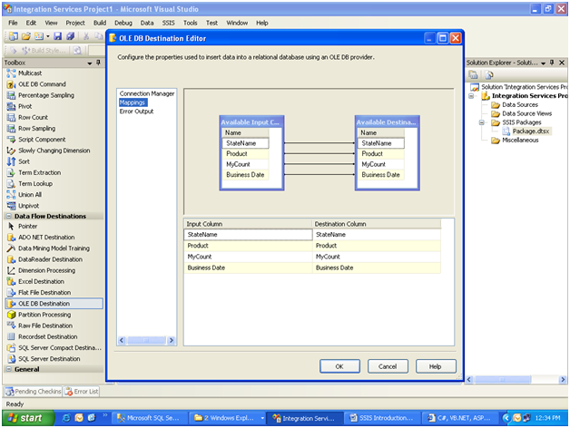
Execute the package after doing all these steps and save it.
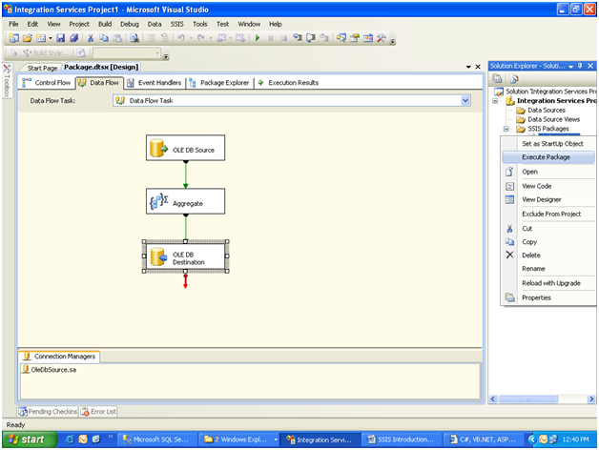
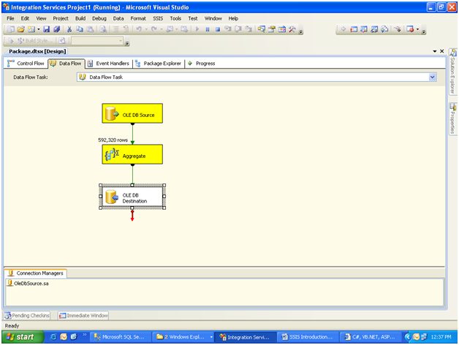
Execute the package we get Yellow colour for running process, Green colour for completed process and red colour for error packages.
Process completed successfully in this final step.
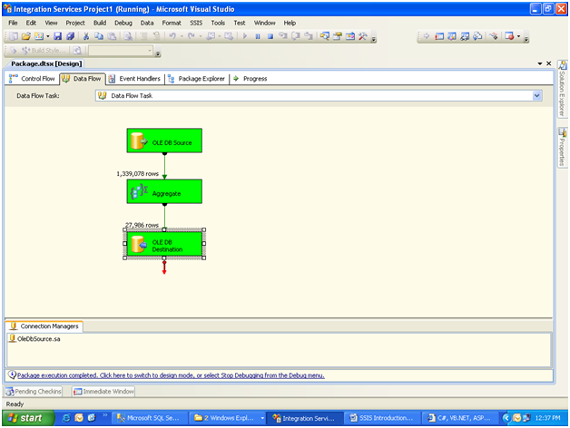
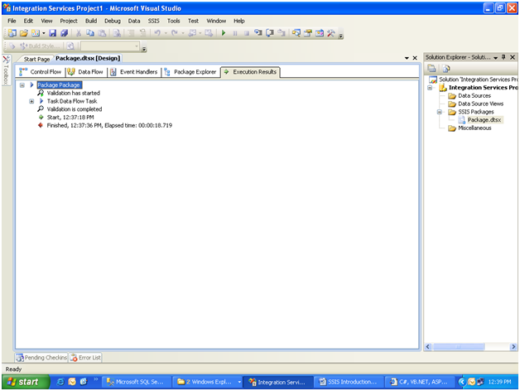
Execution results can be viewed in execution results.

Conclusion: These are the steps to be done for using ssis package and to execute the package successfully.

