Login Screen

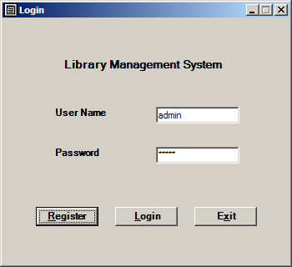

If user logon with valid id and password he gets action screen
Manage Categories and Add/Remove Books is available for admin user which exists in system after installation. As of now no new user created will be admin.
Admin user available in system at start is admin with password as admin

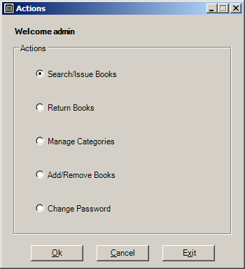

Search/Issue Books screen accessed from actions screen, in this screen search and issue is done. First user enters the criteria for book searching and a book is successfully find than user can select the book he wishes to get issued in grid and get it issued.
Maximum number of books allowed for issue is 3

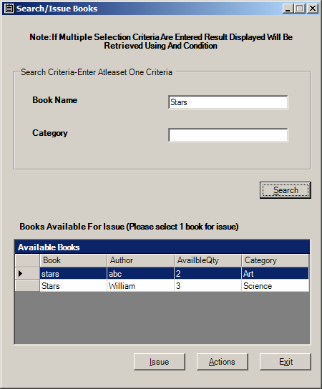

Return book shows all books issued to user and user can select book that he wishes to return

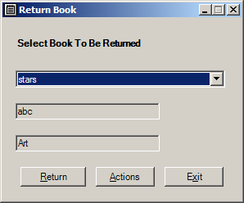

Add category

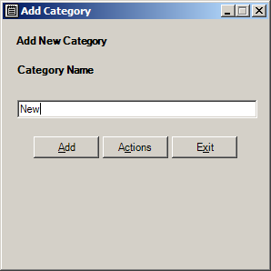
Add Books or remove books
For adding there should be at least one category

Books can be removed, all books in system are shown in Remove books section user can use Remove button to remove books after setting Quantity to be removed of book selected.
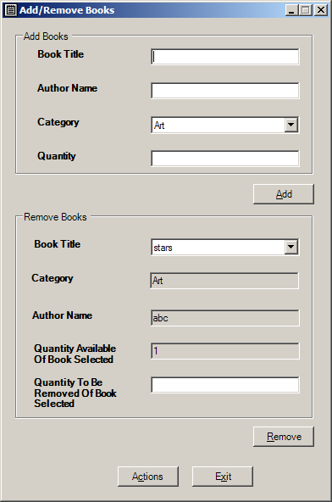
Register a new user

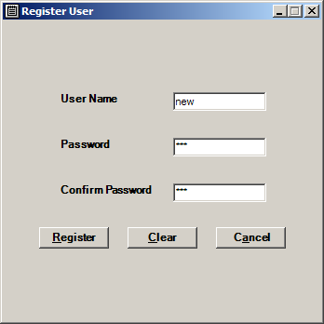

Change user password

