CRM – Common errors and best practices

Solution problems
solutions can cause problems, some common problems are
- CRM 2011 – Solution not importing – Timeout errors
Increase the OLEDBTimeout and the ExtendedTimeout
- CRM 2011 – SQL error while importing solution in crm 2011
Error can be because of mismatch in data type of the field.
To resolve the error you have to delete the variable in the CRM organisation you are trying to import the solution to. Then you will be able to import the solution.
The best way to find the variable is to use WinMerge and compare the customization.xml files in the previous solution file and the new solution customization.xml. You can get the solution file by exporting it if you don’t have one to hand.
- CRM2011 OptionSetId Cannot be Changed when Importing Unmanaged Solution
When working with unmanaged solution at some point I decided some of the Option Sets should change from entity level to global option sets.
It failed, it gave the error – ‘OptionSetId’ cannot be changed’ when importing. It took me a while to work out which option set was causing me problems but in the end I removed and deleted most of them until I got the right one.
- CRM 2011 – error when importing solution
Error: The solution file is invalid.
The compressed file must contain the following files at its root: solution.xml, customizations.xml, and [Content_Types].xml
The problem was I was zipping up the solution folder; this then creates a zip file with a folder at the root and then the three solution files.
Solution: What you have to do is select the three xml files and then zip them up. This then it doesn’t create the root folder.
Reason for error during import can be related to permissions.
Solution:
“Import Customizations” permission. “Import Customizations” and “Import Job” permissions are required to import and install solutions in CRM. Make sure it is set to Organization.
- How to delete components from managed solution in Dynamics CRM?

There can be requirements to delete the components from the managed solution. Neither directly deleting the components from managed solution works nor deleting the field from unmanaged solution and migrating as managed solution to target environment works.
We can make use of OOB feature of solution management.OOB feature used is Clone the solution. The version of the solution will be upgraded when we clone the solution.

Steps:
Steps to be followed are given below:
- Delete the components from your unmanaged solution that are not required or replaced.
- Make note of Version Number and click on Clone Solution.
- You can check the Version Number. It is increased by 1 count (It was 1.0.0.0, now it’s 1.1.0.0). Click on Save
- 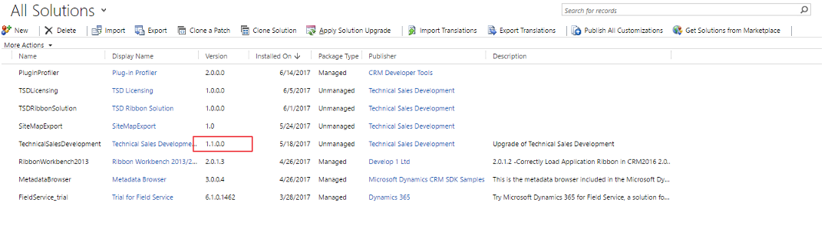
- Export the solution as managed and import on the target environment
- While importing this solution, make sure that you checked “Stage for Upgrade”
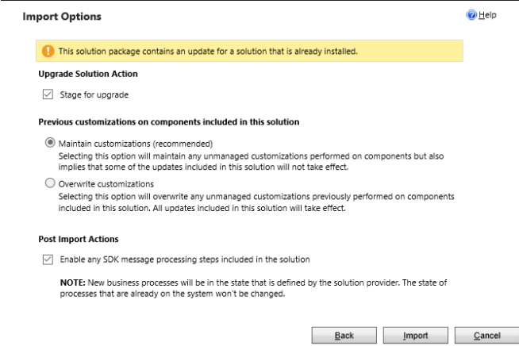

Error while adding Report file (RDL) to Sales- Reports
- Dependency calculation error – Just retry

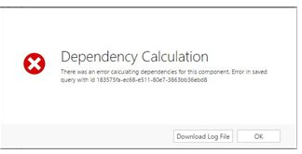
- Online Report Upload Issue
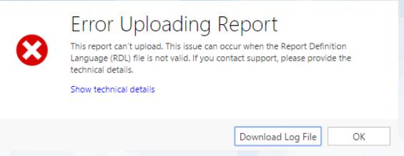

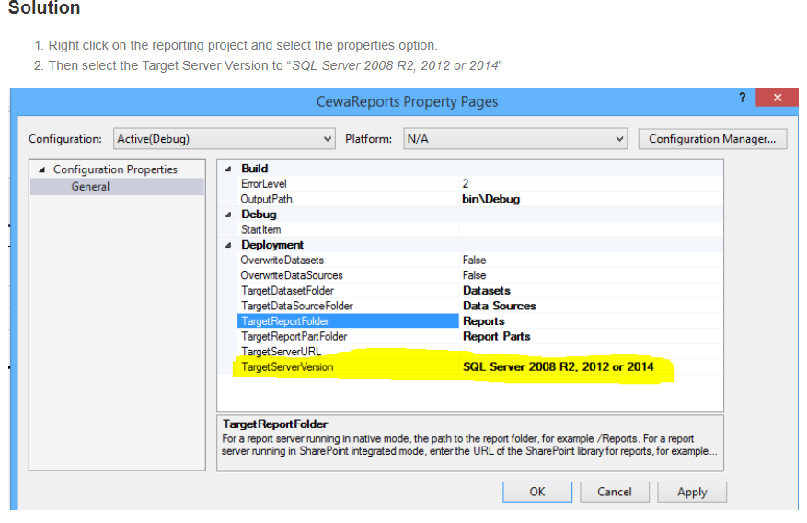

SSRS REPORTS IN CRM
https://www.youtube.com/watch?v=pRLSDvlHezk

All about CRM
https://www.youtube.com/watch?v=b819UmiKDUA

CRM Ribbon customization
https://www.powerobjects.com/2012/07/09/guide-for-crm-2011-ribbon-customization/

https://www.youtube.com/watch?v=BAalZIDp3cg

PlugIn basics, development , deployment
https://community.dynamics.com/365/b/softchiefmicrosoftdynamics365/archive/2016/11/12/dynamics-365-crm-plug-ins
PlugIn context- https://msdn.microsoft.com/en-us/library/gg309673.aspx#bkmk_inputandoutput

https://www.youtube.com/watch?v=gxFtZd1BPKw
https://www.youtube.com/watch?v=G_WPaHZZk7k
Chk with karthik….
- Where to look for PI request or response? - DeleteRequest
- for deployment using solution
https://crmbook.powerobjects.com/extending-crm/plug-in-development-and-workflow-extensions/plug-ins/registering-and-deploying-plug-ins/
Debug PI
- https://www.youtube.com/watch?v=zTM2l-J6opk
- https://dynamics365blocks.wordpress.com/2016/12/06/how-to-debug-a-plugin-in-dynamics-365-online-using-plugin-profiler/

Deploying Plugins with the Microsoft Dynamics CRM 2011 Developer Toolkit (alternate for PI Reg tool)
http://eimagine.com/how-to-deploying-plugins-with-the-microsoft-dynamics-crm-2011-developer-toolkit-tutorial/

Plugins Secure and UnSecure Configurations

https://www.youtube.com/watch?v=ZVzwHG_VA6k
https://www.youtube.com/watch?v=edOwzUJ30kk

Action in Dynamics CRM
https://www.youtube.com/watch?v=ON3k5cy23Fc

CRM - Custom Actions

https://www.youtube.com/watch?v=-V9nAF2cjJA

Web Resources
https://www.youtube.com/watch?v=R76ZVZ9L8Ns

Business Rules
https://www.youtube.com/watch?v=U59pJZ2rm-g

Becoming a D365 developer
https://www.youtube.com/watch?v=FnWugHDVPi4

How to Consume the External Web API or Webservices from Dynamics 365(CRM)Plugin

https://www.youtube.com/watch?v=jDuR8YbSkGo

How to Update a Record with Xrm.WebApi In Dynamics 365 v9.x

https://www.youtube.com/watch?v=dJ-m0MIvdmY

XRM Tool box usage
https://www.youtube.com/watch?v=TSN2oVKnjM0

JavaScript Development
https://www.youtube.com/watch?v=wxMB-cIQPUw
https://www.youtube.com/watch?v=nDRJk_33sa8
https://www.youtube.com/watch?v=Ztha5urjKQg
Debug JS- https://www.youtube.com/watch?v=CL2hvOMvg9c

Business Rules in Dynamics CRM 2016
https://www.youtube.com/watch?v=Q7CrKDztt5I

MS CRM 2015 Integration with Web Application(ASP.Net) and Retrieving Data and showing in Grid
https://www.youtube.com/watch?v=0SgQ7Z1MANU&t=10s

Product Name | Version | Code Name
Fall 2017 ? | ?? | Calcium
July 2017 ? | 9.0 | Potassium
365 Dec 2016 | 8.2 | Centaurus
2016 SP1 and Spring 2016 | 8.1 | Naos
2016 | 8.0 | Ara
2015 (Online only) | 7.1 | Carina
2015 | 7.0 | Vega
2013 SP1 and Spring 14 | 6.1 | Leo
2013 | 6.0 | Orion
2011 (Online only) | 5.0 | Polaris
2011 | 5.0
4.0 | 4.0 | Titan
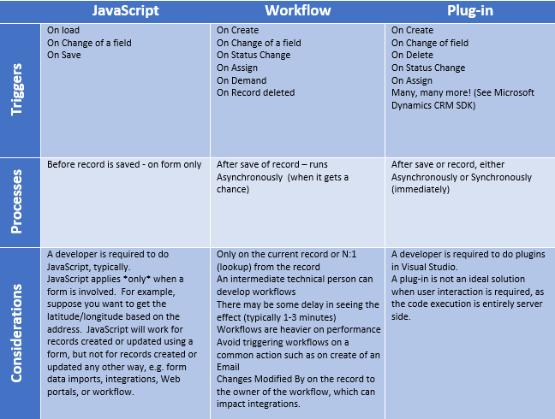

Setup CRM Dynamics account (trial version)
https://www.youtube.com/watch?v=F7cZXe7MJjE

Sign-in page
https://portal.office.com/

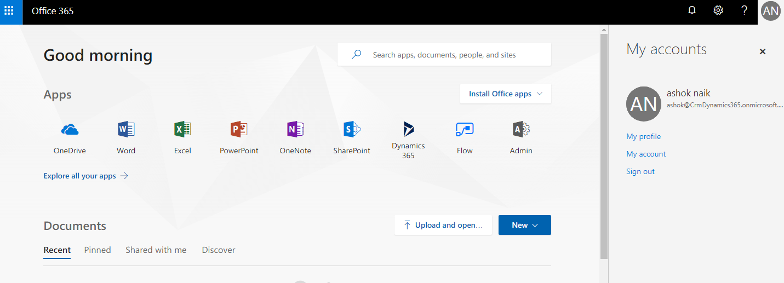

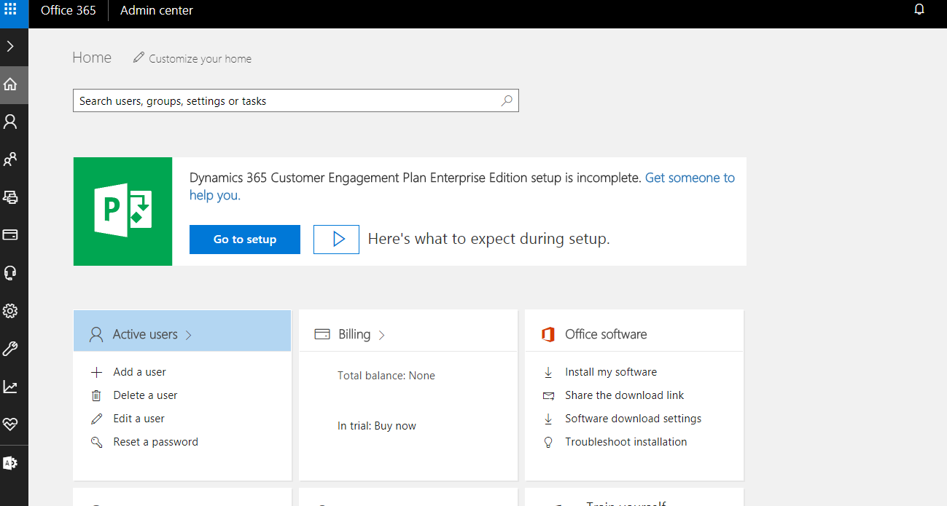

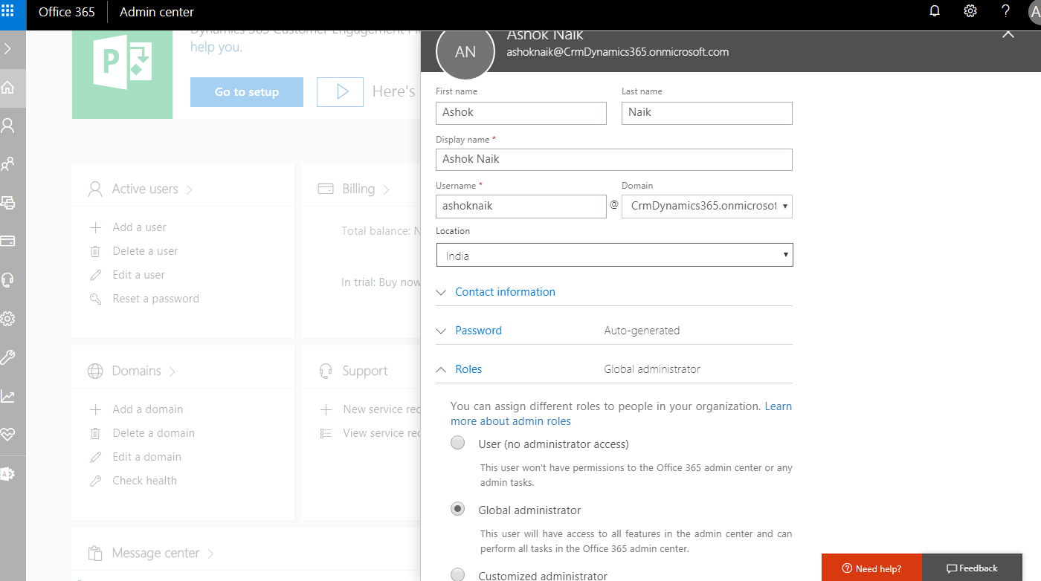

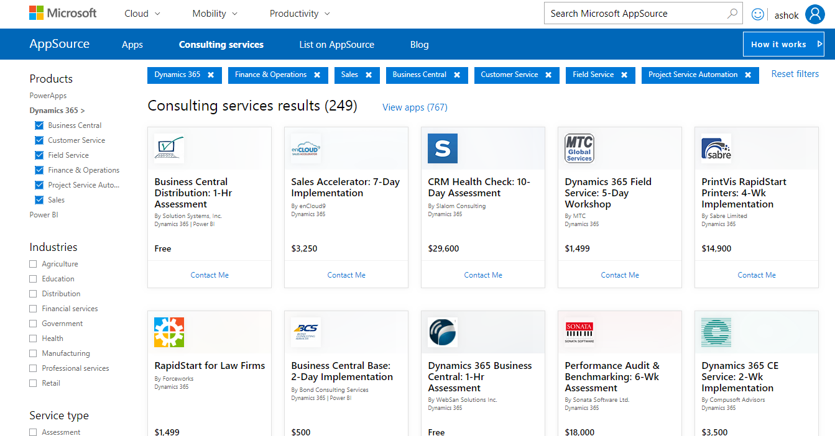

Microsoft Dynamics CRM 2016 Installation
https://www.youtube.com/watch?v=5DZirKc7dSA
After installation you be able to browse
Crm web client using https://<OrganizationUnit>/< OrgName>/main.aspx#201921109

Global search
- Add the entities to include in Global search (upto 10 entities)

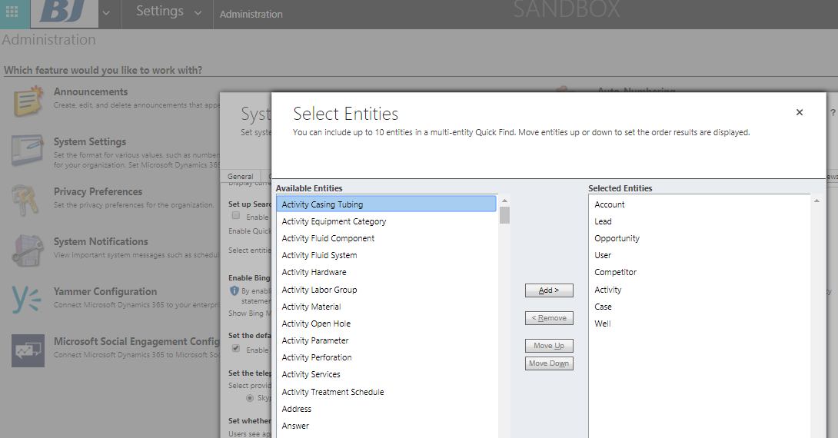

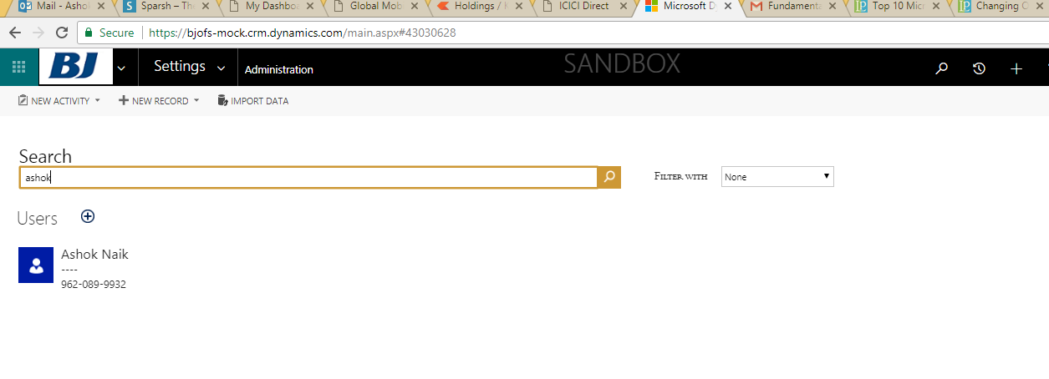
One Note integration

Set up OneNote integration
https://docs.microsoft.com/en-us/dynamics365/customer-engagement/admin/set-up-onenote-integration-in-dynamics-365
Create Local optionset(OS)
- Local OS will be created at field level
- Choose DT= optionset - use existing OS – NO – add the Label/values- reorder items (if required)
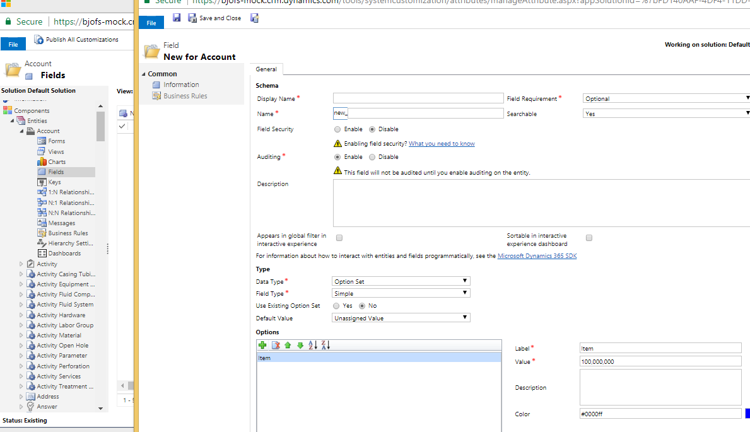

Create global optionset
- Scope is - multiple entities
- Create a global optionset –“PaymentTerms” - Save – Publish
- To use it- Form – New field- Datatype= Optionset= choose existing OS - ‘PaymentTerms’ – save - publish
- This global OS can be used in multiple forms/entities

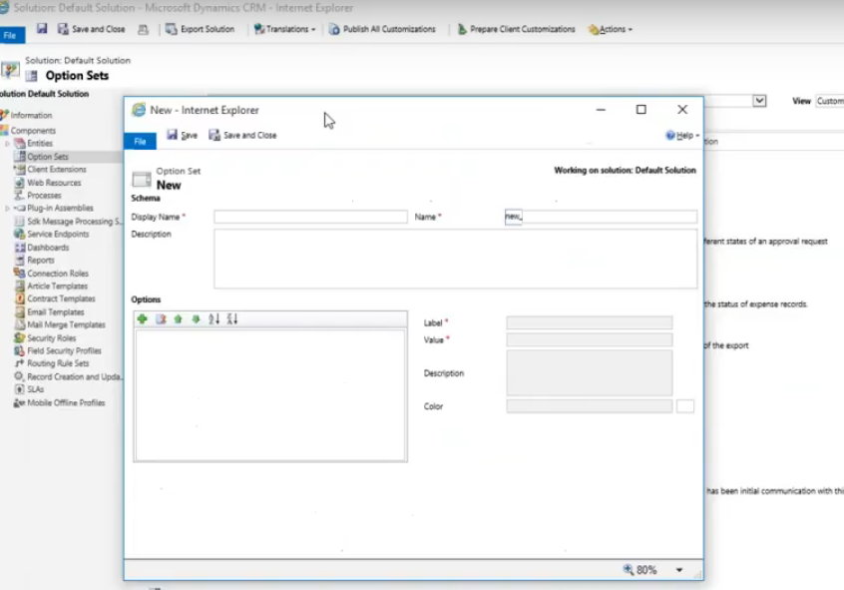

Pre-requisites required for CRM development
- .Net Framework v4.5.2 , 4.6 or onwards
- Visual studio 2015 Enterprise
- SQL Server Data Tools for Visual Studio 2013/2015 (Change/modify VS2015 installation and choose checkbox SSDT)
- BIDS (Business Intelligence) for Visual studio 2015
- To have SQLite as a datasource
Install - sqlite-netFx46-setup-bundle-x86-2015-1.0.108.0(for 32 bit Visual Studio https://system.data.sqlite.org/downloads/1.0.108.0/sqlite-netFx46-setup-bundle-x86-2015-1.0.108.0.exe) OR sqlite-netFx46-setup-x64-2015-1.0.108.0(for 64 bit Visual Studio https://system.data.sqlite.org/downloads/1.0.108.0/sqlite-netFx46-binary-bundle-x64-2015-1.0.108.0.zip)
Post installation of Sqlite, make sure you are able to add Datasets to the project with System.Data.SQLite Database File (.NET Framework Data Provider for SQLite) as a datasource.

- Install NuGet pkg like below (for first time setup) -
PM> Install-Package Microsoft.ReportViewer.WinForms -Version 10.0.40219.1

- log4net v 2.0.8.0 - for logging exceptions application exception in a log file.
- DB Browser for SQLite (http://sqlitebrowser.org/) to view/modify/query DB entities, update data and to execute queries.

Business Units
- Change BU
Settings- security- users – choose user – CHANGE BUSINESS UNIT- choose required BU from the lookup.
- Please note, when we change BU all security roles will be unchecked.
- To take care of security roles- make note of security roles prior changing BU, then change BU and set back the same roles again.

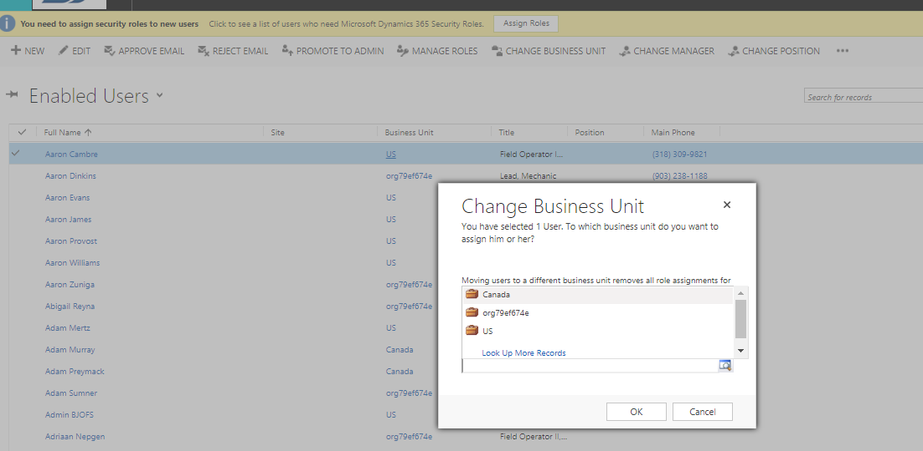

Can we change privilege(read,write..) for the selected user?
It can’t be changed directly on user but it should be done at security role level.

Share vs assign. can we see records assigned to me?
Share – Ownership will be shared with other user.
We can see/edit the shared entity based on the priviledge what we have. Sysytem admin wil have all privileges(read/write etc.).
Assign – Ownership will be transferred to other user.

SSRS Reports
Pre-requisites
- Visual studio with BIDS (Business Intelligence Development Studio)

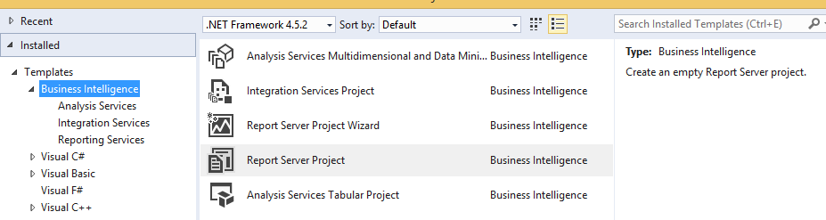

- Microsoft Dynamics 365 Report Authoring Extension (to have fetch xml querying option as a DataSource)

SSRS Reports development
- Add New Project - Choose Report server project from BIDS
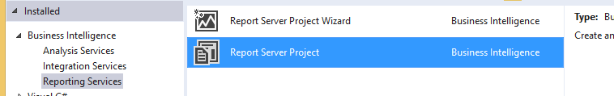

- Add New/Existing RDL file – Design RDL according to the requirement/template provided by customer.
- Go to Report Data (Ctrl+Alt+D)
- Add datasource-> Choose Embedded Connection type = Microsoft Dynamics 365 Fetch
- Connection string:-
for ex: https://disco.crm8.dynamics.com/;orgc77244d6
The last param OrganizationName/Unique Name is optional.
- Set credentials
Uname/pwd = Crm user or Crm admin credens
**Note: If you have more than one organization on the same account, you need to specify organization unique id along with CRM online URL.
Syntax: <<CRM ONLINE URL>>;<<Organization_UniqueID>>
Example: http://----.CRm5.dynamics.com;org2beffc

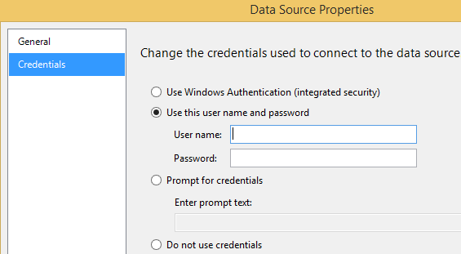

- Add DataSet(s)
- Chose datasource and Query types (Text, Table, Store proc)
- Text= Fetch XML

<fetch version="1.0" output-format="xml-platform" mapping="logical" distinct="true">
<entity name="ofs_applicationconfig">
<attribute name="ofs_applicationconfigid" />
<attribute name="ofs_name" />
<attribute name="createdon" />
<attribute name="ofs_value" />
<attribute name="ofs_businessunit" />
<attribute name="ofs_description" />
<attribute name="ownerid" />
<attribute name="createdby" />
<attribute name="modifiedon" />
<attribute name="modifiedby" />
<order attribute="ofs_name" descending="false" />
<link-entity name="annotation" from="objectid" to="ofs_applicationconfigid" alias="notes">
<attribute name="documentbody" />
<filter>
<condition attribute="filename" operator="eq" value="bjlogo.png" />
</filter>
</link-entity>
</entity>
</fetch>

**Above fetch Xml is obtained from Advanced find option- Where Notes is added to Application configuration entity with BJLogo.png as an attachment.
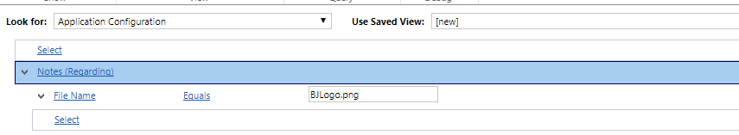

- Use Query designer option from dataset properties and verify above fetchXml retrives data properly (supply credentials if asked for) And RUN the query.

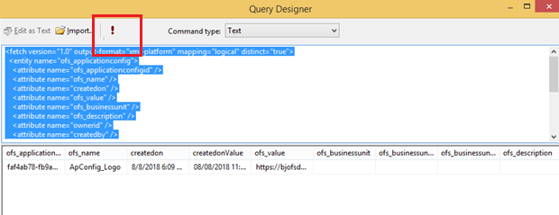

- Use Preview option (next to Design) to preview result in Rdl file (supply credentials if asked for).
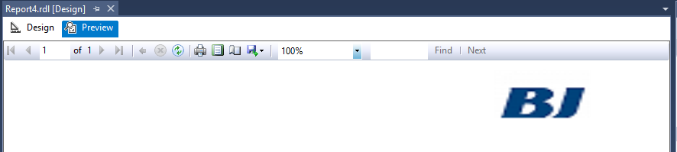
- To get the Image/Logo on Rdl report
- Place Image control on RDL design
- Set Image source=First(Fields!notes_documentbody.Value, "BJ_Logo")
- Expression = System.Convert.FromBase64String(First(Fields!notes_documentbody.Value, "DataSet2"))
- MIME Type = image/png (or relevant one)
- Add dataset to RDL by using above connection details and FetchXml query.
Deployment of SSRS reports to CRM D365
Ref- https://www.codeproject.com/Tips/1000276/Creating-a-SSRS-Report-With-Microsoft-Dynamics-CRM
- Go to Slaes/Reports OR Settings-> Solutions-> choose existing or create a new soln
- Go to Reports tab -> New -> Report-> Existing File -> Browse for RDL (which is designed in Reports projects, BUILD succeded, a RDL file from Bin/Debug folder).
** If RDL is taken from project direct ,then we get error- Invalid RDL while adding existing report as a report type.

- Categorization
Choose Categories= Sales report
Related Record Types = Field Tickets/ Event Logs (choose a relevant one)
Display In = Reports area/ Forms for related record types.
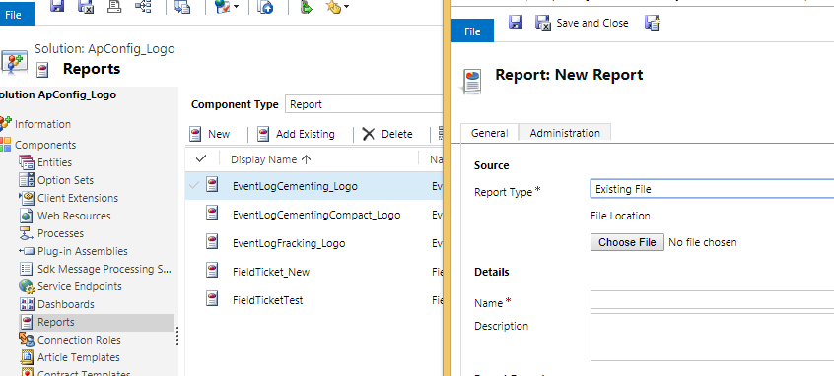

- Save and Close
- Publish All customizations from the selected solution

Verifying the reports
- Open the respective record (ex: Event Logs)
- Run report
- Choose the report name (set in reports wizard while creating/browsing report)

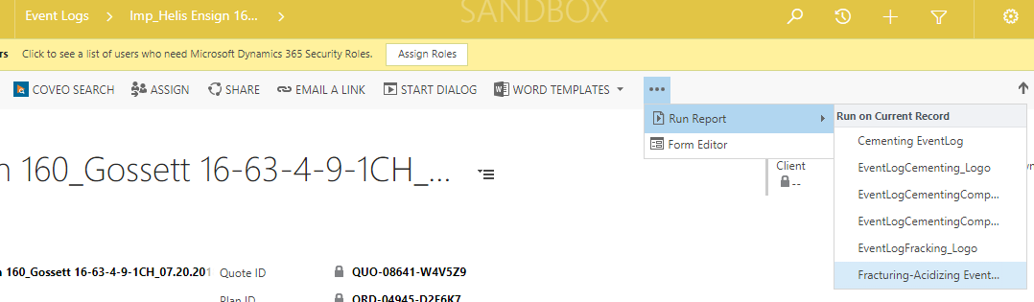

*Any deployed reports in Crm solutions and want to modify format, logo, query..anything in RDL file, please delete existing RDL from Settings- Customizations-Customize the system (Default solution)-Reports- choose Rdl to be deleted- Delete- PUBLISH all customizations (Publishing is not mandatory) – Refresh List in Reports screen.
Next GoTo - Settings- Customizations – Solutions- AppConfig soln/default soln/REPORTS tab – Delete Rdl (if exists here) -> PUBLISH customizations- – Refresh List in Reports screen

Next - Add the modified RDL to AppConfig soln/Reports and -> PUBLISH customizations.

DEPLOYMENT OF CRM Solution
Deployment of SSRS reports from Dev to DevSIT environment
- Login to source environment ex: Dev
- Choose the solution to export or add existing reports to the existing solution and export (ex: Phase3Sprint1 solution).

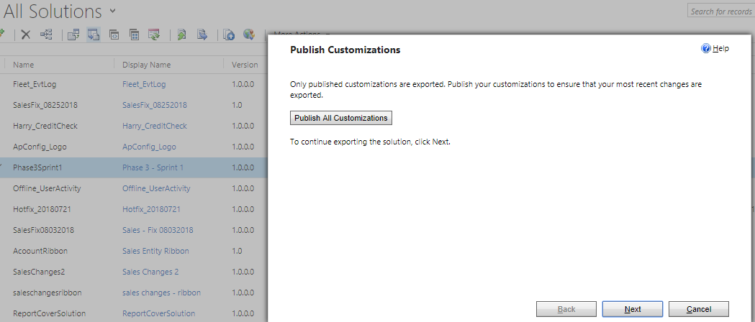

- Solution will be export as Phase3Sprint1_1_0_0_0 and downloaded to a folder.
Import solution
- Login to target environment ex: DevSIT
- Choose an existing soln or create a new
- Choose the soln and click on Import button and browse “Phase3Sprint1_1_0_0_0.Zip” – Next-Next
- Publish All Customizations and Verify the changes.

Errors/challenged faced: -
- Error while trying to navigate to RDL report in CRM
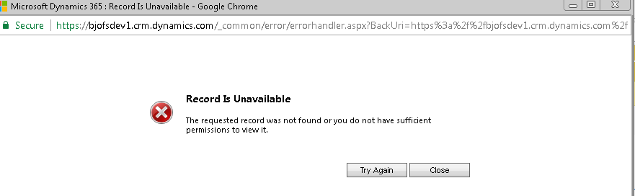
Reason: If the report is not refreshed/reflecting. Or if we do not have the required permissions.
Solution:
- Make sure report is uploaded properly.
- Refresh Crm site in browser and try opening report again

- Error uploading report – Invalid RDL

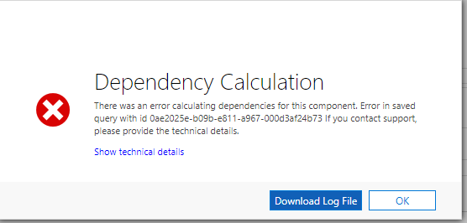
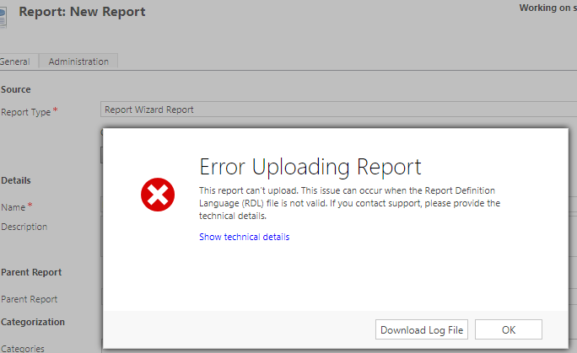

Reason: Trying to add RDL from outside the BIN/Debug folder.
Solution: Always add RDL which is BUILD in VS. So take RDL file from ~\SSRS_Reports\bin\Debug (an example path).
- Blur image on SSRS reports
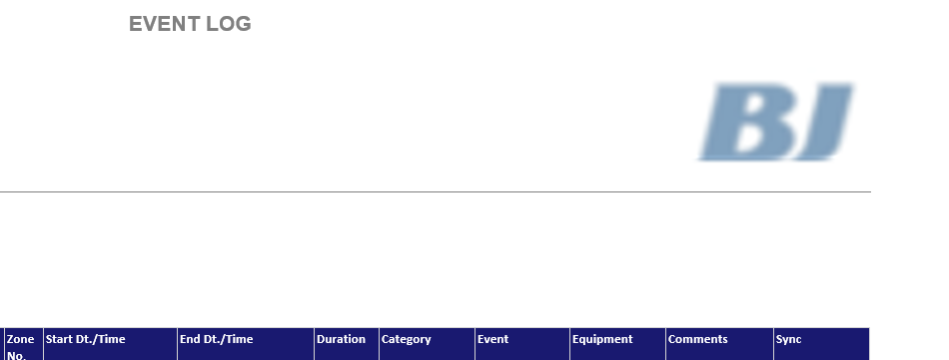

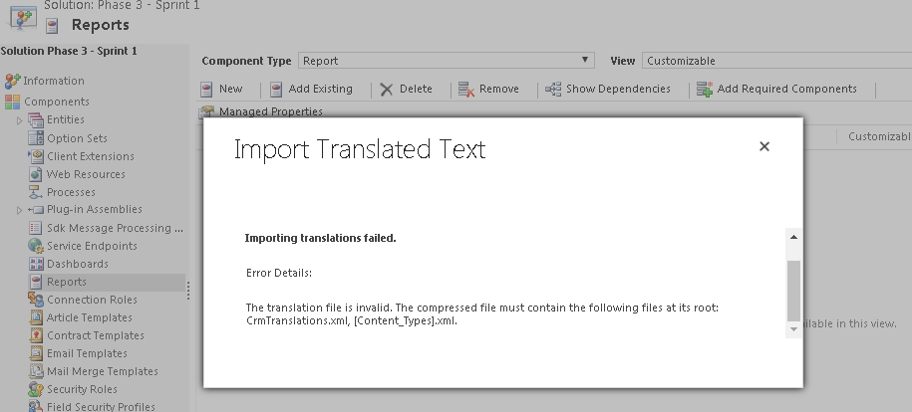

Import Notes with Attachments using Data Import in CRM
https://arunpotti.wordpress.com/2015/10/04/import-notes-with-attachments-using-data-import-in-crm/
- Unable to open Reports from a CRM instance.

Reason: Can be network issue Or Session timeout
Solution: Logout from Crm and login
Or try after sometime.
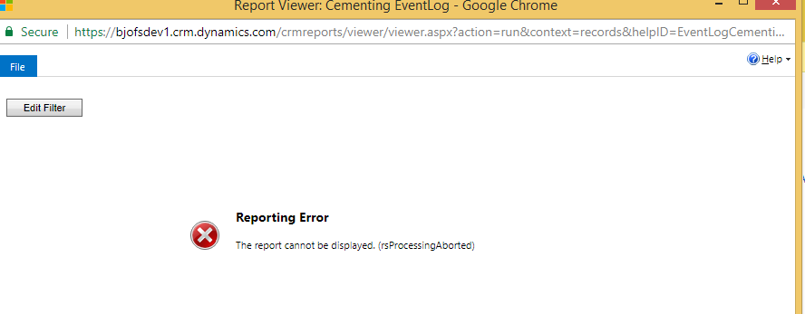

- Unable to open RDL designer
Pre-requisites for RDL : BIDS, Report authorizing extension (for fetch xml)
Issue: The report definition has an invalid target namespace.

Solution: -
- Right click Rdl- View code-
Keep Namespace like xmlns:rd=http://schemas.microsoft.com/SQLServer/reporting/2016/01/reportdefinition
- If we get error related to ‘ReportParametersLayout’, then search for this tag in design and remove this tag from report design.
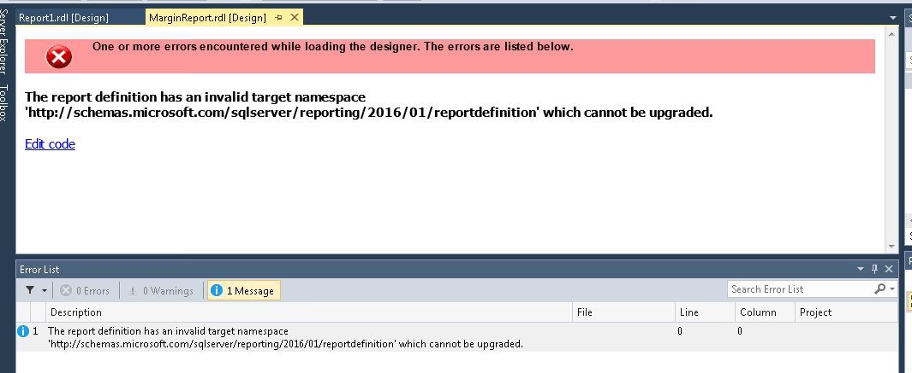

- Table/Tablix on RDL: Repetition of RDL rows in data preview

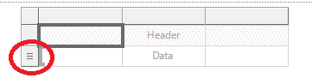
- If we want only title text/header, then delete Data row (select row-delete rows)
- If only data rows are required, then delete header.
- If more rows required, then add
Rt. click row- insert row- Inside group- Below
- If we see = mark on row column(as show in screenshot), we can see rows /data repetition, so to avoid this ,

Rt. click row-Delete row group- Delete group- Delete group only.
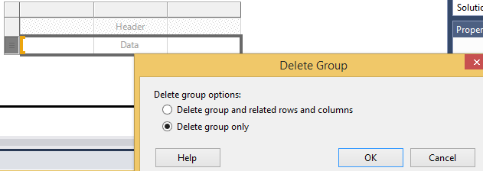

- Error while previewing RDL file or while executing FetchXml query
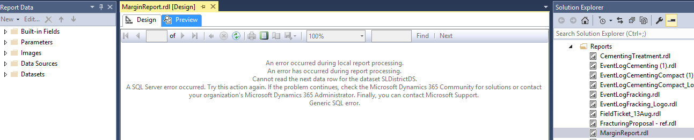
Reason : issue in queery
Solution: Put Order attribute at the end, after all the attributes (before <filetr> and </entity>)

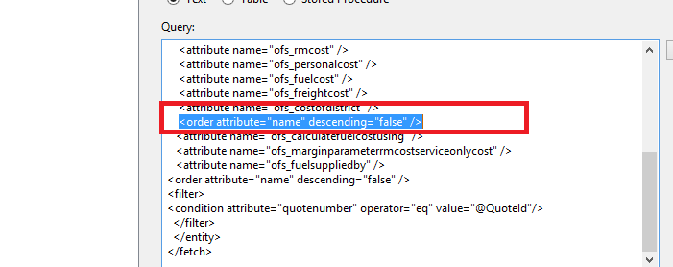

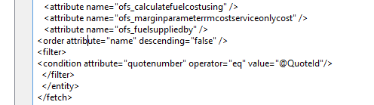

Date formats in RDL file/SSRS reports
Keep textbox expression like
=Format(Fields!createdonValue.Value,"dd/MM/yyyy")

Hide Textbox – based on an expression
Right click Textbox- Textbox properties- Visibility- show or hide based on an expression
Ex:-
=Iif(Fields!ofs_calculatepersonalcostusing.Value = "$",false,true)

Date format for a TextBox in RDL.
=Format(Fields!createdonValue.Value,"MM/dd/yyyy")
Textbox property- Number - Default

