Deployment of SSRS Reports in CRM D365.
- Use existing solution or create a new one
Solution name = SalesFix_08252018S
Publisher = OFS (mandatory)
Version =1.0.0.0
- Add changed components or modified Reports(RDL)
Open solution - Navigate to Reports tab (left pane)
NEW – Report Type - Existing file (browse the Rdl file which is built after a change in Visual studio).
Choose,
Categories = Sales Report
Related Record Types = Event Logs or Field Tickets etc.
Display In /Reports area = Forms for related records
- Publish customizations
- To Launch the REPORT
GoTo – Sales – Event Logs- Run Report- Choose ‘Cementing EventLog’/’Fracturing-Acidizing EvtLog’

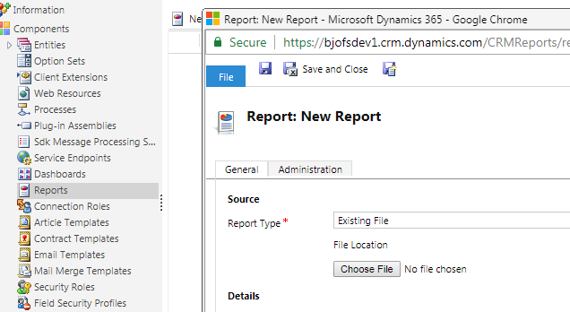

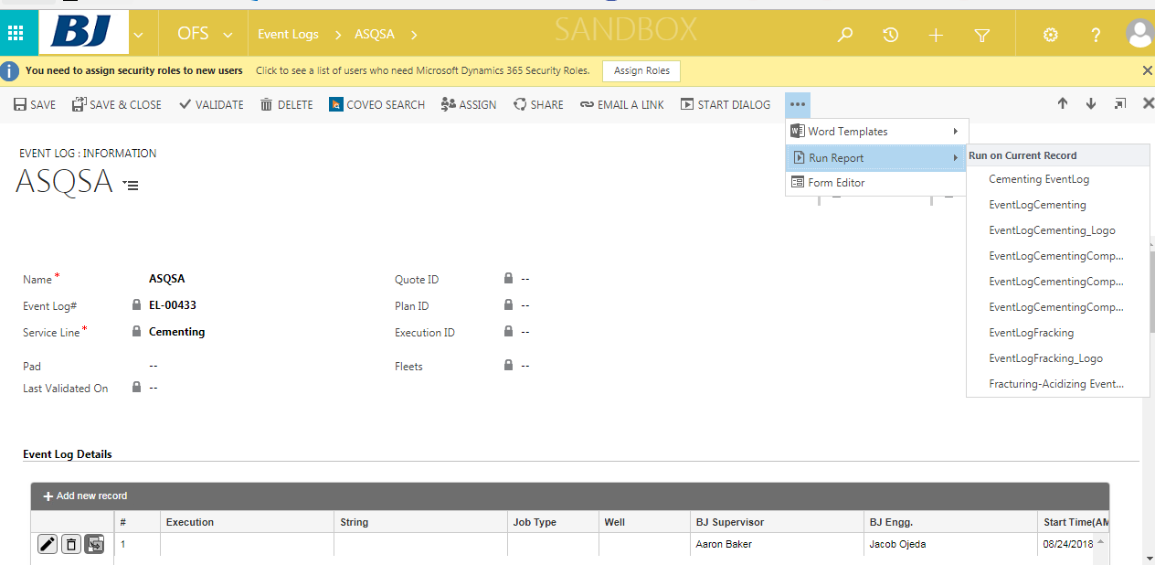
ADD Existing (from default solution) – Components /reports from Default solution will be listed
